Stress and Coping Strategies

Teacher's Guide
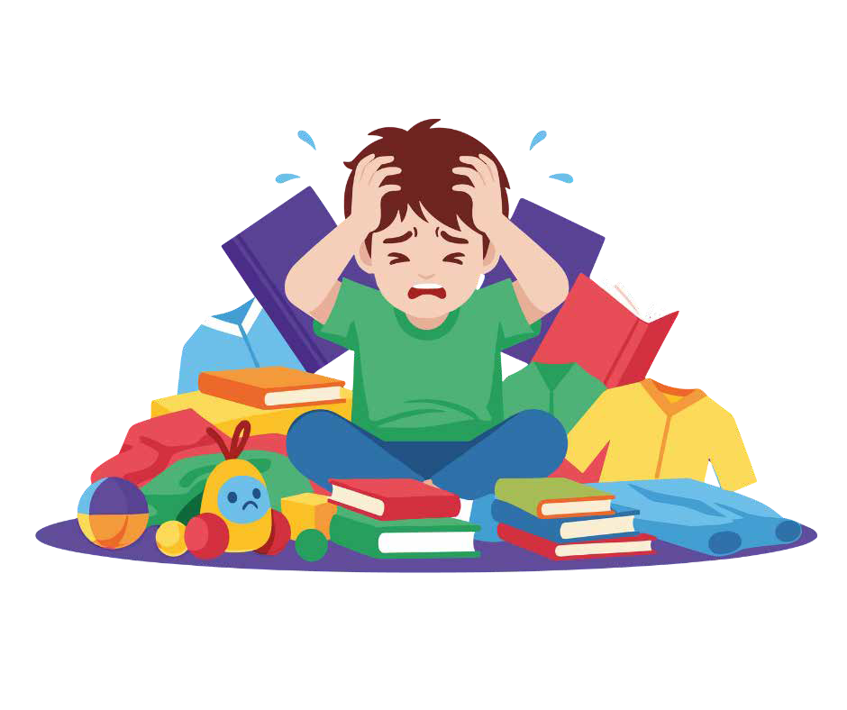

Primary school activities

INDEX
- Introduction: Why work on stress in primary school? 3
- Objectives: Module focus and pedagogical principles 3
- Recommendations for teachers: What this workshop is and isn’t 4
- Day 1 — What stresses me out and how do I notice it?
  - MA 1.1 — Introduction and presentation 6
  - MA 1.2 — Emotional monsters 8
  - MA 1.3 — Game "All those who..." 10
  - MA 1.4 — Head Picture — What stresses me out? 12
  - MA 1.5 — Body Picture — How do I notice it in my body? 14
  - A 1.6 — Key stress concepts 16
  - A 1.7 — Game "Dr. Beat" 18
  - A 1.8 — Emotional tank model 20
  - A 1.9 — Pizza massage 23
  - A 1.10 — Guided Visualization 25
  - MA 1.11 — Day 1 Closing 27
- Day 2 — Learning to regulate and take care of myself
  - MA 2.1 — Welcome and Day 1 reminder 29
  - A 2.2 — Game "Lifting weights" — The weight of stress 31
  - MA 2.3 — Strategies for managing stress 33
  - A 2.4 — Game "1-7" 36
  - MA 2.5 — Emotional Treasure Chest 38
  - A 2.6 — My Stress Poster 40
  - MA 2.7 — Visualizing My Planet / Inner Place of Power 42
  - MA 2.8 — Module closing 44
- Complementary activities
  - Complementary Activity 1 — Stress Traffic Light 46
  - Complementary Activity 2 — Emotional First Aid Kit 48
- Printable materials and resources
  - Checklist of materials per session 50
    - Day 1.
▫ AP 1.4 Head Picture — What stresses me out? 52
▫ AP 1.5 Body Picture — How do I notice it in my body? 53
▫ A 1.6 Key stress concepts 55
    - Day 2
▫ AP 2.3 Strategies for managing stress 56
▫ AP 2.5 Emotional Treasure Chest 63
▫ A 2.6 My Stress Poster 64
- Complementary activities
▫ AC 1. Stress Traffic Light 65
▫ AC 2. Emotional First Aid Kit 66

INTRODUCTION

Stress is a daily experience that affects both children and adults, especially in stages where academic, social, and emotional responsibilities increase. At this age, many students begin to feel greater pressure for school performance, changes in friendships, extracurricular activities, or family expectations, although they do not always have the tools to understand or manage it.

This module is designed so that students recognize what stress is, how it manifests in their body and emotions, and what strategies they can use to regulate themselves in a healthy way. Through body dynamics, reflection activities, group games, debates, and visualization exercises, students will learn to identify early signs of stress and develop personal resources to help them face difficult situations.

The approach of the module is practical, experiential, and respectful of the developmental stage of 5th and 6th grade Primary students. It seeks for students to acquire emotional awareness, personal autonomy, and self-care skills, while strengthening group cohesion and mutual support.

Module Objectives

- Understand what stress is from a clear and accessible perspective, differentiating functional stress (which helps performance) from stress that exceeds a person's capacity.
- Identify everyday situations that can generate stress at school, at home, or in social life.
- Recognize how stress manifests in the body, emotions, thoughts, and behavior.
- Explore practical regulation tools (breathing, visualization, body movement, cognitive strategies).
- Reflect on the importance of asking for help and recognizing one's own limits.
- Develop personal resources such as the "emotional treasure chest" or the "stress poster" to have accessible reminders during the school year.
- Promote personal and group responsibility in emotional care and classroom climate.

Expected results for module 2

Keywords
- Stress
- Activation
- Physiological response
- Brain in emergency mode
- Emotional tank
- Regulation
- Self-care
- Coping strategies
- Body signals
- Automatic thoughts
- Support
- Attention and concentration

In this module, they will understand what stress is, how it works in their body and mind, and they will learn practical tools to regulate, care for, and better manage moments of activation.

Orientation for the teacher — Flexible use of the module

This module has been designed as a flexible bank of activities, not as a rigid program that must be completed in its entirety. Although the workshop is planned for 2
sessions of 60-90 minutes, it includes more activities than strictly necessary, with the aim that the teacher can adapt the path to the rhythm of the group, the time
available, and their own experience.

Keep in mind that:

It is not necessary to perform all activities.
- Some activities are intended as key, as they support the main objectives of the module.
- Others function as support, deepening, or alternative activities, useful if the group moves quickly or if more time is available.
- You can choose, combine, or substitute activities without losing pedagogical coherence.

If this is the first time you are teaching this module, we recommend:

- Prioritize the key activities indicated in the guide. Indicated as AP + number (main activity) in pink and A + number (secondary activity) in blue. (e.g., MA1 or A3).
- Maintain a calm pace, without rushing to "get to everything."
- Remember that the objective is not to complete activities, but to facilitate understanding, body awareness, and practical stress regulation tools.

The module will function correctly even if only part of the proposed material is used. Trust your professional judgment and the group's response.

Recommendations for the teacher

- Create a safe climate: some students may feel vulnerable when talking about what stresses them. Always reinforce listening and prevent anyone from being ridiculed for sharing their emotions.
- Avoid direct personal exposure: instead of asking "what stresses you out?", use group dynamics, anonymous cards, or fictional examples.
- Observe body signals: excessive yawning, restlessness, nervous laughter, difficulty concentrating, or irritability can indicate emotional activation.
- Combine moments of activity and calm: alternating movement dynamics with breathing or visualization exercises helps maintain the group's attention.
- Validate all experiences: do not minimize the students' stress ("it's not that big of a deal"). For them, it is real and their body experiences it as such.
- Invite reflection without forcing: if a student does not want to participate in certain exercises, they can observe.
- Encourage asking for help: remember that the adult reference in the school is an important support; normalize that they seek them out when they need it.

Day 1. What stresses me out and how do I notice it? Activity 1: Introduction to the workshop and presenta-tion in a circle (5-10 minutes). Adjust according to the size of the group
MA1
and the classroom climate.

Objective:
Materials
Classroom with a circle of chairs. Clear space for moving around.
      - Welcome and present the workings of the workshop.
      - Create an atmosphere of trust, calm, and participation.
      - Introduce the module's topic: stress and how we can manage it.

1.1.2. Activity Description:
- Form the circle:
  - Invite the students to sit in a circle so everyone can see each other.
  - Explain that this will be the workspace for the first part of the workshop.

- Initial presentation: Give a brief welcome and explain the general purpose:
  - Today we are going to talk about stress, a sensation that we have all felt at some point. We will see what it is, how it affects us, and what strategies we can use to feel better."

- Clarify that there will be games, body exercises, moments of reflection, and creative activities.

- Personal presentation with gesture:
  - Tell the students that, one by one, they should present themselves saying:

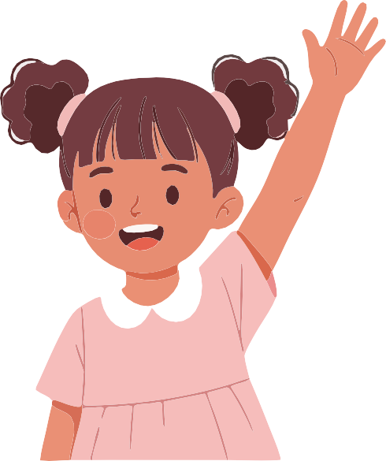
"My name is and today I feel "
and accompany the emotion with a brief gesture.

The group responds in unison:
"Hello , you feel " and replicates the gesture.

- This dynamic:
  - Breaks the ice, allows for observing the group's emotional climate, and prepares for working on emotions and stress.

Teacher's Note:
- Maintain a calm and close tone to model the climate we want to generate.
- Accept any emotion that appears in the presentation round (tiredness, nerves, joy, boredom... all are valid).
- Avoid interpretations, judgments, or "forcing" complex gestures; a small body signal is enough.
- Do not go deeper yet into what stress is: this explanation will be developed later in the module.
- If nervous laughter or embarrassment appears, normalize it: they are habitual reactions when starting an emotional workshop.

MA2
Activity 2: "Emotional Monsters" (10 minutes).
You can expand it if the group participates actively.

Objective:
Materials
Cards or sheets for drawing (optional). Whiteboard to collect ideas (optional).
      - Activate emotional recognition in a dynamic way.
      - Connect emotions with the topic of stress.
      - Make it easier for students to identify how emotions are expressed in the body and behavior.

Activity Description:
      - Present the dynamic:
        - Briefly explain that emotions can be felt and expressed in many ways:
          - "We are going to represent emotions through small gestures or movements, as if they were 'emotional monsters'. The idea is to recognize how they look, how they sound, or how they feel inside."
        - Clarify that they are not literal costumes, but metaphors to better understand emotions.

      - Invitation to participate:
        - Ask for volunteers who want to draw an "emotional monster" on paper or describe it with words.
        - These "monsters" represent emotions such as:

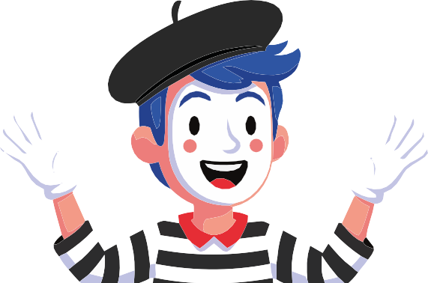
Fear Joy
Embarrassment Rage
Stress Tiredness Frustration

        - You can start yourself to model the activity.

      - Mime or brief representation:
        - Each volunteer represents the "emotional monster" with a movement, posture, or brief sound.
        - The group tries to guess which emotion it is.

      - Guided conversation:
        - Launch short questions to open reflection:
          - "How is this emotion noticed in the body?"
          - "What does this monster do when it appears?"
          - "What changes in our way of speaking or moving?"
          - "Do emotions change throughout the day?"

      - Introduce the concept of the "stress monster" :
- "How do you imagine the stress monster would be? What does it do? Does it go fast? Does it get agitated? Does it press?"
- Allow the students to describe it freely.

Teacher's Note:
- This activity is not childish if it is oriented from symbolic and metaphorical language (something that adolescents continue to use).
- Ensure that participation is voluntary; some students may feel uncomfortable representing emotions.
- You can use drawings instead of mime if the group is shy.
- Always keep the conversation from curiosity, without judging or analyzing individually.
- This activity serves as a bridge towards the topic of stress, without yet entering into theoretical explanations.

MA3
Activity 3: Game "All those who...” (10 minutes).
Adjust according to the group's participation

Objective:
Materials
Circle of chairs (one fewer than the number of students).
Free space to move..
      - Identify shared emotional experiences
within the group.
      - Normalize that we all feel stress or intense emotions at different times.
      - Generate cohesion and prepare students to talk about the topic without individual exposure.

Activity Description:
      - Prepare the circle: Place one fewer chair than the number of students.

      - Explain the basic rules:
        - "The person who stays in the center will say a phrase starting with 'All those who...' and the rest will change seats if it applies to them."
- Clarify that they cannot return to their own chair and must do so without pushing.

      - Start as the teacher:
- To break the ice, launch a simple first phrase:
  - "All those who arrived with energy today... change seats."
- This sets the tone of safety and rhythm.

      - Give way to the students:
- Whoever is left without a chair moves to the center and proposes a phrase related to
emotions or stress signals.
- Guide them if needed, with examples such as:
  - "All those who felt nervous about an exam this week..."
  - "All those who sometimes sleep worse when they are worried..."
  - "All those who have been angry about something that went wrong..."
  - "All those who have felt pressure to finish tasks..."
  - "All those who wanted a break and couldn't have one..."
- Maintain open and general phrases, never directed at specific personal situations.

      - Maintain a dynamic rhythm:
- Let the activity flow, alternating emotion, humor, and movement.
- The idea is to see that we all share similar experiences without entering into private details.

      - Brief closing:
- Before moving to the next activity, launch a short reflection:
  - "Have you noticed that almost all of us changed seats several times? This shows that many of our emotions are common, as are the situations that generate stress for us."

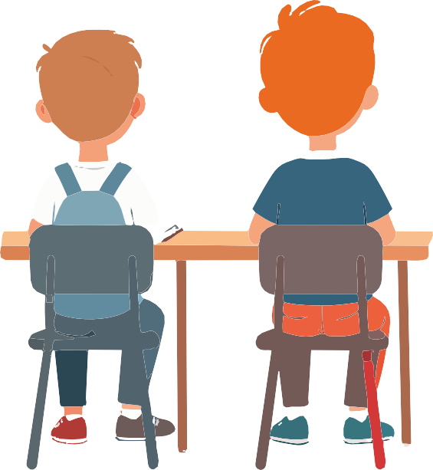
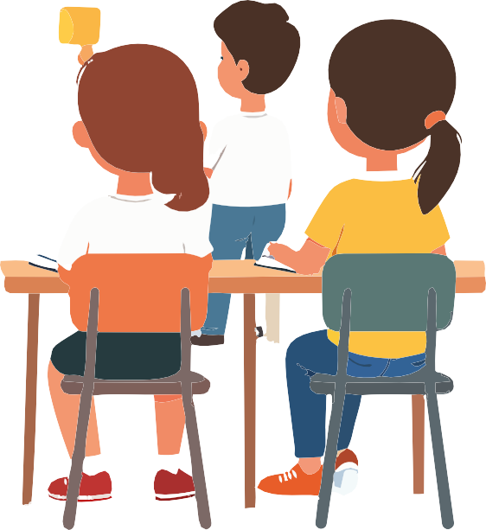

Teacher's Note:
- Avoid phrases that may expose a student or point to a specific classroom event.
- If the group tends toward excessive humor, gently redirect them to phrases that provide emotional information.
- Observe which emotions generate more movement; it will give you clues about the group's general state.
- Remember that this activity serves as a bridge to go deeper into the topic of stress without doing so theoretically yet.

MA4
Activity 4: "Head Picture" – What stresses me out? (15 minutes).
Adjust according to the group's participation

Objective:
Materials
Large cardstock or whiteboard. Markers of various colors.
Drawing of a large-sized head (can be prepared in advance).
      - Identify everyday situations that generate stress in students.
      - Understand that stress does not always come from "big" things; sometimes it arises from daily pressures.
      - Create a visual map that will be the basis for the rest of the module.

Activity Description:
      - Present the "Head Picture":
        - Explain to the group:
          - "We are going to create a mental map together about the things that generate stress for us. We won't talk about personal cases, but about general situations that can happen to many kids your age."
        - Clarify that there are no right or wrong answers.

      - Draw the head in the center:
        - Draw or show a large, simple, empty head.
        - Around it, draw "rays" or lines coming from the center outward.
        - Explain:
          - "Each ray will represent something that can cause stress. We will write them together."

      - Guided question: launch the central question of the exercise:
- "What things usually generate stress in your day-to-day life?"
- Invite them to respond generally, for example:

- Studies
- Exams
- Limited time
- Arguments
- Adult expectations
- Sports or competitions
- Problems with friends
- Unexpected changes
- Loud or crowded environments
- Too many activities
- Lack of rest.

- Write each entry on a separate line.
- If new categories appear, add more lines.

      - Go deeper lightly:
        - Avoid entering into personal experiences, but you can ask:
          - "Does this happen to many of you?"
          - "What does it feel like to experience this pressure?"
        - Help the students see that various experiences are shared, which reduces the feeling of isolation.

      - Connect with the module's objective:
        - When the map is full, explain:
          - "What we are doing is naming the things that press us. When we identify our stressors, it is easier to find strategies to manage them. This list will serve us in the following activi-ties."

Teacher's Note:
- If the group wanders into very specific examples, redirect them to general categories.
- Ensure you maintain a tone that normalizes stress as something human, not a personal failure.
- This exercise is key: it will allow you to see common tendencies in the class and anticipate emotional needs.
- You can save the poster to use on Day 2 during the creation of the "stress poster."

MA5

Activity 5: "Body Picture" — How do I notice stress in my body? (10 minutes). Adjust according to the group's participation

Objective:
Materials
Large body silhouette on a whiteboard or cardstock. Colored markers.
(Optional) Post-its for students to place specific sensations.
      - Help students identify physical signals of stress.
      - Understand that the body sends warnings before an emotion overflows.
      - Connect stress with real and common bodily sensations.

Activity Description:
      - Present the body silhouette: draw or show a simple, large human figure.
        - Explain:
          - "Now we are going to see how stress manifests in our body. Sometimes we feel some-thing even before realizing that we are stressed."
        - Clarify that each body is different, and that's okay.

      - Guided question: Launch the question:
- "When you are stressed, what do you notice in your body?"
- Record the responses directly on the silhouette, using different colors to differentiate sensa-tions.
- Responses may appear such as:

Stomach ache Cold or sweaty hands
Tension in shoulders or jaw Rapid breathing
Racing heart Lump in the throat Urge to cry Shaking
Heat sensation Sudden tiredness Headache.

- Please validate all entries.

      - Normalize the experience:
        - Once the silhouette is completed, explain:
          - "All these signs are warnings from the body. It is its way of telling us that we need to stop, breathe, or ask for help. Stress does not appear all at once: it usually gives signals. When we identify them in time, it is easier to regulate ourselves."

      - Relationship with the "Head Picture":
        - Make a small connection:
          - "In the previous exercise, we saw what stresses us, and now we are seeing how we feel it. These two maps together will help us find good strategies for Day 2."

Teacher's Note:
- Keep the space safe: some students may mention symptoms related to anxiety. Welcome them calmly and redirect toward the general.
- Avoid analyzing individual cases. The exercise is group-based and symbolic.
- This body map can remain visible throughout the module to reinforce learning.

Activity 6: Key Stress Concepts (10 minutes).
A6
Adjust according to the size of the group and the classroom climate.

Objective:
Materials
Cards with concepts:
- "Stressful situations"
- "Stress reactions"
- "Positive stress / useful stress"
- "Stress killers" (what helps). Space on the floor or whiteboard to place them.
Markers (optional).
      - Introduce basic stress concepts in a clear and accessible way.
      - Differentiate what stresses us, how our body reacts, and what strategies help us regulate.
      - Prepare the group for the body and self-control exercises that follow.

Activity Description:
      - Present the cards on the floor or board: place them in this order:
        - Stressful situations
        - Stress responses
        - Stress killers (tools that help)

      - Explain:
        - "We are going to look at three key ideas to understand stress. This will help us recognize what causes it, what happens to us inside, and what we can do."

Question 1: Stressful situations Question 2: Stress reactions

Stressful situations

Stress reactions

- "At what times of the day do you feel under pressure or stressed?"

- Refer back to the "Head Picture" map made earlier.
  - "What happens inside when we are stres-sed? What does our body feel? What thoughts appear? What behaviors change?"

- Connect with the "Body Picture"

- Note responses or simply collect them verbally.
- Clarify:
  - "Stressful situations are not the
- Rapid breathing
- Tension
- Racing heart
- Worry
- Irritability
- Blockage.

same for everyone. What stresses one person might not stress another, and that is normal."
- Explain in an accessible way
  - "These reactions are not bad. The body is trying to help us focus and perform better. Sometimes stress is useful to activate us."

Question 3: "Stress killers" (what helps)

Stress Killers

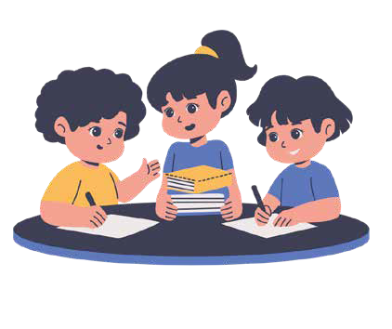
  - "What things help you lower the tension when you are stressed?"

- Collect spontaneous ideas:

- Movement
- Breathing
- Listening to music
- Talking to someone
- Resting, drinking water
- Doing something they like.

- Connect with what will be seen in the rest of the module.
- Clarify:
  - "Stress killers are like service stations: things that refill our emotional tank and help us balance ourselves."

      - Activity Closing:
        - Highlight: "So far we have seen what stresses us, how we feel it, and what can help us. In the next activities, we are going to experiment with all of this through our bodies."

Teacher's Note:

- Keep the conversation simple and structured; this activity is a bridge between the emotional part and physical exercises.
- If confusion arises about "good stress" vs. "bad stress", use relatable examples:
  - "Before an exam or a match, a little stress helps you focus. But if the stress lasts too long, the body gets tired and we need tools to recover."
- Ensure students understand that the goal is not to eliminate stress, but to learn to manage it.

Activity 7: Game "Dr. Beat" — How does my heart change with stress? (5 minutes). Adjust according to the size of the group and the classroom climate.
A7

Objective
Materials
Clear space to do squats or movement.
Stopwatch or clock (optional). Relative silence to be able to listen to the pulse.
      - Understand in a practical way how stress activates the body.
      - Observe changes in heart rate and breathing.
      - Relate physical sensations to emotions and pressure situations.

Activity Description:
      - Brief introduction: explain to the students:
        - "Our body reacts to stress very quickly. We are going to do a small experiment to notice how our heart and breathing change."

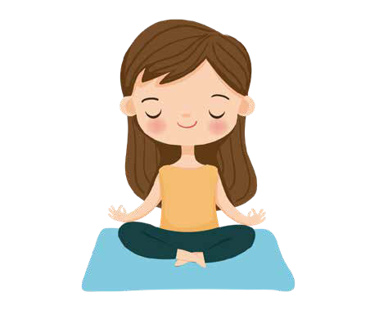
First observation: at rest
        - Ask them to:
          - Sit or stand in silence, place a hand on their chest or neck, and observe if they can feel their heart.

        - Guide with phrases like:
          - "Breathe normally and pay attention. Do you notice your pulse? Is it fast, slow...?"
        - Give them 30-40 seconds.

      - Physical activation
        - Ask the group:
          - "Now we are going to do 10 rapid squats. When we finish, we will listen to our bodies again."
        - Lead the count so they all go at the same pace.

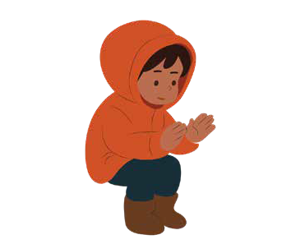
Second observation: after effort
- Indicate:
  - "Now stay still and put your hand back on your chest. What do you notice? Does the heart beat differently? What about your breathing?"
- Give them 20-30 seconds to observe.

      - Brief explanation:
        - Connect the physical experience with stress:
          - "When we are calm, the heart goes slower. When we are stressed, nervous, or exerting ourselves, the heart beats faster and we breathe more quickly. This is not bad: it is the body preparing us to act or focus."

      - Clarify:
        - "Stress makes sense: it helps us perform when we need it. But if it stays for too long, we can get very tired. That’s why we need strategies to relax, just like we 'bring down the revs' after running."

Teacher's Note:
- Ensure that everyone can perform the squats safely; if someone has physical discomfort, they can do a soft alternative (lifting knees, walking fast on the spot).
- Avoid competing ("who does it faster"); this is a body listening exercise, not a performance one.
- If the group is very agitated, allow a few seconds of calm breathing before moving to the next activity.
- Connect this exercise with what will come later (regulation techniques and "emotional tank").

Activity 8: The “Emotional Tank” Model (10- 15 minutes). Adjust accor-ding to group size and classroom climate.
A8

Objective:
Materials
Whiteboard or large cardstock. Chalk or colored markers.
Space so everyone can see the drawing clearly.
      - Understand the “emotional tank” as a metaphor for well-being.
      - Identify what things “fill” the tank and what things “empty” it.
      - Relate this idea to the importance of “stress killers” (regulation tools).

Activity Description:
      - Present the concept: explain
        - “Just as a car needs gasoline to run, we have an emotional tank that fills with good things and empties when we experience difficult or stressful situations.”
- Mention that you will draw it together.

      - Draw a large circle on the board. That circle represents the empty emotional tank.
- Question:
  - “When our tank is full... how do we feel?”
- Collect ideas and add them inside the circle, for example:

Joy Energy Calm Motivation
Confidence Safety

      - Identify what fills the tank:
- Question:
  - “What things help you fill your emotional tank?”
- Write around the tank (outside the circle) the “service stations” of well-being:

Friends
Support

Family

Music.

Nature

Free time
Joy Energy Calm Motivation
Confidence Safety

Playing

Sleeping well

Laughing

Feeling understood

      - Identify what empties or “makes holes” in the tank:
- Now ask:
  - “What things make holes in the tank or empty it?”
- Collect general examples, not personal ones:

Tiredness.

Music.

Too many tasks

Sudden changes
Nature

Friends
Arguments with friends

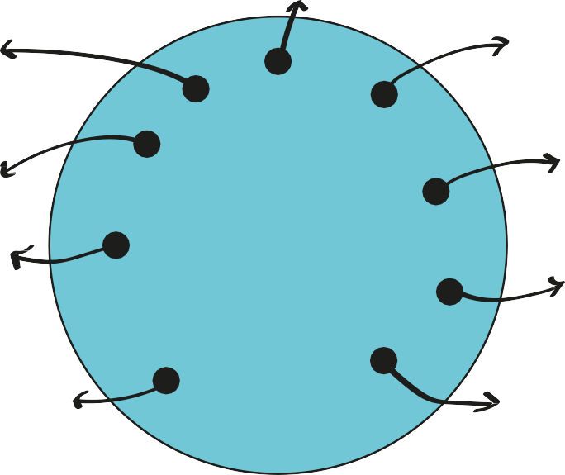
Joy Energy Calm Motivation
Confidence Safety

Support

Academic pressure
Family

Bad grades
Sleeping well

Fights

Laughing

Family worries Feeling alone
Free time Playing

Feeling understood

- Draw them around the tank with another color, as “holes”.
- Explain:
  - “When these things happen, it’s normal to feel stressed, sad, or overwhelmed. The important thing is to know how to fill the tank again.”

      - Brief closing:
- Make an accessible synthesis:
  - “We all have an emotional tank, and we all have days when it fills or empties more. It’s not about avoiding stress completely, but about knowing what strategies help us recharge when we need it.”

Teacher's Note:
- Prevent students from mentioning very personal situations; redirect toward general categories.
- If someone shares something sensitive, validate their emotion and return the focus to the exercise (“this happens to many people...”).
- This model is key for the module: it will serve as the basis for Day 2 regulation work.
- Use different colors to facilitate visual understanding (green = full / red = empty).

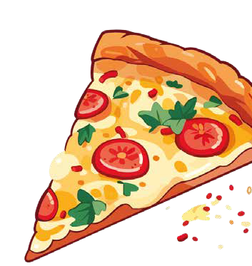
Activity 9: “Pizza Massage” — Body strategy to reduce stress
A9
(15 minutes). Adjust according to group size and classroom climate.

Objective:
Materials
Chairs placed in pairs or trios. Soft music (optional).
Box with small massage objects (optional): soft balls, rollers, feathers, etc.
      - Practice a brief and respectful body relaxation technique.
      - Recognize how tension decreases when receiving a relaxing stimulus.
      - Promote mutual care, boundaries, and respectful communication.

Activity Description:
      - Brief introduction: explain to the group
        - “Stress accumulates a lot in the body. Today we are going to use a very simple technique to release tension in the back and shoulders, always respecting our partner's boundaries.”
- Clarify that the activity is optional: whoever does not want to receive a massage can use a massage object, massage their own arm, or be part of the group without receiving contact.

      - Form pairs or trios: Organize the chairs so that one student can sit behind the other.
- Indicate:
  - Person A receives the massage.
  - Person B performs it.
  - Then they will switch.
- Give an important instruction:
  - “The massage is done on the shoulders and the upper part of the back, without touching the spine. Everything must be done in a gentle, respec-tful way, taking care of your partner.”

      - Begin the “Pizza Massage” guide:
- Guide the actions step by step, in a calm tone:
  - Clean the surface:
    - “Imagine the back is the base of a pizza. First, we ‘clean the table’, making gentle movements with our hands.”

Add flour:
    - “With your fingertips, simulate sprinkling flour so the dough doesn't stick.”
  - Knead the dough:
    - “We make small circular movements with gentle pressure, as if we were kneading.”
  - Stretch the dough:
    - “Slide your hands outward, from the center toward the sides, as if stretching the pizza.”

  - Add ingredients:
    - Tomato: gentle taps with closed fists.
    - Salami: press gently with a flat hand.
    - Peppers: short lines with one finger.
    - Mushrooms: gentle pressure with the thumb.
    - Onion: circles with fingers.
    - Cheese: very light touches with fingertips.

Step 1
Put the pizza in the oven
“We slowly slide our hands from the bottom upward, as if placing the pizza in the oven.”

Step 2
Heat the pizza

“We rub our hands to warm them up and lean them gently on the shoulders or upper part of the back (avoiding the spine).”

Step 3
Take the pizza out of the oven
“We slide our hand gently downward to finish.”

      - Role exchange
- Have students switch. Maintain a calm rhythm.

      - Brief closing:
- Invite them to reflect:
  - What did you notice before and after receiving the massage?
  - Has the tension in your body changed?
  - How does it feel to help someone else relax?”

Teacher's Note:
- Body respect: remind the group they can say “softer”, “less pressure” or “I prefer not to continue”. This is part of emotional learning.
- Avoid an infantile tone; present it as a body regulation exercise.
- If a student feels uncomfortable with contact, offer alternatives:
  - Self-massage,
  - Using massage balls,
  - Or remaining as an observer.
- Maintain a quiet environment, with soft music if it helps.

A10

Activity 10: Guided Journey to your “Inner Place of Power” (10 minutes). Adjust according to group size and classroom climate.

Objective:

Materials
Silent classroom.
Soft music optional (relaxing environment).
* Students can sit at their desks or on the floor, however they are most comfortable.
      - Facilitate an experience of calm and inner connection.
      - Learn a mental strategy to regulate stress in moments of high pressure.
      - Encourage imagination as a self-care tool.

Activity Description:
      - Preparing the environment: explain briefly
        - "We are going to do a visualization exercise to find an inner place where you feel good, safe, and calm. This place will serve as a resource to return to when you are very stressed."
- Invite them to sit comfortably, with a straight but relaxed back. They can close their eyes only if they want to.

      - Brief breathing guide:
        - “"Take a deep breath... Inhale through your nose, and release the air little by little... Notice how your body releases tension..."
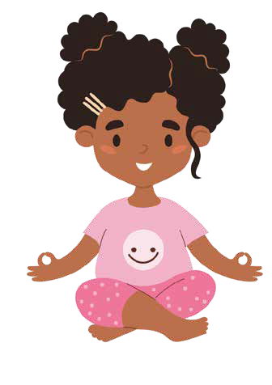
- Lead two or three guided breaths.

      - Start the visualization: Read in a calm and paced voice

We are going to look for a place where you feel completely well. It can be a real place you know, like a forest, a house, a beach, your room... Or it can be an imaginary place, inven-ted by you. Imagine you are traveling toward that place. You can arrive by walking, flying, on a train, in a boat... whatever you want.

When you arrive, look around:
- What do you see?
- What colors are there?
- Is there light, shadow, sun, clouds...?
- Listen:
  - What sounds are in your place?
  - Is there silence?
  - Is there water, wind, music...?
- Notice the temperature:
  - Is it warm, cool, soff...?

Think about what things make you feel good there. It can be a sensation, an object, a landsca-pe, a smell... Everything that helps you feel safe and calm. This place is yours alone. No one can enter without your permission. Here you can rest, think, breathe... or simply be.

25

      - Anchoring the experience: Guide
- "To return to this place when you need it, find a word that represents it: it can be 'calm', 'home', 'forest', your name... whatever you choose. Repeat the word in your mind while you remember the place. This word will be like a key to return when you are stressed."

      - Closing the visualization:
- "Return little by little... Moving your fingers, breathing deeply... and when you are ready, open your eyes."

      - Pause for a few seconds.

Teacher's Note:
- Keep a neutral and calm tone throughout the activity.
- Avoid analysing the visualisations or asking for personal details (especially at this age).
- It is normal for some pupils not to concentrate fully; encourage them to practise at other times.
- This exercise can be used again before exams, assessments, conflicts or particularly stressful days.
- If any pupil prefers not to close their eyes, that is perfectly fine.
- If the group is very restless, feel free to reduce the duration to 5–7 minutes.

Activity 11: Day 1 Closing (5 minutes).
MA11
Adjust according to group size and classroom climate.

Objective:
Materials
Circle of chairs.
“Head Picture” and “Body Picture” posters visible (optional).
      - Integrate what was learned during the session.
      - Provide an emotional closing that reinfor-ces calm and cohesion.
      - Prepare students for the next session of the module (Day 2).

Activity Description:
      - Return to the circle: Invite students to return to the initial circle, maintaining a quiet atmosphere after the visualization.
        - Explain:
          - "We are going to close the first day of the workshop by remembering what we have discovered about stress and our bodies."

      - Launch a simple question for them to answer in one word or short phrase:
- "What has been the most useful or interesting thing today?"
- Or provide alternatives if they need support:
  - "Something I understood better..."
  - "Something I didn't know about stress..."
  - "Something that helped me relax..."
- Avoid letting them go into personal details; keep responses general.

      - Connection with activities: Summarize clearly
- "Today we saw what things can stress us, how the body feels it, and what signals it gives us. We also practiced a technique to relax and discovered our 'place of power'."
- Be sure to name at least these key ideas:

O1 Stress is a normal response of the body.
O2 Body signals.
O3 Stressful situations.
O4 Tank model.
O5 Regulation activities.

      - Day 2 Preview: Introduce what they will do in the next session:
- "In our next meeting, we will see more strategies to handle stress and we will build something special: your emotional treasure chest and a poster with your own tools for difficult moments."
- This generates positive expectation.

      - Emotional Closing
        - Offer a phrase that reinforces safety
          - "Remember: we all feel stress sometimes. The important thing is to learn what we need and how we can help ourselves."

Teacher's Note:
- Keep the closing short and kind.
- Avoid opening long debates; this moment is for emotional integration, not analysis.
- If a student shares something personal, thank them for their trust and return the focus to the group.
- It is a good idea to leave the “Head Picture” or “Body Picture” posters visible to serve as a reminder during the week.

Day 2. What can I do and who helps me?
A1
Activity 1: Welcome and Day 1 reminder (10 minutes). Adjust accor-ding to the group size and classroom climate.

Objective:

Materials
Circle of chairs.
Whiteboard (optional) to note key ideas.
Day 1 poster visible (if you saved it).
      - Recover the learning from Day 1 and reconnect the group with the topic of stress.
      - Identify who was present and who was not, and offer a quick summary.
      - Prepare the emotional climate for the second block of work.

2.1.2. Activity Description:
- Create the opening circle: Instruct students to sit as they did the previous day.
  - Generate a calm atmosphere, especially if they have just come from recess or another demanding subject.

- Activation question: Invite a brief and concrete reflection
- "What do you remember from the previous workshop? What did we learn about stress?"
- Allow short answers.
- If not many emerge, you can guide them:
  - "What things can generate stress for us?"
  - "What signals does the body give?"
  - "What was the emotional tank?"
- Write 2–3 key words on the board.

- Check attendance: Ask
- "Is there anyone who was not at the previous session?"
- If a student was absent, offer a 30-second mini-summary:
  - "We saw what things stress us out, how the body notices it, what stress does to us, and we practiced a relaxation technique. Today we will continue learning tools to manage it better."
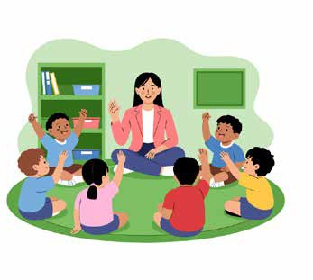
- Avoid repeating the entire session; this review is only contextual.

29

- Connection with the day's objective: Explain briefly
  - "Today we are going to focus on how to manage stress, what tools we can use in our daily lives, and how to ask for help when we need it. We are going to build something personal that will serve you throughout the entire course."
  - (This anticipates the treasure chest, the stress poster, and the new strategies.)

- Light emotional activation
  - Ask a quick question to connect the emotional part:
    - "Who has had a moment of stress this week?" (Raising a hand is enough. No explana-tion is requested.)
  - Normalize:
    - "Stress appears many times in life, not only in exams or big problems. Today we will see how to manage it."

Teacher's Note
- Keep this start brief so as not to lose time from the main block of Day 2.
- Avoid having students share deep personal experiences (we will work on them generally).
- If the environment is very distracted, do 2 deep breaths all together before moving to the next activity.
- Keep the Day 1 posters visible if you kept them; they help reinforce continuity.

Activity 2: “Lifting weights” — The weight of stress (10 minutes).
A2
Adjust according to the group size and classroom climate.

Objective:
Materials
Small bottles full of water (approx. 500 g) or similar weighted objects.
Space so that everyone can stretch their arm without hitting each other.
      - Understand that stress does not only depend on intensity, but on the time during which we sustain it.
      - Introduce the metaphor of "emotional weight" and the need to let go.
      - Prepare students to reflect on stress management strategies.

Activity Description:
      - Give a weight to each student: Hand a bottle or similar object to each student.
        - Explain:
          - "We are going to try something simple to better understand how stress works."

      - Initial question: Before starting, ask
- "Does this object seem light or heavy to you?" Normally they will say "light."
- Explain to them:
  - "The weight seems small... but look what happens when we hold it for a while."

      - Physical exercise: Ask
- Stretch the arm forward, parallel to the floor.
- Hold the bottle with the hand.
- Indicate:
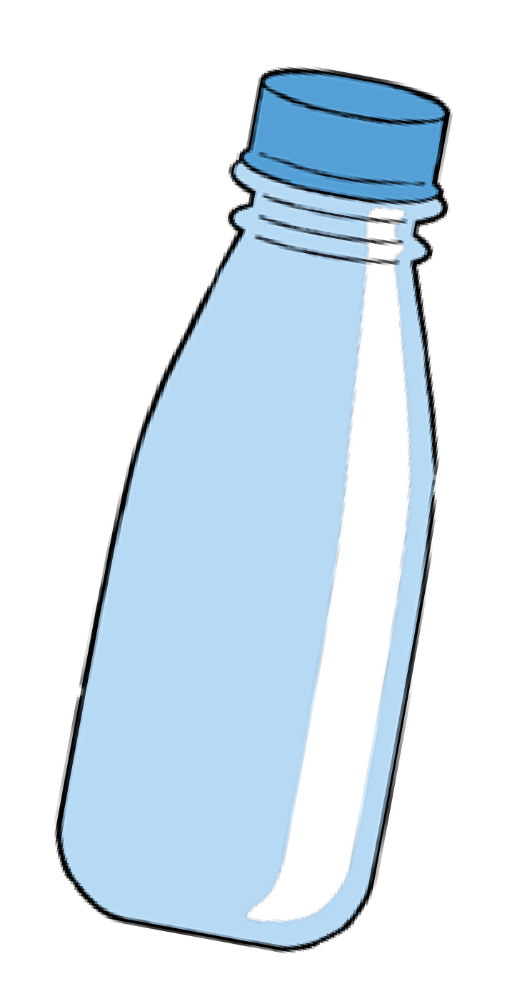
  - "Keep your arm stretched out without bending it. Just breathe normally."
- Wait 20–30 seconds. (At this age, they will feel the effort quickly.)

      - Observation: Ask
        - "How does the arm feel now? More tired than at the beginning? Heavier?"

      - Reflection guide:
- "The object has not changed."
- "It weighs the same as it did a minute ago."
- "So... why is it harder to hold now?"
- This connects directly to the key message.

      - Connection with stress: Explain
- "Stress works just like this weight. Even if a situation is not very big, if we hold it for a long time, it becomes heavier."

- Example:



- Thinking all day about an exam.
- Arguing with a friend and not resolving it.
- Having many tasks without rest.
- Accumulating small worries.
- Keeping emotions in silence.

- Add:
  - "It doesn't matter how strong you are: if you never let go of the weight, the arm gets tired. That's why we need to learn to let go, rest, and ask for help."

      - Let go of the weight
        - Ask them to lower their arm and place the bottle on their lap or on the floor.
        - Conclude:
          - "What happened to your body when you let it go?"
          - "Did you notice the immediate relief?"
        - This helps to anchor the metaphor.

Teacher's Note
- Ensure that no student has pain or physical difficulty; allow alternatives (hold with two hands, hold for less time).
- Avoid having the exercise turn into a competition.
- Keep the focus on the body sensation, not on performance.
- This exercise directly prepares the next activity on how to let go of stress and what strategies help (stress killers, 3-finger method, etc.).

MA3

Activity 3: Strategies for managing stress (10 -15 minutes). Adjust according to the size of the group and the classroom climate

Objective:
Materials
Printed or projected cards of:
- 3-finger method
- Coping Skills (useful strategies)
- Helper Cards (who helps me) Whiteboard or surface to place the cards.
Markers.
      - Present practical tools for managing stress.
      - Teach students to think about solutions
when they feel pressured.
      - Identify people or resources that can help in difficult times.
      - Connect the physical experience of the previous exercise with mental and beha-vioral strategies.

Activity Description:
      - Introduction: “How do I let go of the weight of stress?”
        - Connect with the previous metaphor:
          - “Just as we let go of physical weight, we can learn to let go of emotional stress. Today we will see strategies that will help you in your daily life.”
        - Write on the board:

Let go
Regulate
Ask for help

      - 3-finger method
        - Explain that it is a simple tool for solving stressful situations.
        - Show the cards or draw three raised fingers.

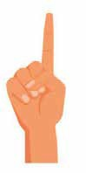
Finger 1 — STOP: What is the problem?

- “First I stop and ask myself: What is happening? What am I worried about?”

Appropriate examples:
“I have an exam tomorrow.”
“I had an argument with a friend.” “I have too many tasks.”

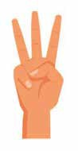
Finger 3 — TEST: Did it work?
Finger 2 — SOLUTIONS: What can I do?

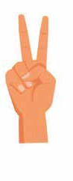
- “I think of several options. Even if they seem small, they all count.”

Examples
Ask the teacher questions Ask a classmate for help Make a plan
Break the task into parts Rest for a moment
Ask for support at home.

  - “I choose one option, try it, and ask myself if it helped me.”

If it doesn’t work:
  - “I look for another option. It’s okay to need more than one attempt.”
This flexibility is key to preventing frustration.

      - Coping Skills: What things help me when I am stressed?
        - Place or project the strategy cards and explain them briefly:

01 02 03

Breathe and regulate your body

- Triangular breathing
- Breathe deeply 3 times
- Walk for a minute
- Drink water.
Healthy distraction / recreation

- Listen to music
- Draw
- Change activities for a moment
- Stretch.
Realistic positive thinking

- “I’ve handled worse things”
- “I can ask for help”
- “This is temporary.”

04 Planning
- Break down tasks
- Make a list
- Organize times.
05 Talk to someone
- Express concern
- Ask for advice
- Ask for company.

- Clarify that each person has different strategies
  - “What helps one person might not help another. The important thing is to know your own tools.”

      - Helper Cards: Who helps me when I feel bad?
        - Present this part as something natural and necessary:
          - “Asking for help is not a sign of weakness, but of emotional intelligence.”
        - Hand out blank cards or show projected ones. Students can think of:

Trusted friends
A family member Teachers
Tutor or co-tutor Counselor Coaches Classmates.

Examples:
        - “My brother — he listens to me.”
        - “My teacher — I can ask them questions.”
        - “My best friend — they calm me down.”


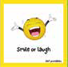

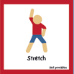

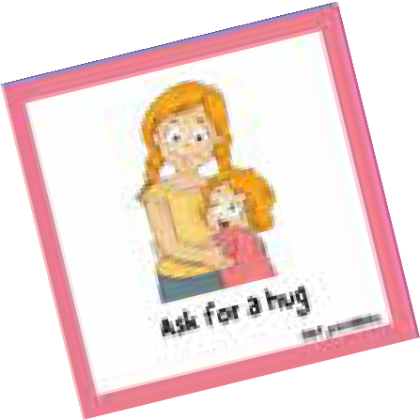

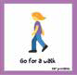
“How can you help me?”
To smile or to
laugh
Go for a walk
Stretch

      - Brief closing
Ask for a hug.
        - Connect everything seen:
          - “Just as stress appears in many forms, there are also many ways to regulate it. The important thing is to get to know yourself and find out what works for you.”

Teacher's Note:
- If the group has difficulty verbalizing strategies, lean on general examples, never personal ones.
- Avoid having the Helper Cards turn into social comparisons (“everyone puts X down”).
- Reinforce the idea that asking for help is a skill, not a sign of weakness.
- These tools will be used later in the Stress Poster and the Treasure Chest.

Activity 4: Game “1-7” (10 -15 minutes).
A4
Adjust according to the size of the group and the classroom climate.

Objective:
Materials
Ample space to form a large circle. No additional material required.
      - Experiment with how we react under pressure and in fast-paced situations.
      - Observe what happens when we must make decisions without thinking too much.
      - Connect sudden stress with the importan-ce of having prior strategies.

Activity Description:
      - Preparation of the circle: Ask students to form a standing circle.
        - Explain:
          - “This game is about following signals quickly. The key is to pay attention and see what happens when a slightly stressful situation arises.”

      - Explain the rules: start the game by showing a signal.

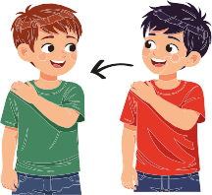
Signal passes to the right

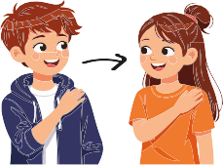
Right hand on left shoulder.
Left hand on right shoulder.

Signal passes to the left

        - Each participant makes the signal to the next classmate, maintaining the rhythm.
        - They will count from 1 to 7: The person with the number 7 raises their hand over their head instead of putting it on the shoulder.

        - This can
          - keep the direction or change it, depending on where their hand points.

      - Short and slow rehearsal:
- “We’re going to do it slowly to understand it, and then we’ll go faster.”
- First signal – signal – signal – signal...
- Then add the count:
  - 1, 2, 3, 4, 5, 6... 7 (hand up), 1, 2, 3...
- Progressively increase the speed.

      - Full game: Now play with
- faster rhythm.
- occasional change of direction.
- full attention.
- If someone makes a mistake:
  - “Whoever makes a mistake sits down for a moment and observes. It’s not a punish-ment; it’s part of the game.”
- Maintain a light and humorous tone, without competitiveness.

      - Final reflection: When finished, gather the group and ask
- “Did anyone feel stressed during the game?”
- “What happened when we tried to follow the fast pace?”
- “What happens when we are under pressure and don’t have a plan?”
- Explain briefly:
  - “Sudden stress makes it hard to think clearly. That’s why it’s important to know strategies and resources before the strong stress appears. That way we know what to do even when there is a rush or a lot of pressure.”
- Connect directly with the previous activity (3 fingers, coping skills, helper cards).

Teacher's Note:

- Control the speed according to the energy of the group.
- If nervous laughter appears, normalize it: it’s part of mild stress and the game.
- Keep the game safe, without hitting or racing.
- This exercise is an excellent bridge to the creative activities of the Treasure Chest and the Stress Poster, where students will create their regulation plan.

MA5

Activity 5: Construction of the “Emotional Treasure Chest” (30 minutes). Adjust according to group size and classroom climate.

Objective:
Materials
Treasure chest template for each student.
Scissors. Glue stick.
Markers or colored pencils.
Small pieces of paper or post-its to write the "treasures."
Optional: stickers or simple decoration.
      - Identify personal resources that help regulate stress.
      - Create a physical object that functions as a visual reminder of self-care.
      - Connect learned strategies with the
students' real lives.
      - Promote emotional autonomy and personal reflection.

Activity Description:
      - Introduction to the exercise: Explain
        - “We all have resources that help us when we are sad, stressed, or overwhelmed. Some are people, others are activities, memories, or places. Today we are going to build a 'treasure chest' where we will keep those personal resources.”
- Clarify that they will not be shared publicly unless they want to. It is a personal space.

      - Hand out the chest template: distribute the sheet with the chest outline.
- Indicate:
  - Cut along the outer lines
  - Fold along the dotted lines
  - Glue the tabs to form the box.
- Support students who need help with folding.

      - Chest decoration: Allow each student to personalize their chest with
        - Preferred colors
        - Symbols that represent them
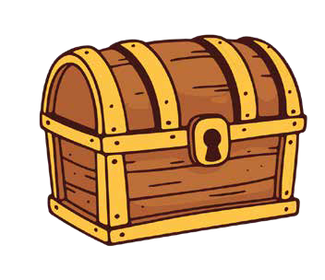
        - Words/drawings that convey calm.
- He recommends keeping it simple so that this part doesn’t take up too much time.

      - Guided reflection: What goes in my chest?
- Hand out small papers or post-its.
- Explain:
  - “We are going to write on these papers the things that help you when you are stressed. They can be people, activities, objects, or thoughts that give you strength.”
- Give general examples (never personal):

People who help:

- My mother because she listens to me
- My best friend because they calm me down
- My coach because they encourage me.
Regulating activities:

- Sports
- Listening to music
- Drawing
- Walking
- Breathing
- Playing with my pet.
Places or memories:

  - The beach
  - My room
  - A trip
  - A forest
  - My 'place of power' from the previous exercise.

Key phrases:

  - “I can handle this”
  - “This is temporary”
  - “Breathe, think, act.”

      - Storing treasures in the chest:
- Cuando tengan 4–6 papeles escritos (o más, según el tiempo), diles:
  - When they have 4–6 papers written, tell them: “Fold your treasures and put them inside the chest. This chest is a personal tool, like a small reminder of what helps you when you don't feel well.”
- You can close it or leave it open, whichever you prefer.

      - Brief closing:
        - “If at any point during the school year you feel stressed, you can return to your chest to remember what helps you. Sometimes, when we are overwhelmed, we forget what works. This chest is there to remind us.”
- Please note that they will be able to use it in the next activity on the stress poster.

Teacher's Note:
- Respect each pupil’s pace; some will want to write a lot, whilst others will write very little.
- Avoid looking at the ‘treasures’ unless they want to share them. It is a personal exercise.
- If anyone is unsure what to write, help them with general questions:
  - “What helps you feel calm?”
  - “What gives you energy?”
  - “Who supports you?”
- Make sure no pupil makes fun of another’s design or content, fostering an atmosphere of respect.
- You can keep the boxes in class or let them take them home.

Activity 6: My Stress Poster (15 minutes).
A6
You can expand it if you want to dedicate more time to creativity.

Objective:
Materials
“My Stress Poster” template for each student (A4 or A3 size).
Markers or colored pencils. Scissors and glue (optional). Treasure Chests from the previous activity, visible for inspiration.
      - Integrate all module learnings in a visual and structured way.
      - Help students identify their personal signals and regulation strategies.
      - Create a tool they can consult during the school year.
      - Promote emotional autonomy.

Activity Description:
      - Presentation:
        - Explain
          - “Today you are going to create your 'My Stress Poster'. This poster will help you remem-ber, in a simple way, what stresses you, how your body notices it, what you can do to regulate, and who you can ask for help.”

      - Poster structure
        - Explain that the poster is divided into 4 sections. Clarify that they do not need to use full names; initials or roles are enough.

What causes me stress..

(Inspired by Day 1 Head Picture)

Examples
- Exams
- Conflicts with friends
- Too many tasks
- Pressure to be perfect
- Unexpected changes.
How do I feel it?

(Inspired by the Body Picture)

Examples
- Racing heart
- Tension in shoulders
- Stomach ache
- Wanting to cry
- Fast breathing.
Who helps me...
(Inspired by the Helper Cards)
Examples:
- Family
- Teacher or tutor
- Trusted friend
- Counselor
- Coach.
40
What helps me...
(Based on Coping Skills and their Treasure Chest)
Examples
- Deep breathing
- Walking
- Asking for help
- Listening to music
- Making a list
- Going to a quiet place.

      - Time to complete the poster:
        - Give them between 10 and 15 minutes.
        - Indicate:
          - “It is not an artistic work, but a personal one. It doesn't matter if it's perfect; what matters is that it is useful for you.”
        - They can colour it in, add drawings, symbols or short phrases.

      - Optional: share voluntarily
        - Never ask them to share sensitive personal situations.
        - Let whoever wants to share a part of the poster (never force);
          - a strategy that works for them
          - a body language cue
          - something that inspires them

      - Store the poster in an accessible place:
- “This poster is a tool for your day-to-day life. You can take it home or leave it in class. The important thing is that you know where it is when you need it.”

Teacher's Note:
- It reinforces the idea that there is no such thing as ‘minor’ or ‘major’ stress; if your body feels it, it’s real.
- It ensures an atmosphere of respect so that no one makes fun of another’s poster.
- You can use these posters to review them later during tutorial sessions or to assess the module’s impact.
- It is an excellent tool for observing common patterns within the group without singling anyone out.

MA7

Activity 7: “My Planet” — Anti-stress and creative visualization exercise (15 minutes).

Objective:
Materials
Quiet classroom.
Soft music (optional).
Space for students to sit comfortably. Stickers or small adhesive dots (optional, for the planet reminder).
      - Develop a powerful mental tool to manage stress.
      - Help students imagine a safe inner space
where they can “reset.”
      - Foster the ability to make decisions about what they allow and what they do not in their emotional world.
      - Close the module with an empowering and meaningful visualization.

Activity Description:
      - Introduction. Explain simply:
        - “Just like we did with the ‘Place of Power,’ today we are going to imagine that we have our own planet. It is a planet where you decide everything: who enters, who stays, who leaves, and what the rules are.”
- Clarify that they will not share personal details afterward (only if they want to).

      - Preparation
- Invite students to get comfortable: sitting in chairs, on the floor, or with their heads resting on the desk if they prefer.
- They may close their eyes if it makes them feel comfortable.

      - Start of the visualization: Read slowly

Imagine you have your own planet... You can give it any name you want. This planet is made just for you, and you decide what it’s like.
Look around: What is its surface like? Does it have mountains, water, forests, cities, clouds, or lights? What colors do you see?
Now listen: What sounds are there on your planet? Is there silence? Is there wind, music, soff voices...?

4. Important decisions

Things you like will appear on your planet... and things that stress you out can also appear: sensations, thoughts, situations, or heavy emotions
Remember: “you decide what you allow and what you don’t.” If something you don’t like appears, you can say to it:
“Thank you for coming to warn me, but I don’t need you here. You can leave.” And you gently push it off the planet.
“Everything that does you good stays. Everything that harms you... you set aside. No need to get angry. You simply decide.”

5. Reminder or “anchor” of the planet

“To remember this planet when you are stressed, think of a small symbol or word that represents it. It could be a star, a color, a short phrase, or the name of the planet.”
- Tell them to repeat it mentally.

- Gentle return
  - “Take a deep breath... Feel your body sitting here... And when you’re ready, open your eyes slowly.”
      - (Optional) Reminder sticker
- If you wish to do so: Hand out a small sticker/colored dot.
- Tell them to place it somewhere they see often: pencil case, planner, folder...
- Explain:
  - “This dot will be a reminder of your planet. When you see it, remember that you decide what you allow in your emotional world.”

Teacher's Note
- Keep the reading slow and steady. You can shorten the script if the group is restless.
- Avoid analyzing individual planets: the exercise is introspective and personal.
- Observe the final atmosphere: it usually generates deep calm.
- This exercise closes the module with a message of emotional autonomy.

MA8

Objective:
Activity 8: Closing of Module 2 (5 minutes).

      - Integrate and consolidate what has been learned in the two sessions.
Materials
Circle of chairs.
Treasure chests and posters visible if you wish to reinforce the learning.
Quiet environment.
      - Reinforce the autonomy and coping strategies of the students.
      - Close the module with a positive and empowering message.

Activity Description:
      - Back to the circle: Instruct students to return to the initial circle.
        - Explain simply
          - “We are going to close this module by remembering what we have learned about stress and how we can take care of ourselves.”

      - Reflection in one word: Ask for a word or short phrase to close.
- “Say a word that describes how you feel now: relaxed, tired, calm, curious, good... or a word from the module that seemed important to you.”
- Avoid digging into personal cases; keep the closing light and respectful.

      - Module synthesis: Give a clear summary
        - Reinforce:
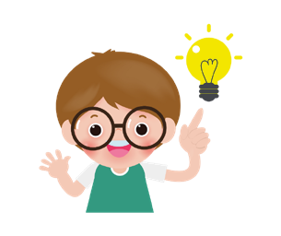
          - “Remember that you have your chest and your poster to use whenever you need them.”
In these two days we have learned:

            - That stress is a normal reaction of the body,
            - That there are signs that warn us,
            - That all people feel stress,
            - That we have strategies to manage it,
            - That we can ask for help when we need it,
            - And that each person has resources that help them feel better.

      - Final question: Ask a simple question to close with intention.
- “What is the first thing you can do when you feel stressed?”
- Allow varied answers:
  - “Breathe,” “Ask for help,” “Go to my safe place,” “Remember my planet,” “Look at my poster,” etc.

      - Emotional message to finish: Conclude with a positive message.
        - “Stress is part of life, but learning to manage it is also part of becoming stronger. You have many tools inside you. Use them when you need them.”

Teacher's Note
- Keep the tone warm and motivating; avoid opening topics that require a long intervention.
- If someone shares a personal concern, thank them for their trust and coordinate follow-up outside of the module closing.
- You can recommend those who need it to keep their chest in an accessible place or to place their poster in their personal folder.
- This activity should leave an atmosphere of calm and cohesion.

Complementary Activities
AC1
Activity 1: “The Stress Traffic Light” — Quick self-regula-tion tool (5 minutes).

Objective:
Materials
Three cardstock sheets: red, yellow, and green.
Markers.
Traffic light template for each student (optional).
Whiteboard.
      - Help students identify their stress level in real time.
      - Learn to adjust their behavior based on emotional intensity.
      - Provide visual cues that can be used throughout the school year.

Activity Description:
      - Present the traffic light: Draw a traffic light on the board with three levels
        - Green: I am fine, focused, and calm.
        - Yellow: I am starting to feel tense, nervous, or worried.
        - Red: I am very stressed, blocked, or about to explode.
          - Explain:
▫ “Stress does not appear all of a sudden. It has levels, just like a traffic light.”


      - Classification: Guiding the group, ask for examples of each level.
- Strategies for each color
  - Ask them:
    - “What can I do when I am in each color?”
- Write the examples on the board.
I am very stressed, blocked, or about to explode.
Signals:
I cannot think clearly / I feel like I'm exploding / I cry / I freeze up completely.
Strategies:
Lower the intensity / Leave the room for a moment (if possible) / Contro-lled breathing / Talk to an adult / Use a "stress killer" from the poster or chest.
I am starting to feel tense, nervous, or worried.
Signals: Strategies:
I find it hard to focus / I feel Prevent it from turning red / Take a
nervous / I'm starting to break / Drink water / Ask for help /
freeze up / I notice tension. Use a coping skill / Change activity
momentarily.
I am fine, focused, and calm.

Signals:
I am focused / I know what I have to do / I am calm.
Strategies:
Maintain well-being / Deep breathing / Stay focused / Ask for help if I need it.
        - Guide them toward strategies.

- Personal mini traffic light (optional)
  - Hand out a traffic light template.
  - Each student: writes their personal signals for each color and what strategy they will use in each case.
  - They can keep it in their notebook or folder.

Teacher's Note
- You can use this traffic light during the year as part of tutoring routines.
- If a student indicates they are in yellow or red, respect their message.
- It is a useful tool to prevent emotional explosions.

AC2

Activity 2: “Emotional First Aid Kit” — Tools for difficult moments (15-20 minutes).

Objective:
Materials
Small box (can be a small bag, a recycled box, or a thick envelope). Small cards or strips of paper.
Markers.
Optional: Stickers, colors, or decorative elements.
      - Create a “mini emotional emergency box” with quick strategies for stressful moments.
      - Turn abstract tools into a physical, easily accessible object.
      - Encourage autonomous self-regulation
and self-care.

Activity Description:
      - Brief presentation
        - Explain:
          - “Just as there are first aid kits to heal body wounds, we are going to create a kit for moments of stress. It will be a small box with reminders and tools that will help you when you are overwhelmed.”

      - Box decoration: Allow them to decorate their box with words or symbols of calm:

        - Star
        - Wave
        - Mountain
- Cloud
- The word “breathe”
- A color that relaxes them.

      - Write the “emotional first aid”: Hand out small cards.
        - Ask them to write short, practical, and quick things, as if they were personal instructions.
        - They can add drawings or symbols instead of phrases if they prefer.






- “Review your stress poster.”
4. Fill the box: Tell them
Take a 1-minute walk.
“Drink water.”
Take 3 deep breaths.
Count to 10.
- “Use your finger strategy #2.”
- “Find someone to support you.”
- “Close your eyes and think of your Place of Power.”
- “You are capable.”
- “This too shall pass.”

- “Keep all your strategies inside the box. This box is personal, but you can carry it in your backpack or leave it in the classroom.”

- Closing: Ask them
- “In what moment do you think this box can help you most?”
- Reinforce:
  - “Remember that you are not alone: asking for help is part of self-care.”

Teacher's Note
- You can leave all the boxes in an accessible space in the classroom.
- It is a useful activity for tutoring, moments of conflict, or before exams.
- It is complementary to the “Treasure Chest,” but this one is faster and focused on immediate reactions.

Checklist of materials for all activities

Day 1. What stresses me out and how do I notice it?

  - Introduction and presentation
Chairs in a circle
Clear space

  - Emotional Monsters
Sheets or cards (optional, for drawing)
Markers or pencils (optional)
Whiteboard (optional, to collect ideas)
  - “Pizza Massage”
Chairs in pairs or trios
Soft music (optional)
Massage object box (optional):
- soft balls
- rollers
- feathers

  - Game “All those who...”
Circle of chairs (one less than the number of students)
Open space to move around

  - “Head Picture”: What stresses me?
Poster or large cardstock
Drawing of a head (can be prepared in advance)
Colored markers
  - Journey to the “Inner Place of Power”
Soft music (optional)
Dim light (optional)
Quiet environment

  - Day 1 Closing
Circle of chairs
Day 1 Posters (“Head Picture” and “Body Picture”) visible (optional)

  - “Body Picture”: How do I notice it in my body?
Poster or cardstock with a large silhouette
Colored markers
Post-its (optional)

  - Key concepts of stress
Cards with the concepts:
    - “Stressing situations”
    - “Stress reactions”
    - “Stress killers”
Whiteboard or floor to place them

  - Game “Dr. Beat”
Clear space to do squats
Stopwatch (optional)

  - “Emotional Tank” Model
Whiteboard or large cardstock
Chalk or colored markers

Day 2. Learning to regulate and take care of myself

  - Welcome and reminder
Circle of chairs
Whiteboard (optional)
Day 1 Poster visible

  - Game “Weightlifting”
Small bottles filled with water (one per student) or similar objects
Space to stretch arms without risk

  - Strategies for managing stress
Cards or slides for:
    - The 3-Finger Method
    - Coping Skills
    - Helper Cards
Whiteboard
Markers

Complementary Activities

  - Stress Traffic Light
Three cardstocks: red, yellow, and green
Markers
Traffic light template for each student
Whiteboard
  - Emotional First Aid Kit
Small boxes / envelopes Small cards
Markers
Stickers (optional)

  - Game “1-7”
Large open space to form a big circle
No additional material

  - Emotional Treasure Chest
Chest template (one per pupil)
Scissors
Glue stick
Crayons / felt-tip pens
Small pieces of paper or Post-it notes
Stickers (optional)

  - My Stress Poster
Stress Poster” template (A4 or A3)
Colored markers or pencils
Scissors and glue (optional)
Treasure Chest from the previous day

  - “My planet” — visualization
Soft music (optional)
Round sticker or adhesive dot (optional)
Quiet environment

  - Module closing
Circle of chairs
Posters and chests visible (optional)

Printable Day 1 Activity 4: Head Picture

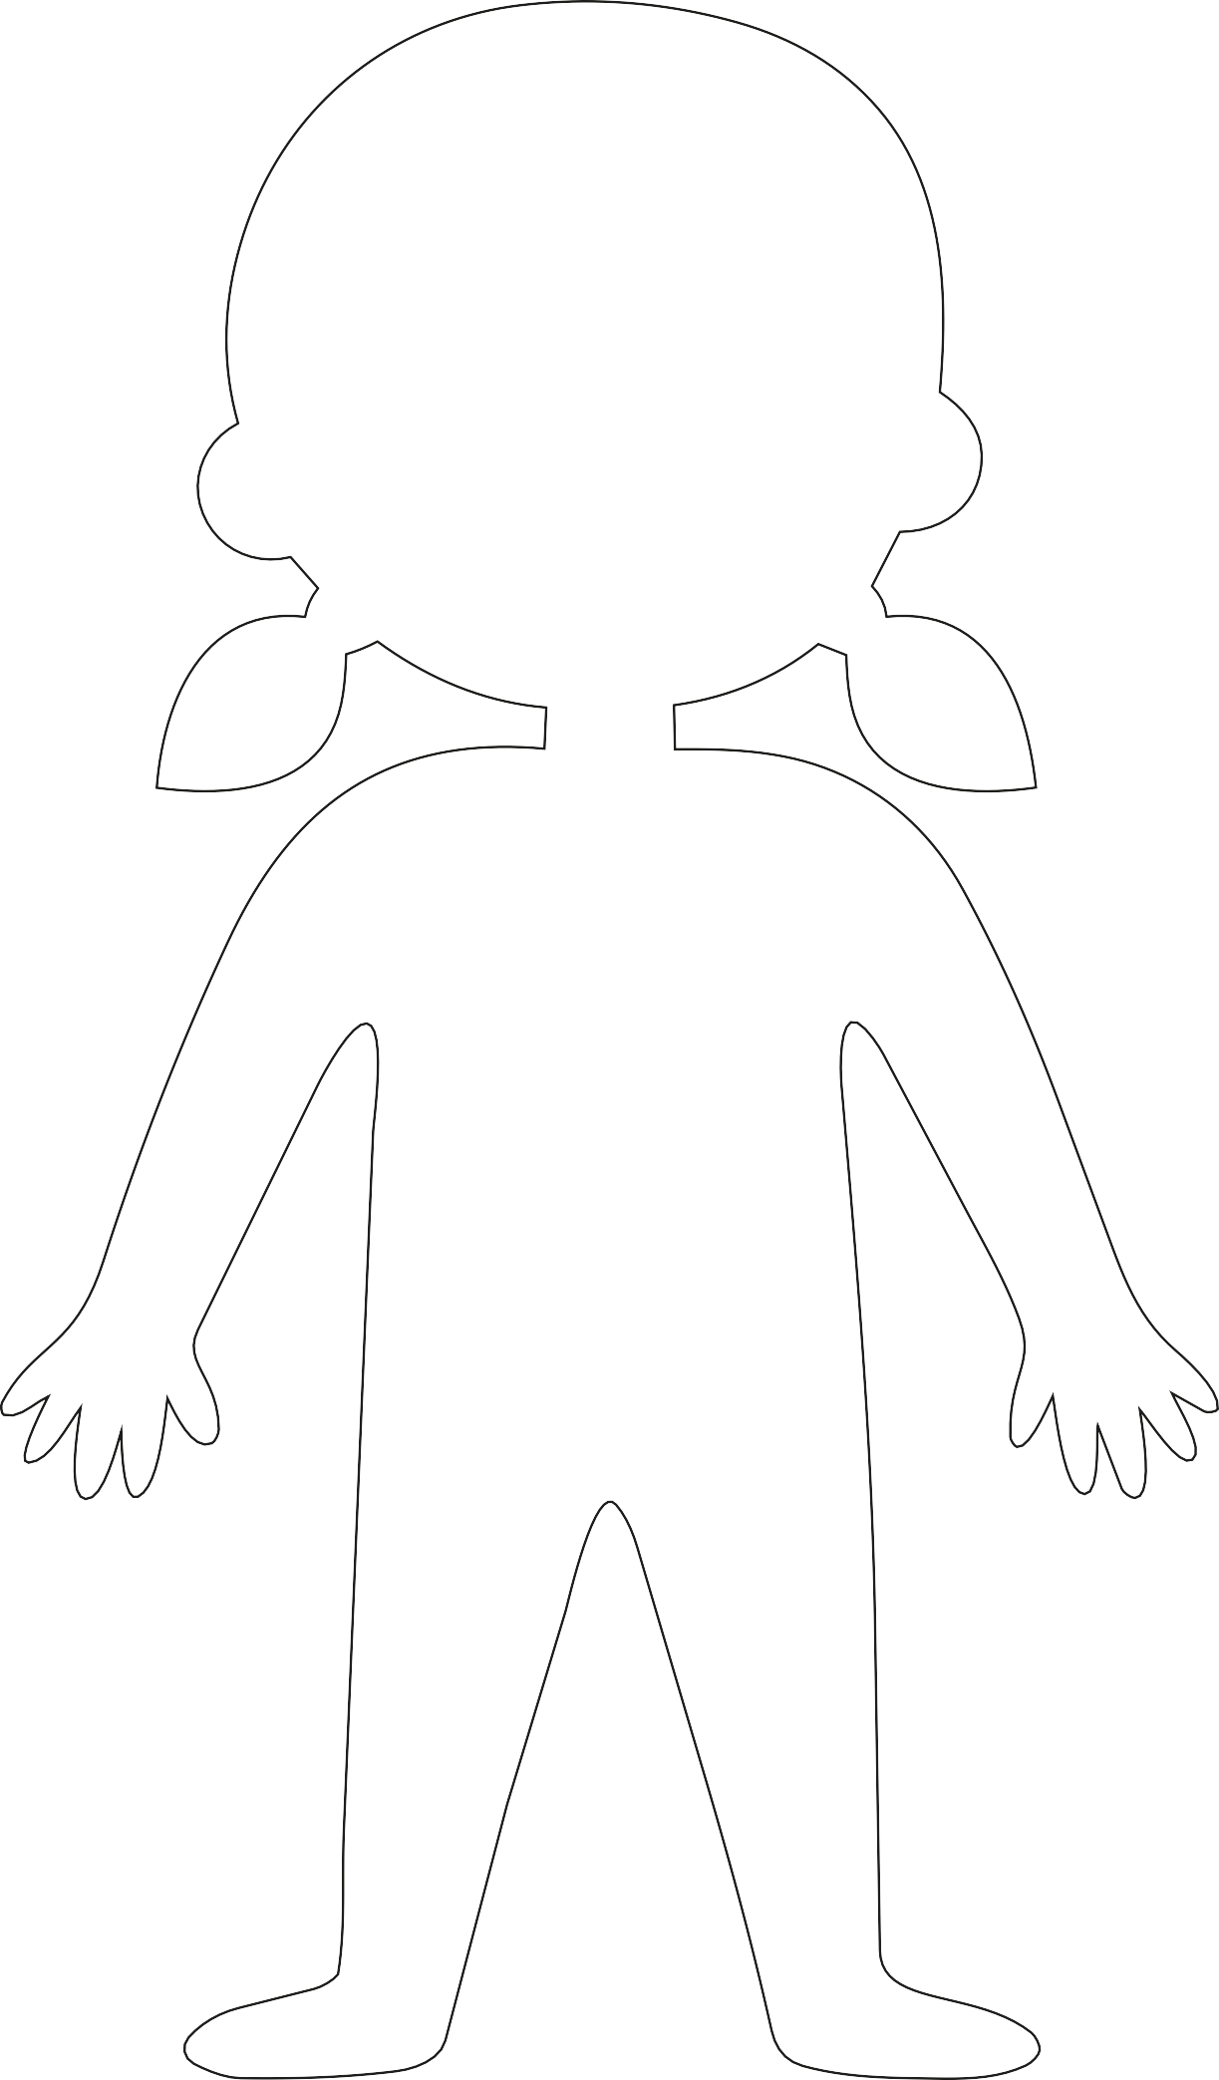
Printable Day 1 Activity 5: Body Picture

54

Handout Day 1 Activity 6: Key concepts of stress

Stressing situations

Stress reactions

Stress Killers

Positive stress / Useful stress

Chew gum
Ask for help Count to 10

Hug a stuffed animal
Play with a fidget
toy
Go for a walk

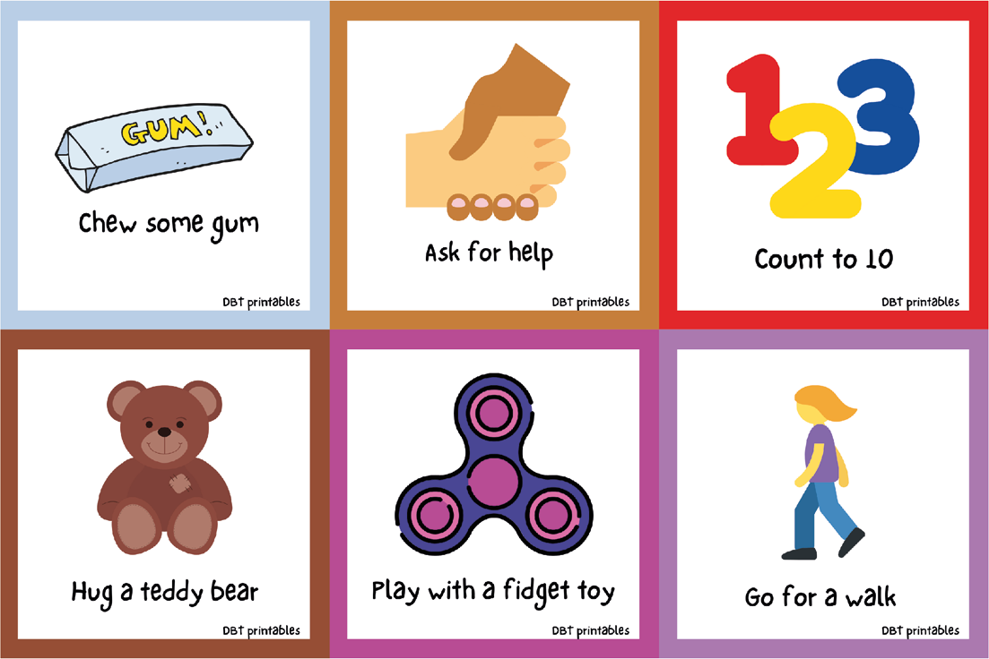
Printable Day 2 Activity 3: Strategies for managing stress
56

Do jumping jacks
Listen to music
Color

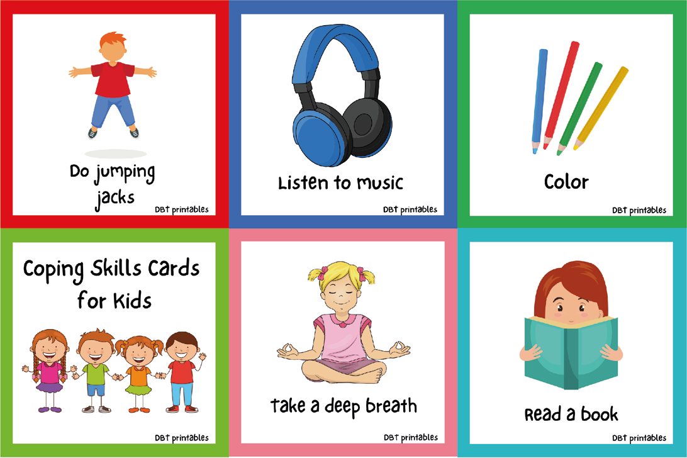
57

Coping skills card for kids

Read a book
Take a deep breath

Meditate Smile or laugh
Make a drawing of how I feel

Take a break
Stretch
Drink some water

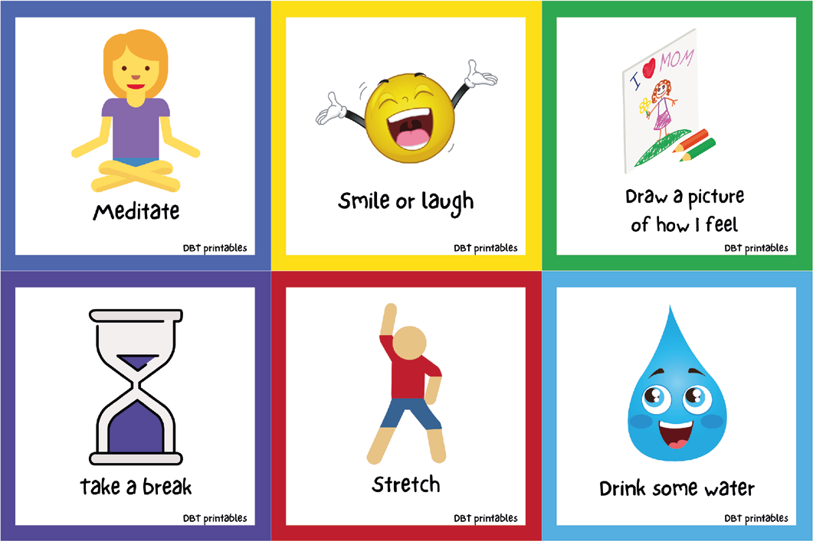
58

Think about something else
Squeeze or play with playdough
Squeeze all my muscles, then let go

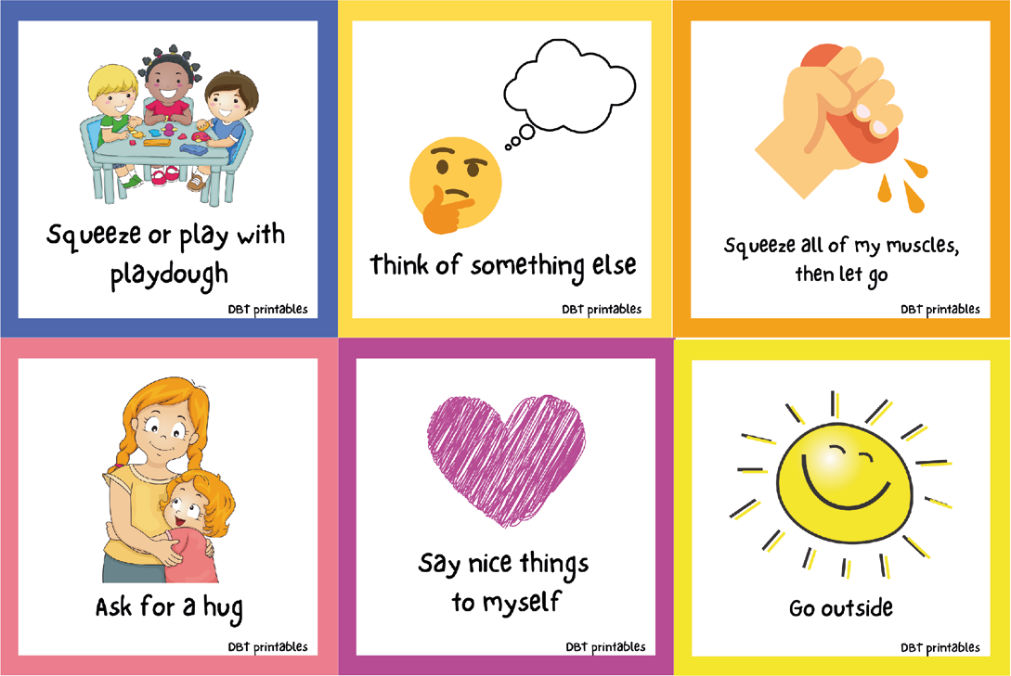
59

Ask for a hug Go outside
Say nice things to myself

Blow soap bubbles
Say nice things to myself
Pet an animal

Give myself a butterfly hug
Draw a sun
Use my words

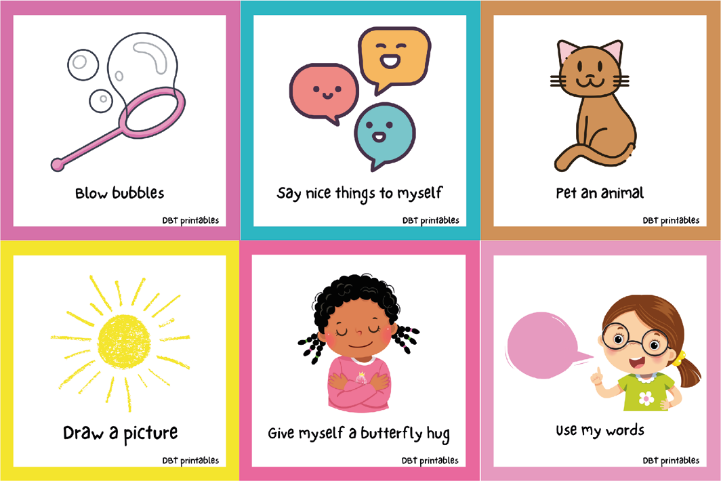
60

Do yoga Exercise Hold ice

Hold for 4

Say “I can do
this”
Talk to a friend
Hold for 4
Square breathing
Exhale for 4
Breathe for 4 counts

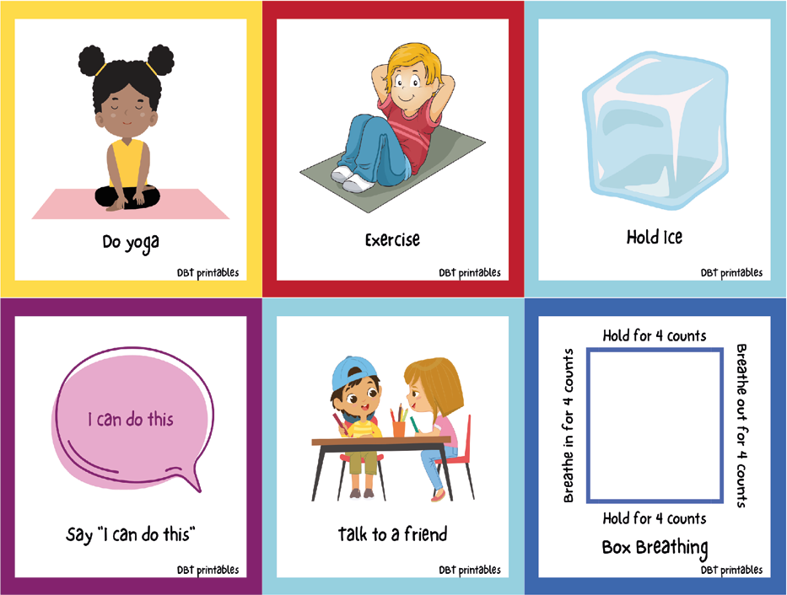
61

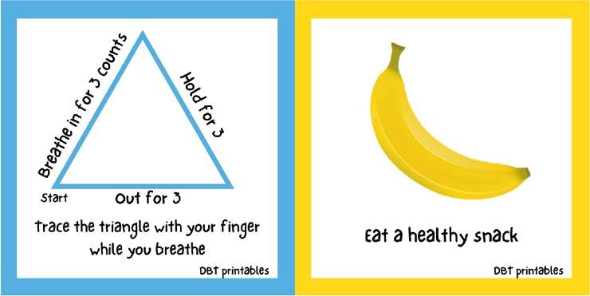
Let's begin
Hold for 3
Inhale counting to 3

Exhale for 3

Trace a triangle with your finger while you breathe
Eat a healthy snack

Printable Day 2 Activity 5: “Emotional Treasure Chest”

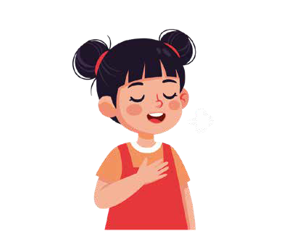
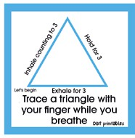
Printable Day 2 Activity 6: “My Stress Poster”
And breathe...
64
What helps me...
Who can help me...

Name:
What causes me stress...
How do I feel about it?


Printable supplementary activity 1: ‘The stress traffic light’

I am very stressed, blocked, or about to explode.

I am starting to feel tense, nervous, or worried.

I am fine, focused, and calm.

Printable supplementary activity 2: “Emotional first aid kit”
66







Erasmus+

Enriching lives, opening minds.


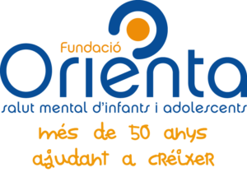

Carl von Ossietzky

Universitat Oldenburg



e.V.

