Mental Illness
Teacher's Guide

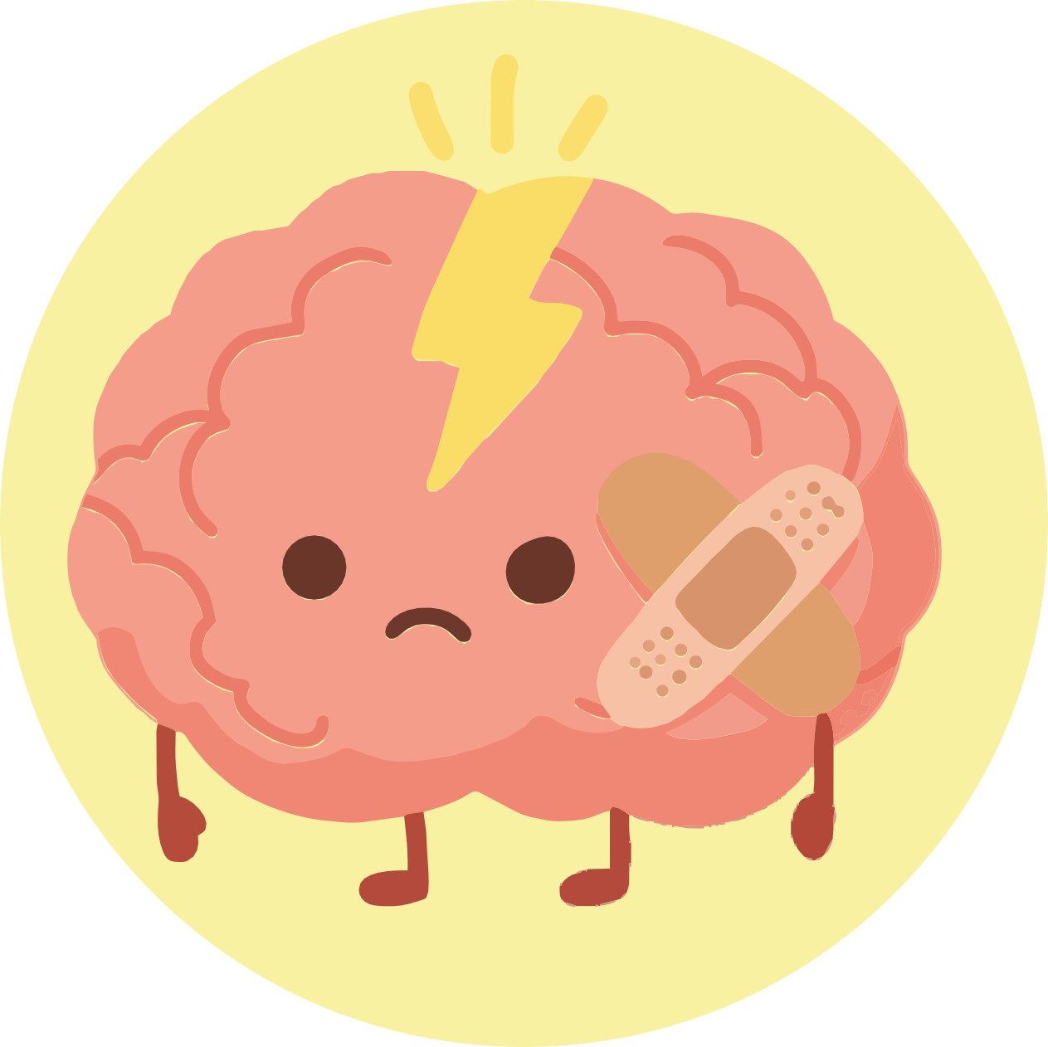

Activities for secondary education

INDEX
- Introduction 3
- Objectives: Module focus and pedagogical principles 3
- Recommendations for teachers: What this workshop is and what it is not 4
- Day 1 — Introduction to mental health
  - Activity 1 — What is mental health? – Introduction 5
  - Activity 2 — What influences my mental health? – Identifying factors 7
  - Activity 3 — Closure – Integrating what has been learnt about mental health 9
- Day 2 — Self-care and stress management
  - Activity 1 — My "Wellness Tree" – Self-care and wellbeing strategies 11
  - Activity 2 — Guided reflection – What actually helps me to feel good? 13
- Day 3 — My support network
  - Activity 1 — Who can help me? – Discovering my support network 15
  - Activity 2 — How do we support someone who needs help? 18
  - Activity 3 — Practising how to help someone in need 20
- Complementary activities
  - Complementary Activity 1 — My emotional first-aid kit 22
  - Complementary Activity 2 — Emotional traffic light 23
- Printable materials and resources
  - Checklist of materials per session 25
    - Day 2: Activity 2.1 — Wellbeing Tree 26
  - Day 3:
    - Activity 3.1 — Concentric circle 27
    - Activity 3.2 — How do we support someone who needs help? 29
    - Activity 3.3 — Practising how to help someone in need 30
  - Complementary activities:
    - Activity 1 — My emotional first-aid kit 31
    - Activity 2 — Emotional traffic light 32

INTRODUCTION

Mental health is a fundamental part of the overall wellbeing of adolescents. It affects how they think, feel, relate to others, and react to everyday situations. During the secondary school years, young people go through a stage of profound changes: academic pressure, identity building, more complex social relationships, and a natural increase in stress. All of this makes understanding mental health especially important.

This module offers students a safe space to reflect on their own wellbeing, identify signs of emotional distress, and learn about support resources. Through participatory activities, pupils will explore what influences their mental health, how to manage stress, and how to create or strengthen a reliable support network. The intention is not to diagnose or delve into sensitive personal experiences, but to provide basic tools for self-care, emotional recognition, and
help-seeking.

The role of teachers will be to support students, facilitate dialogue and set an example of an open, respectful and non-judgemental attitude. The module is designed to encourage realistic and mature discussions about mental health, always within clear boundaries and with an educational focus.

Module Objectives

- Understand what mental health is and how it affects general wellbeing. Pupils will explore the factors that influence mental health and how they relate to their daily lives.
- Identify signs of stress, distress, or emotional overload. Recognising early symptoms helps prevent deeper difficulties.
- Learn basic self-care strategies. Through the "Wellness Tree", students will reflect on habits that strengthen their physical, emotional, and social wellbeing.
- Understand the importance of asking for help. We will work on the idea that seeking support is an act of self-care and not a sign of weakness.
- Identify different sources of support. The "Circle of Support" will help pupils visualise people and resources they can turn to in times of need.
- Promote a culture of respect and stigma reduction. Normalising conversations about mental health is key to breaking taboos and fostering empathy.

Expected results for module 4

Key words
- Health
- Mental health
- Needs
- Emotions
- Feelings
- Wellbeing
- Support
- Asking for help
- Health professionals (psychologist, doctor)
- Trusted people
- Reliable adults
- Respect
- Confidentiality

By the end of this module, children will unders-tand that health also has to do with what we feel; they will be better able to recognise their needs and emotions, and they will know which people they can ask for help when they or others do not feel well.

Recommendations for the teacher

- Create a safe and trusting environment. Before starting the activities, establish clear rules: respect, confidentiality, and voluntary participation. Students must feel free not to share personal details.
- Avoid letting the debate drift into clinical situations. The objective is educational: to talk about wellbeing, stress, support, and self-care. This is not a space to evaluate, diagnose, or resolve clinical problems.
- Model an open and non-judgemental attitude. Listen actively, validate emotions, and show empathy. Avoid minimising ("It's not a big deal") or dramatising ("That is extremely serious") the experiences expressed.
- Maintain clear boundaries. If a significant concern arises, avoid delving deeper in public. Take note of the concern and direct the pupil towards the school's appropriate channels.
- Encourage balanced participation. Some pupils will share easily; others will prefer not to. Both options must be accepted without pressure.
- Facilitate the use of visual tools. The Wellness Tree and the Circle of Support are key to understanding the module. Give them enough time and space.
- Always end with a closing activity. Sessions must end in a contained manner, ensuring that no pupil remains emotionally triggered or uncomfortable.

The proposals in this module are designed as a flexible guide for working on mental health with naturalness and sensitivity. You can adapt the dynamics to the rhythm and
needs of your group.

You know your pupils better than anyone and will know how to support them in the most appropriate way.

Day 1. Introduction to mental health (50 running time)
A1
Activity 1: What is mental health? (15 - 20 minutes). Adjust according to group size and classroom atmosphere.

Objective:
Materials
Whiteboard or flipchart Markers (felt-tip pens)
Initial written question (optional) Space prepared for open dialogue
      - Introduce the concept of mental health, promote an initial reflection on what influences the emotional well-being of
adolescents, and normalise talking about mental health as part of general health.

1.1.2. Activity Description:

- Initial activation: What does mental health mean to you?
  - Explain to students that this module will cover topics related to well-being, emotions, and thoughts, and that everyone — just as they have physical health — has mental health.
  - Pose the central question: "What does mental health mean to you?" Invite voluntary responses.
  - Ensure they know there are no right or wrong answers: the goal is to explore initial perceptions.
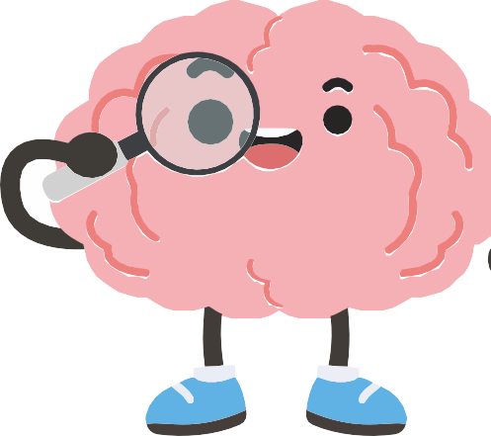
  - You can guide them with gentle questions:
    - "What things affect how you think or feel?"
    - "Is mental health only about problems?"
    - "What relationship could it have with daily life at secondary school?"
  - This phase helps break taboos and opens space for non-ju-dgmental reflection.

- Brief and accessible explanation: What is mental health?
  - Offer a definition: "Mental health is part of overall well-being. It affects how we think, feel, act, and relate to others. It is not just 'not being unwell', but also being able to manage stress, make healthy decisions, and relate in a positive way."

  - Underline: "We all have mental health and we need to look after it."
  - Guided debate: factors that influence mental health.
  - On the whiteboard, draw two columns:

Factors that hinder:

- Sleep
- Home environment
- Friendships
- School workload.

Factors that help

- Screen use (monitored)
- Physical activity
- External expectations.

- Synthesis and final reflection: Close with a clear message:
  - Mental health changes depending on what we experience.
  - Many external and internal factors influence it.
  - Talking about it helps us understand ourselves better.

- Looking after our mental health is as important as looking after our body.

- You can reinforce this with a final question: "What new idea are you taking away about mental health?"

Teacher's Note
- Maintain a climate of active listening and respect.
- Avoid delving into students' deep personal experiences.
- Do not turn the dialogue into a clinical space: the objective is educational.
- Observe signs of significant distress, but address them outside the classroom following the
school's protocols.
- Validate all contributions and avoid judgements or corrections.
- Model an open and normalising attitude: talking about mental health is healthy and necessary

Activity 2 - What influences my mental health? (15-20 minutes). Adjust according to the size of the group and the atmosphere in the classroom
A2

Objective:
Materials
Whiteboard or screen Markers
Space for open discussion (Optional) Sticky notes for students
      - Help students identify factors that positively or negatively influence their mental health, promoting personal awareness and critical thinking about their own well-being.

1.2.2. Activity Description:
- Introduction: connecting mental health and daily life
  - Explain: "Mental health is not something abstract: it is affected by things we do, think, experience, and feel every day."
  - Pose the question: "What things do you think influence how you feel mentally and emotio-nally?"
  - Allow free responses.

- Brainstorming: factors that influence well-being
  - Draw two columns on the whiteboard:

Factors that affect me negatively Factors that help my well-being

  - Invite students to participate and write their contributions under each column.
  - You can guide them with questions:
    - "How does sleep influence your mental health?"
    - "Does social media help you or affect you? When?"
    - "What role do friendships play?"
    - "Does school pressure influence how you think or feel?"
  - Important: Keep the conversation at a general level, not personal..

- Brief activity: My own influence map
  - Optional for greater participation.
  - Hand out 3 sticky notes per student, or ask them to think mentally.
  - They can place them on the board or share voluntarily:

1 thing that improves their well-being

1 thing that makes it difficult

1 thing they want to improve

- Teacher's synthesis
  - Summarise the patterns that have emerged:
    - There are external factors (school, family, networks, friendships).
    - And internal factors (thoughts, emotions, expectations).
    - All of them influence our mental well-being.
  - Highlight: "Mental health does not depend on a single thing, but on a set of elements that we can learn to recognise."

Teacher's Note

- Do not allow the conversation to drift into deep personal experiences.
- Keep the focus on identifying factors, not on clinical analysis.
- If a sensitive issue arises (violence, ideation, etc.), continue the activity and manage the concern outside the classroom following the school's protocol.
- Reinforce that there are no right or wrong answers: each student experiences different influences.
- Model balanced examples if the group remains silent.

Activity 3 - Closure: Integrating what has been learnt (10 minutes).
A3
Adjust according to the size of the group and the atmosphere in the classroom

Objective:
Materials
Whiteboard or flipchart Marker pens
(Optional) Sticky notes for short answers
      - Consolidate the main ideas worked on during the session, reinforce the unders-tanding of the concept of mental health, and prepare students to move towards the topic of self-care in the next session.

1.3.2. Activity Description:
- Integration question: What key ideas are you taking away today?
  - "What important idea are you taking away about mental health?"
- Invite them to share voluntarily.
- You can guide them with gentle questions:
  - "What have you discovered about how mental health affects us?"
  - "Is there anything you hadn't considered before?"
  - "Why do you think it is important to talk about this in secondary school?"
- Write keywords on the whiteboard as they appear (Well-being, emotions, stress, support, balance, thoughts, habits...).

- Teacher's clarification: debunking common myths
- Clarify aloud:

- We all have mental health, not just "people with problems".

- Mental health changes depending on our experiences.
- Talking about these topics is not a sign of weakness, but of self-care.

- Looking after your mental health is just as important as looking after your body.

- Optional mini-activity: One word to summarise my state
- Ask students to share (voluntarily):
  - "One word that describes how you are ending this session."
- It can be an emotion, a reflection, or a neutral word.
- Do not delve into personal explanations; naming the word is enough.
- Quick alternative: If they do not want to share aloud, they can write the word on paper and stick it anonymously on the whiteboard.

- Transition to Session 2: Close by saying:
- "In the next session, we will see what things we can do to look after our mental health, how to manage stress, and which habits help us feel better. We will work with the Wellness Tree and explore strategies you can apply in your daily life."

Teacher's Note

- Keep the closure brief and with a positive tone; avoid ending the session with unresolved doubts or activated emotions.
- Remind them that they do not need to share anything personal if they don't want to.
- Observe if any student shows significant distress; manage any concerns outside the classroom following the school's protocols.
- Reinforce the idea of normalisation: talking about mental health in a secondary classroom is an act of prevention and well-being.

Day 2 - Self-care and stress management (45 running time)
A1
Activity 1: My "Wellness Tree" – Self-care and well-being stra-tegies (20-30 minutes). Adjust according to the size of the group and the atmosphere in the classroom

Objective:

Materials
Printed ‘Wellbeing Tree’ worksheet (1 per pupil)
Pencils, felt-tip pens or coloured pencils Whiteboard or screen to display examples Optional soft music to accompany the activity
Tables set up for individual work
      - Help students identify behaviours, habits, and resources that contribute to their physical, emotional, and social well-be-ing; foster awareness of self-care and stress prevention.

2.1.2. Activity Description:
- Introduction: What things help me to be well?
  - "What things do you do that help you feel good about yourself?"
- Allow them to share spontaneous ideas.
- Guide with examples: Resting well, limiting screen time, talking to someone, doing sport,

creative activities, disconnecting from stress.
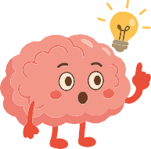

- Get plenty of rest
- Limit screen time when needed
- Talk to someone
- Take part in sport
- Creative activities
- Take a break from stress

  - Do not delve into personal experiences; keep it at a general level.

- Explanation of the "Wellness Tree": Hand out the template to each student.
- Explain:
  - "Each part of the tree represents different areas of your well-being. We are going to identify what things help you look after yourself in your daily life."
- Clarify that they can use words, phrases, drawings, or symbols.


Leaves: Small actions I can take
when I am stressed. Branches: Activities that
nourish me (friends, sport, music).

Trunk: My strengths (resilience, creativity, humour).

Roots: Habits that sustain me (sleep, eating well, routines).

11

- Individual work:
- Ask the students to work quietly for 10–15 minutes.
- Instruct:
  - "It will not be graded. This is a personal exercise for you to get to know yourself better."
- You could play some soft music to create a contemplative atmosphere.
- If someone is stuck, suggest some questions:
  - "What has helped you this week?"
  - "Who supports you when you are stressed?"

- Optional group discussion: Ask volunteers to share part of their tree (not the whole thing).
- You can display common patterns on the board without mentioning names.
- Emphasise that there are no ‘correct’ trees: each one reflects a personal reality.

- Final synthesis:
- Self-care is an essential part of mental health.
- We cannot always control what happens to us, but we can control how we look after ourselves.
- Transition:
  - "In the next session, we will work on how to ask for help using the 'Circle of Support'."

Teacher's Note

- Avoid correcting or judging the elements of the tree: every student has their own process.
- Look out for signs of distress or significant gaps (for example, trees without leaves or roots), but address any concerns outside the classroom.
- Emphasise that self-care is not a luxury, but a necessity for maintaining mental health.

Activity 2: Guided reflection – What actually helps me to feel good? (10-15 minutes). Adjust according to group size and classroom atmosphere.
A2

Objective:
Materials
The “Wellness Trees” completed by the students
Whiteboard or flipchart Felt-tip pens
Space for quiet dialogue
      - To help students identify common patterns in their self-care strategies, deepen their understanding of their own well-being, and promote respectful exchange among peers.

2.2.2. Activity Description:
- Opening: connecting with the previous activity
  - Begin by saying:
    - “Now that you have completed your Wellness Tree, let’s reflect on what things actually help you in your day-to-day life.”
  - Clarify that it is not necessary to share anything personal, only general ideas.

- Guiding questions to analyse their own tree
  - Invite students to look at their tree in silence and answer mentally:
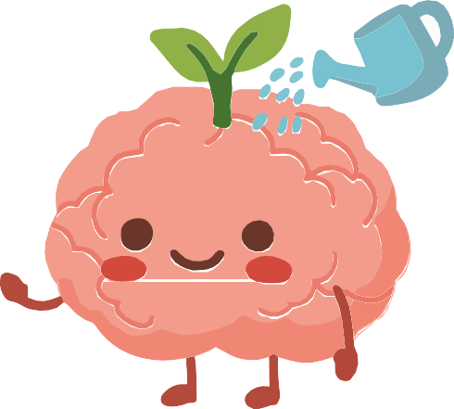
    - “Which part of my tree is the fullest?”
    - “Which soil do I usually turn to when I am stressed?”
    - “Which roots (habits) support me best?”
    - “Which leaves (quick actions) really work for me?”
  - You can write these questions on the board as a visual aid.

- Voluntary sharing
  - Ask a few students to share one idea from their tree.
  - Suggestions to keep it from being too personal:
    - “One thing that helps me to be well is…”
    - “An important root in my case is…”
    - “A leaf I use when I need to calm down is…”
  - While they share, note down keywords on the board to highlight patterns:
    - E.g. rest, music, sport, friends, talking, disconnecting from social media, nature…
  - Ensure that no one comments on or judges anyone else's tree.

- Integration: identifying similarities and differences
  - Guide this group reflection:
    - “Which things are repeated across several trees?”
    - “Which things are different depending on each person?”
  - Highlight conclusions from the lesson plan:
    - Not all strategies work the same for everyone.
    - Self-care is personal and adaptable.
  - Knowing what helps you is a tool for managing stress.

- Gentle closing: a sentence for integration
  - Ask each student to complete in their mind (or on paper):
    - “One thing I want to keep doing to look after myself is…”
  - It is not necessary to share this out loud.
  - Connect with the next activity in the following session:
    - “In the next session, we will see who can support us when what we do for ourselves is not enough.”

Teacher's Note

- Avoid students delving into experiences of intense distress; redirect towards general strategies.
- Validate all forms of self-care without judgement.
- If you observe empty trees or signs of disengagement, make a discrete note for private follow-up.
- Keep the atmosphere quiet and supportive, avoiding rushing.
- Finish by ensuring that everyone feels regulated before moving on to other content.

Day 3. My support network (60 minutes)
A1
Activity 1: Who can help me? – Discovering my support ne-twork (10-15 minutes). Adjust according to group size and classroom atmosphere.

Objective:
Materials
Printed “Circle of Support” template, 1 per student
Pencils, felt-tip pens or colours Whiteboard or flipchart
Felt-tip pens
Chairs in a flexible arrangement (circle or work tables)
      - For students to identify the people and resources that form part of their emotional support network: friends, family, teachers, professionals and services.
      - To help them understand that asking for help is an act of self-care, and that different types of support exist for different needs.

3.1.2. Activity Description:
- Initial question: Who helps in different situations?
  - “Who helps you when...?”
- Ask 2-3 questions to activate their thinking:
  - “Who helps you when you have a physical problem, like a strong pain?”
  - “And who helps you when something worries you on the inside?”
  - “Who would you turn to if you felt very stressed?”
- Allow spontaneous answers: family, friends, doctors, school psychologist, teachers, etc.
- Objective: to normalise that there are many types of help and that we all need them at different times.

- Explanation: What is a support network?
  - “A support network is the set of people and resources you can turn to when you need help. No one has to handle everything alone.”
- You can add:
  - Not everyone helps us in the same way.
  - We don’t always turn to the same people depending on the situation.
  - Identifying your network helps you feel more secure.

- Presentation of the “Circle of Support” – hand out the template to each student.
- Indicate and clarify that:
  - It is not compulsory to fill everything in.
  - They do not have to share anything personal.

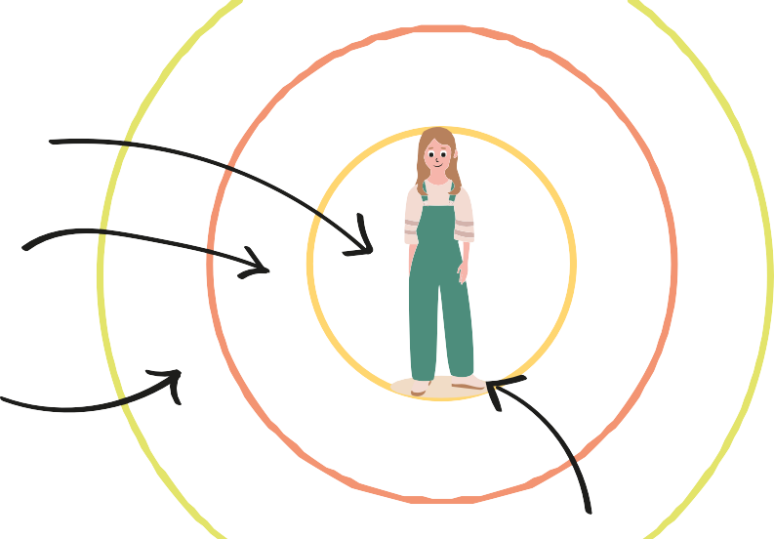
The circles around represent different levels of support:
Inner (family, close friends)

Intermediate (teachers, counsellor, coach...)

Outer (doctor, psychologist, school services)

The centre of the circle is the person

- Individual activity: completing the circle
- Ask them to write or draw in each section:
  - People they feel safe with
  - Adults they can turn to
  - School resources
  - External services (if they know them)
  - Actions they usually take when they need support
- You can guide them with questions:
  - “Who listens to you without judging?”
  - “Which adult do you feel comfortable asking for help?”
  - “Which professional could help you if you felt very low for a while?”
- Reminder for the group:
  - This is not an assessment. It is a personal tool.

- Voluntary sharing
- Invite anyone who wants to share only a part of their circle:
  - “Someone I trust is...”
  - “A support I sometimes forget about is...”
  - “A person who helps me with school matters is...”
- Write common categories on the board: friends, family, teachers, tutor, counsellor, doctor, activities, etc.
- Highlight that:
  - There is no “correct” number of supports. Every network is different.

- Final reflection: Pose the question
  - “What have we learned today about asking for help and about the different supports we have?”
- Gather key ideas:
  - We all need help sometimes.
  - We can ask for help at different levels.
  - We don’t have to manage stress or difficult emotions alone.
  - Talking to someone can greatly change a situation.
  - Sometimes we help others; other times we need help ourselves.
- Transition to the next activity:
  - “In the next part, we will see how to ask for help and how to accompany someone who needs it.”

Teacher's Note

- Avoid the conversation becoming personal or clinical.
- If a student shows a total absence of a support network, observe them discretely for subsequent follow-up.
- Stress that asking for help is not a sign of weakness, but of emotional responsibility.
- Reinforce the importance of seeking an adult at the school when the situation requires it.
- Maintain a safe environment: each person's support network is not judged or compared.

Activity 2: How do we accompany someone who needs su-pport? (15-20 minutes). Adjust according to group size and classroom atmosphere.
A2

Objective:
Materials
Question cards for groups (one per group)
Sheets or paper for noting down ideas Felt-tip pens
Chairs or tables to form small groups (3-5 students)
      - To develop observation, empathy, and communication skills; to reflect on appropriate ways to offer help and to understand the boundaries of what an adolescent can handle.

3.2.2. Activity Description:
- Group organisation: Divide the class into groups of 3 to 5 people.

  - Hand out a question card to each group.

What can I say if someone doesn't want to talk?
What DOES NOT
help in these situations?
How does someone behave who has been sad for a long time?

  - Indicate that they will work for a few minutes to share ideas and reach joint conclusions.
  - Clarify:
    - "This is not about personal experiences, but about thinking through general situations."

- Guided debate within the groups: Ask them to answer the questions on the card.
  - If necessary, remind them of these guidelines:
    - Listen without judging.
    - Do not minimise problems.
    - Do not try to "fix" everything.
    - Knowing when to ask an adult for help.
  - You can walk among the groups to offer support without intervening too much.

- Recording ideas: Each group should write their conclusions on a sheet.
  - Emphasise that there is no need to write a lot, just clear ideas.

Signs that someone needs support
1.
2.

What a friend can do
1.
2.

What an adult should handle
1.
2.

How to accompany without pressure
1.
2.

- Sharing ideas
  - Ask each group to share 1 or 2 key ideas.
  - Note down common categories on the board, for example:

What DOES help What DOES NOT help

- Listening
- Showing availability
- Validating emotions
- Accompanying them to find an adult
- Giving quick solutions
- Mocking or making fun
- Minimising ("it's nothing")
- Spreading what the person tells you

  - This reinforces real socio-emotional skills.

- Teacher's conclusion
  - Summarise by highlighting:
    - Everyone has a limited role: an adolescent is not a therapist, but they can accompany.
    - Some problems require adult or professional help.
    - Knowing how to recognise signs and ask for help is a vital skill.
    - Accompanying is not pressuring: it is being available and listening.
  - Transition to the next activity:
    - "Now we will look at some real situations and practice how to respond appropriately."

Teacher's Note

- Observe group dynamics: dominant students, silences, discomfort.
- Keep the debate at a general level without allowing real classroom cases to be mentioned.
- Gently redirect if personal experiences arise ("We can talk about this at another time; here we are working on general ideas").
- Reinforce healthy boundaries: what corresponds to a friend and what corresponds to an adult.
- If signs of distress appear in any student, make a note for subsequent follow-up.

A3 Activity 3: Practising how to help someone in need (20-25 minutes).

Objective:
Materials
Scenario cards (1 per group)
Ample space to move around or perform Sheets for jotting down quick ideas (optional)
      - To practise peer emotional support skills, learn to react appropriately to signs of distress, and understand when it is necessary to turn to an adult or professional.

3.3.2. Activity Description:

- Preparation: handing out scenarios
  - Divide students into small groups (3–5 people).
  - Hand out one scenario card to each group.
    - Indicate: “You are going to think about how you would act in this situation and perform it briefly.”
  - Clarify:
    - This is not professional theatre; a simple representation is enough.
    - No one should act as a “psychologist”, only as a peer who accompanies.
    - If the scenario touches on something sensitive, they may ask to change it.




Someone stops talking to their friends without giving any explanation.

A friend has a constant fear of making mistakes in class.

A friend says they cannot cope with the academic pressure.

- Planning the role and dialogue – ask groups to reflect:
  - What signs show that the person needs help?
  - How can we approach them without being intrusive?
  - What phrases help?
  - What phrases DO NOT help?
  - When would we ask an adult for support?

- Role-play performance
  - Each group performs their scene for 1–2 minutes.
  - The rest of the class observes with respect.

What DOES help What DOES NOT help

- “I’m here if you need to talk.”
- “Would you like me to go with you to talk to someone?”
- “What you feel is valid.”
- “You are not alone.”
- “You’re exaggerating.”
- “That’s nothing.”
- “Just get over it.”
- “I’m also doing terribly, don't complain.”

  - You can ask them to perform two versions:
    - A correct one
    - An incorrect one (for comparison)
  - This usually generates reflection without exposing real experiences.

- Brief discussion after each scene
  - Ask questions immediately after:
    - “What worked well in this scene?”
    - “What should be avoided?”
    - “When would it be important to notify an adult?”
    - “How was support shown without pressuring?”
  - Summarise the answers on the board.

- Closing the activity: make a clear summary
- “Helping does not mean solving another person's problem. It means accompanying, listening, and seeking adult support when necessary.”
- Connect with the module objective:
  - “Asking for help is an act of care. Offering help is too.”

Teacher's Note

- Supervise that no scenario becomes too personal.
- Remind them that these role-plays are generalised and should not be based on real cases
within the group.
- If a scene reflects deep distress, redirect and address the issue outside the classroom
according to school protocol.
- Always validate the effort, more than the acting itself.
- Reinforce that the student’s role is to accompany, not to solve.
- Keep the session light and safe; avoid role-plays emotionally triggering the group.

Complementary activities
AC1
Activity 1: “My emotional first-aid kit” (20-25 minutes).

Objective:
Materials
Sheets of paper or small cards Felt-tip pens or pencils Whiteboard or flipchart
      - To help students identify internal and external resources they can use when they feel low, reinforcing emotional autonomy and self-care.

4.1.2. Activity Description:
- Introduction: What is an emotional first-aid kit?
  - Explain:
    - “Just as we have a physical first-aid kit to treat ourselves when we get hurt, we can also have an emotional first-aid kit for when we feel hurt on the inside.”

- Individual activity: creating their own first-aid kit
  - Ask each student to divide the paper into 3 sections:
    - Things I can do myself (breathing, listening to music, walking...)
    - People I can talk to (friends, family, teachers...)
    - Places or actions that calm me (my room, reading, disconnecting from screens...)

- Voluntary sharing
  - Each student can share 1 item from their kit.
  - Write examples on the board.

- Closing
  - Reinforce:
    - “Having identified what helps you allows you to react better when you are stressed or sad.”

Teacher's Note

- Prevent students from sharing sensitive personal situations.
- If a student is unable to fill in the first-aid kit, observe them for subsequent follow-up.
- Reinforce the idea that self-care is personal and should not be compared.

AC2

Complementary activities
Activity 2: “Emotional traffic light” (15-20 minutes).


Objective:
Materials
Cardboard or paper Felt-tip pens
Space for group work (Optional) Printable emotional traffic light
      - To understand different levels of emotional distress and learn to act appropriately according to intensity: self-help, asking a friend for help, or asking an adult for help.

4.2.2. Activity Description:
- Presentation of the emotional traffic light
  - Draw a traffic light on the board.

- Work in pairs or small groups
  - Give each group a piece of card with a traffic light drawn on it.
  - Ask them to write examples for each colour:
    - Situations
    - Thoughts
    - Body signals
    - What to do at each level

- Sharing ideas
  - Each group shares 1 example of each colour.
  - The teacher adds clarifications:
    - Green: self-care
    - Amber: seek support from someone close
    - Red: immediate adult help

- Closing
  - Connect with the module objective:
    - “Recognising the level of distress helps us ask for the right help at the right time.”

Strong emotions or serious problems I need help from an adult NOW!
“I feel overwhelmed”, “I think I can’t take any more”

More intense emotions

Necesito I need to talk to someone
“I’ve been worried for days”, “I’m arguing a lot with someone”

Manageable emotions

I can solve it on my own
“I’m nervous about an exam”, “I’m angry but it will pass”

Teacher's Note

- Monitor how they categorise the examples to spot any potential red flags.
- Reinforce clear boundaries: a teenager should never be left to deal with a ‘red’ issue.
- Keep the tone practical, not clinical.

Material Checklist for all activities
Day 3: Support network

3.1 Support circle
Support Circle printed template (1 per student)
Pencils, markers or colours Whiteboard or flipchart
Markers
  - How do we support someone in need?
Question cards for each group Sheets or paper to jot down ideas Markers
Chairs or desks for cooperative work

  - Role-play: Practising how to help
Scenario cards (1 per group) Clear space for role-playing Paper for notes (optional)

  - Module closure
Whiteboard (optional)
Markers
(Optional) Cards to write a final reflection
Supplementary activities

  - My emotional first-aid kit
Sheets or small cards Markers or pencils Whiteboard or flipchart
  - Emotional traffic light
Cardboard or paper Markers
Space for group work
(Optional) Emotional traffic light printable
Day 1: Introduction to mental health

  - Emotional safety rules
Whiteboard or flipchart Markers (felt-tip pens)
Initial written question (optional) Space prepared for open dialogue

  - Factors influencing my well-being
Whiteboard Markers
(Optional) Sticky notes for students to write ideas
Space to write columns: "Factors that help / Factors that hinder"
  - Session closure
Whiteboard (optional)
Markers
(Optional) Small slips of paper to write a closing word
Day 2: Self-care and stress management

  - Wellness Tree
Wellness Tree printed template (1 per student)
Pencils, markers or colours
Whiteboard or screen to explain the tree structure
Desks prepared for individual work (Optional) Soft background music
  - Guided reflection on the Wellness Tree
Completed Wellness Trees by the students Whiteboard (to identify patterns)
Markers

  - Session closure
(Optional) Whiteboard to write final ideas

Printable Day 2 Activity 1: Wellbeing Tree

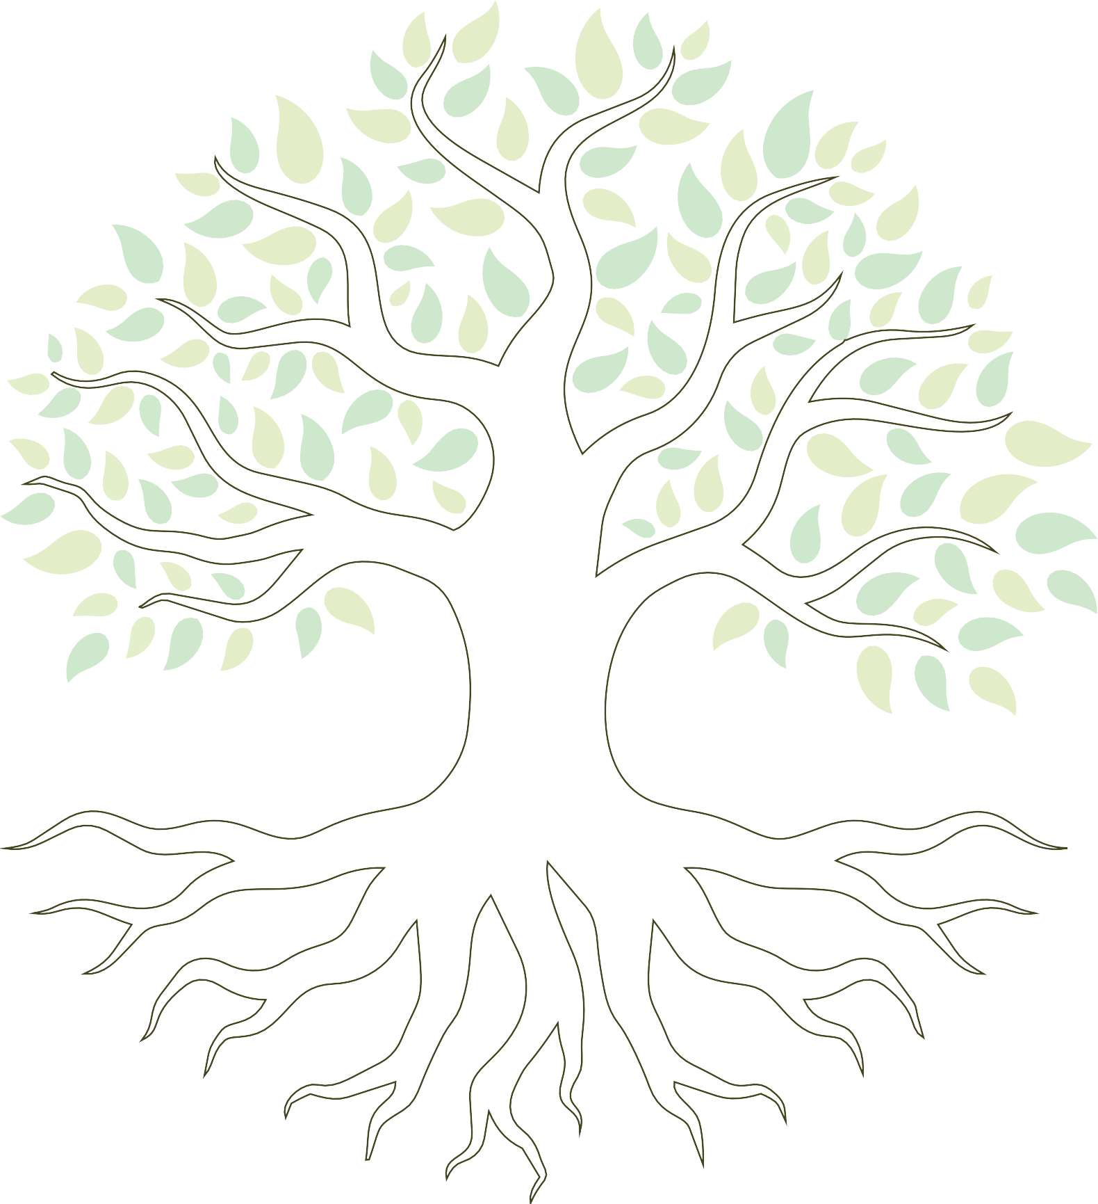

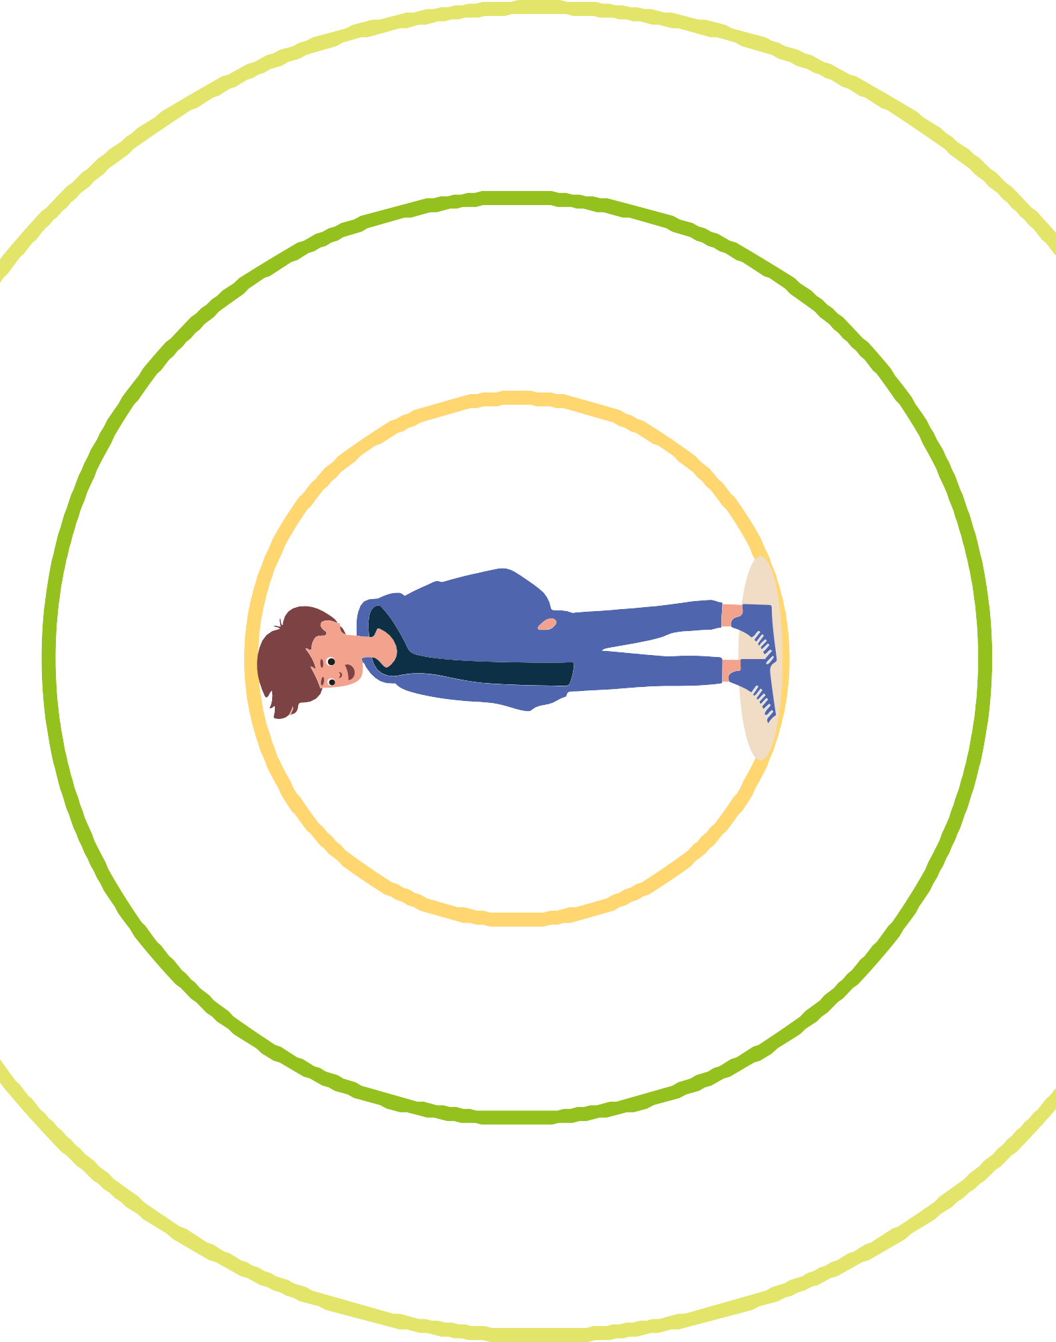
Printable for Day 3 Activity 1: Concentric circles

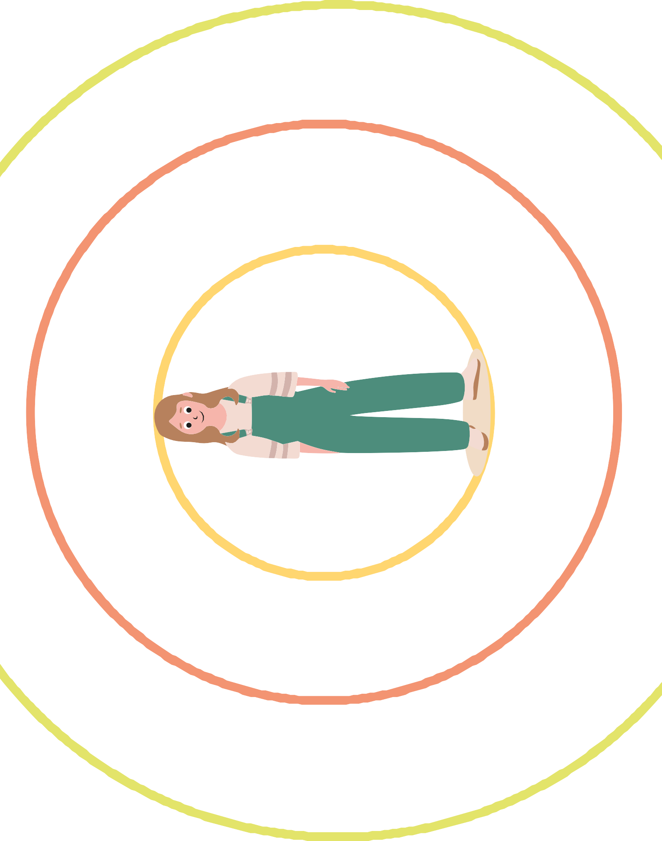

Printable for Day 3, Activity 2: How can we support someone who needs help?

How can I tell if someone needs help?

When can a friend help?

When is it better to turn to an adult?

What can I say if someone doesn't want to talk?

What DOES NOT
help in these situations?

How does someone behave who has been sad for a long time?

What can I say if someone doesn't want to talk?

What does "being there" for someone mean?

What happens if we don't know what to do?

Why might saying "it's nothing" not be helpful?

Can I help someone if I don't feel well myself?

How do I know when a situation is too big for me?

What things can a friend do to help?

Which words can make someone feel better?

What things can cause harm, even if we don't mean to?

Printable for Day 3 Activity 3: Role-play — We practise how to help someone in need

A classmate is irritable almost every day and gets angry easily.

Someone mentions that they feel empty or demotivated

A classmate is isolating themselves from the group and avoids meeting up outside school.

Someone stops talking to their friends without giving any explanation.

A friend has a constant fear of making mistakes in class.

A friend says she cannot cope with the academic pressure.

Someone gets angry when asked how they are.

Someone feels attacked and gets angry when asked how they are.

A friend expresses that she feels very lonely, even when surrounded by people.

A friend loses interest in things she used to enjoy very much.

A classmate minimises what they feel, saying "it doesn't matter".

A student freezes in exams even though they have studied.

A classmate feels pressured by their group to do things they don't want to do.

A friend says she feels constantly nervous without knowing why.

A friend feels like she doesn't fit in with her group of friends.

Printable complementary activity 1: ‘My emotional first-aid kit’
31


Printable complementary activity 2: ‘Emotional traffic lights’

Emociones fuertes o problemas serios Necesito apoyo de un adulto YA!

Emociones más intensas Necesito hablar con alguien

Emociones manejables Puedo resolverlo solo/a







Erasmus+

Enriching lives, opening minds.


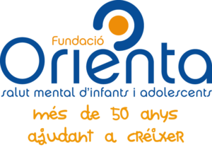

Carl von Ossietzky

Universitat Oldenburg



e.V.



