Bullying and Cyberbullying
Understanding, Reflecting, and Acting
Teacher's Guide

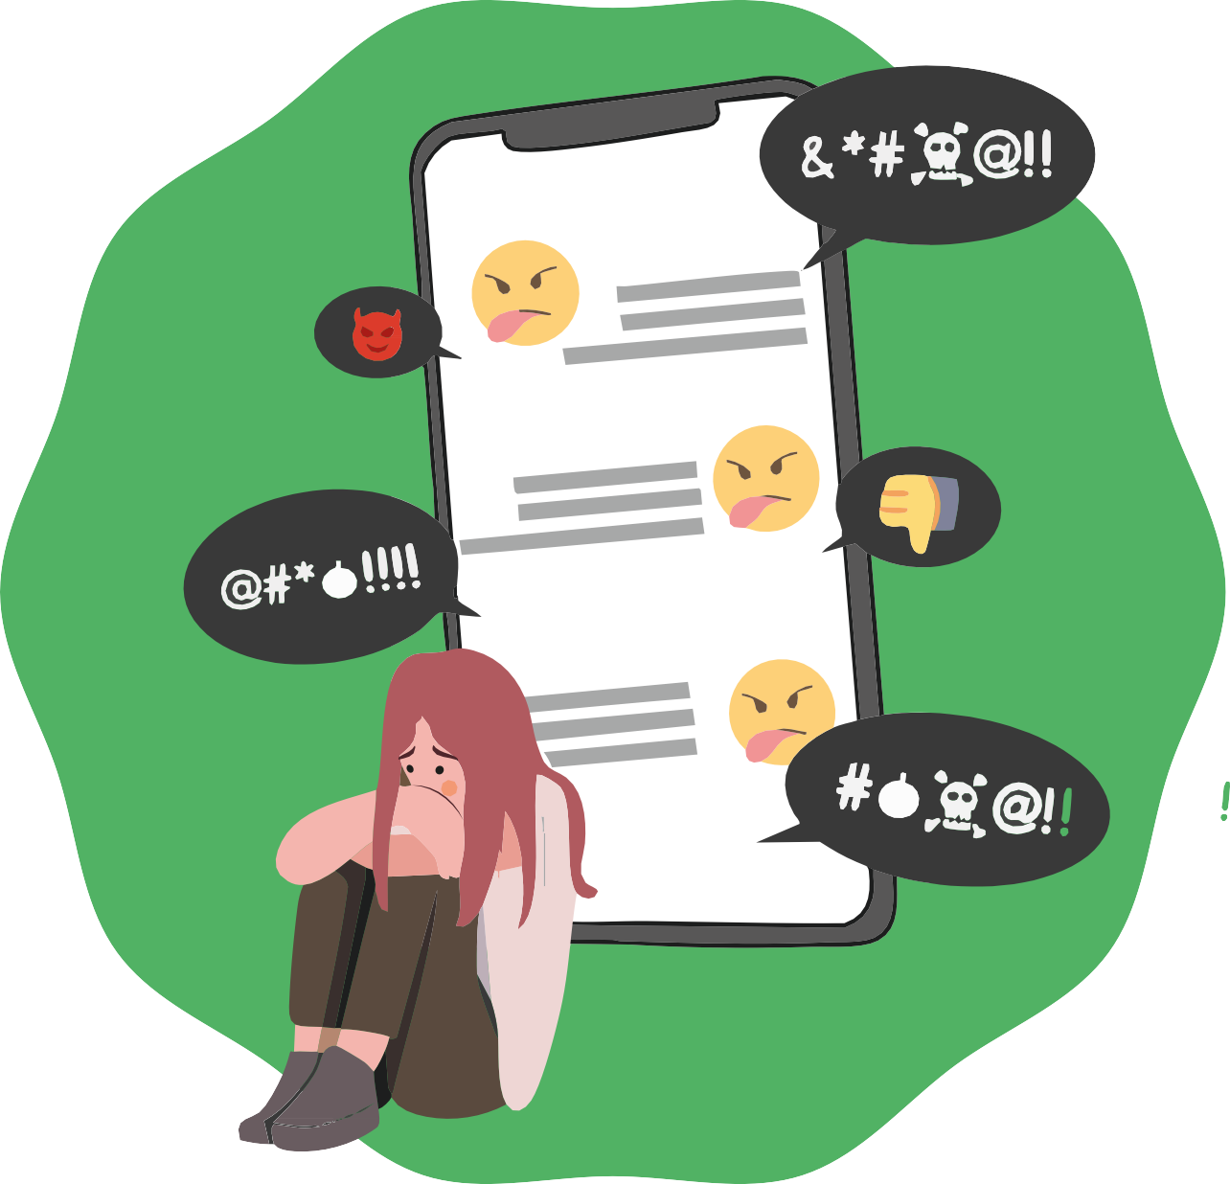

Secondary School

INDEX
- Instruction and objectives 3
- Key points for the teacher 4
- Day 1
  - Activity 1: Introduction and Presentation 5
  - Activity 2: Introduction Round – Positive Qualities 7
  - Activity 3: Movement Game – “Yes / No” 8
  - Activity 4: Video Dynamic – “The Impact of Words” 10
  - Activity 5: Paper Cards – Feelings During Bully 12
- Day 2
  - Activity 1: Review Circle and Introduction to Cyberbullying 14
  - Activity 2: Video - No Hate Speech + Debate 15
  - Activity 3: Game – “Common Messages” 16
  - Activity 4: Exercise – “Silent Steps Forward” 18
  - Activity 5: Strategies Against Bullying – Review of Class Rules 20
  - Activity 6: Closing Circle – Self-love Cards 22
- Complementary activities
  - Activity 1: The Anonymous Message Box 24
  - Activity 2: The Web of Trust 25
  - Printable materials and resources
    - Checklist of materials per session 26
    - Day 1
▫ Activity 3: Movement Game – “Yes / No” 27
▫ Activity 5: Paper Cards – Feelings During Bully 29
    - Day 2.
▫ Activity 3: Game – “Common Messages” 38
▫ Activity 6: Closing Circle – Self-love Cards 42

INTRODUCTION
Bullying is a form of peer violence characterized by repetition over time, a power imbalance, and the intention to cause harm. It is not an isolated conflict but a dynamic in which one or more students exercise power over another who finds it difficult to defend themselves.

Bullying can manifest in different ways:

- Physical: hitting, pushing.
- Verbal: insults, mockery.
- Social: exclusion, rumors.
- Digital or cyberbullying: through technology.

In secondary school, adolescents are building their identity and sense of belonging to the group. In this context, bullying can have particularly severe consequences: low self-esteem, emotional problems, anxiety, school absenteeism, and even depression. Cyberbullying amplifies these risks, as it can happen at any time, anonymously, and reach a much wider audience.

Bullying affects not only the victim but also the classroom climate. Bystanders play a crucial role: their silence can reinforce the bully, while their support can become a protective factor. Therefore, students must understand that there are no neutral bystanders: everyone has an influence on the situation.

Objectives

- Understand what bullying is and how it differs from normal conflict.
- Identify the roles involved: bully, victim, followers, bystanders, defenders.
- Reflect on the feelings of each role to foster empathy.
- Learn about the risks and characteristics of cyberbullying and prevention strategies.
- Promote digital responsibility and safe use of social media.
- Provide the group with practical action strategies to improve coexistence.
- Strengthen a safe and respectful school climate.

The ideas we share in this workshop are simply suggestions on how you might use the material. Feel free to adapt it to your needs: you can divide the workshop into two parts, spread it over several days, or
complete it all in one session — whatever works best for you. You know your students and what suits them best.

Likewise, the materials can be used either in printed or digital format, depending on what is most convenient for you.

Key Guidelines for Teachers

- Prepare the space: arrange chairs in a circle to encourage participation and equality.
- Set clear rules: respect, active listening, and confidentiality during activities.
- Facilitate without judging: guide debates with open questions, encouraging reflection.
- Balance participation: ensure that everyone takes part, avoiding monopolization.
- Ensure emotional safety: use films, stories, or puppets instead of real examples to avoid exposing anyone.
- Reinforce the search for support: explain that asking for help is not “snitching,” but a form of protection.
- Connect with real life: link the content to students’ daily experiences, both at school and online.

Expected outcomes for module 5

Keywords
- Emotional regulation
- Active empathy
- Group dynamics
- Non-violent communication
- Personal boundaries
- Active listening
- Mutual respect
- Trust
- Discrimination
- Exclude / include
- Conflict management
- Social intelligence
- Classroom climate
- Social roles
- Bullying prevention

By the end of this module, students are expected to become aware of the impact of their actions on coexistence, develop tools for respectful conflict management, and understand their role in preventing bullying and exclusion in the classroom.

Day 1. Bullying in General (1h 30m total duration)
A1
Activity 1: Introduction and Presentation (Approximately 5 minutes) Adapt it according to the size and pace of the group.

Objective
Materials
Classroom arranged with chairs in a circle. (Optional) Blackboard/flipchart and markers
      - Welcome and explain the dynamics of the workshop.
      - Create an atmosphere of trust and openness.
      - Introduce the topic of bullying in secondary school.

Steps to facilitate the activity:
      - Form the circle
        - Arrange all the chairs in a circle, making sure that all students can see each other.

      - Explain the dynamics of the workshop
        - Indicate that there will be activities, debates, breaks, and a space for questions or comments.
        - Reinforce that this is a safe space to share ideas and opinions, always with respect.

      - Introduce the topic
        - Say something like:
          - “Today we are going to reflect on how we treat each other in class and what bullying means.”

      - Ask the initial question
        - “What is bullying?”
        - Listen and collect some spontaneous answers from the students.

      - Present Olweus’ definition
        - Explain:

          - “According to Dan Olweus, bullying is when someone suffers repeated negative behavior, which continues over time and where there is a power imbalance between the victim and the aggressor.”
5

Note for the teacher:
- Keep the explanation brief and simple, so you can quickly move on to student participation.
- Validate all initial answers, even if they are not exact: they serve as a starting point.
- If questions arise about the definition, remember that it will be explored in more depth in later activities.

Activity 2: Introduction Round – Positive Qualities (Approximately 10 minutes)
A2
Adapt it according to the number of students

Objectives

Materials
Classroom organised in a circle of chairs
      - Promote integration and participation from the beginning.
      - Recognize and value positive personal qualities.
      - Create a climate of trust that makes it easier to talk about sensitive topics such as bullying.

Steps to facilitate the activity:
      - Explain the instructions: “Now we are going to introduce ourselves in a special way. Each person will say their name and a positive quality they believe they have. It can be something they are good at, a characteristic of their personality, or something they like about themselves.”

      - Give examples: Examples: “I’m Marta and I’m a good friend,” “I’m Alex and I draw well.”

      - Model the dynamic: Start yourself as the teacher to give an example, sharing your name and a real positive quality.

      - Carry out the full round: The turn moves around the circle until everyone has introduced themsel-ves.

      - Optional – Reinforcement variation: After each student shares their quality, the group can respond with a simple gesture of recognition (a short applause, a thumbs up, or a smile).

“I’m Marta”
“I’m a good friend”,
“I deserve respect”
“I’m enough, just as I’m”
Note for the teacher:
- Encourage students to be specific and authentic in their qualities.
- If a student feels uncomfortable or does not know what to say, suggest simple examples or allow them a moment to think.
- Reinforce the importance of respecting and listening to each intervention, without mockery or
interruptions.

Activity 3: Movement Game – “Yes / No” (Approximately 15 minutes) Adapt it according to the size and energy of the group.
A3

Objectives
Materials
Large poster with “YES.” Large poster with “NO.”
Wide space in the classroom to move freely.
      - Explore opinions and attitudes toward bullying.
      - Encourage group reflection in a brief and dyna-mic way.
      - Identify common perceptions within the group about bullying.

Steps to facilitate the activity:
      - Prepare the space
        - Place the “YES” poster at one end of the classroom and the “NO” poster at the opposite end.
        - Explain that you will read statements related to bullying and that each student must stand on the side that best reflects their opinion.

      - Explain the instructions
        - Clarify: “There are no right or wrong answers. We want to see what we think and feel. After each statement, we will talk very briefly.”

      - Present statements to the group
        - Read a statement out loud and let students position themselves on the corresponding side.
        - Examples of statements:

“If I see someone being bullied, I prefer to walk away.”
01
          - Why walk away?
          - Is it because you are afraid of being bullied too?
          - How could you protect yourself without putting yourself in danger?

“If someone is being bullied and tells an adult, they are a snitch.”
03

Explain the difference:
          - Snitching is when there is no real harm (e.g., cheating on a test)
          - Asking for help is when someone is suffering and needs support.
“I am afraid that I will also be bullied if I help someone.”
Explain that this fear is common, but helping does not mean exposing yourself: asking for help works.
02

“I would talk to my parents or my teacher if I felt uncomfortable or mistreated in class.”
04

Reinforce how important it is to talk about concerns: bullying can affect health. Ask:
- who else could you go to if you don’t want to talk to your parents or partner? (e.g., teachers, counselors, school support system).

  - Optional question: “I have personally seen someone in my class constantly mocked or excluded.”
▫ Normalize: most will say yes, which shows that bullying affects us all.

      - Brief dialogue After each statement, invite 2–3 students to explain why they chose “YES” or “NO.”
        - Keep the interventions short, since the topic will be addressed in more depth later.

      - Closing the activity
        - Summarize with a key idea:

“Bullying is not an isolated problem: it affects us as a group. These statements show us that we all have thoughts and fears about the issue, and that it is worth talking about them.”

Note for the teacher:
- Monitor carefully so that responses do not generate mockery; intervene quickly if it happens.
- Keep the activity dynamic: deeper exploration will come later.
- Use this exercise as an initial “thermometer” to get to know the group’s perceptions.

Activity 4: Video Dynamic – “The Impact of Words”
A4
(Approximately 20 to 25 minutes) Includes viewing the video and the subsequent discussion.

Objectives
Materials
Projector or screen with sound Internet access to play the video [YouTube – The Impact of Words] Blackboard or flipchart to note down key ideas
      - Reflect on how negative words (insults, mockery, labels) affect people.
      - Raise awareness that bullying is not always physical: verbal harm also leaves a mark.
      - Promote respect and empathy in everyday commu-nication.

Steps to facilitate the activity

It is also available in the Power Point and below is the direct link.
Click here! https://www.youtube.
com/watch?v=3JI4Kg RLefE

      - Introduction to the video (2–3 min)
        - Say to the group:
          - “We are going to watch a video that shows how a girl feels when she starts receiving insults and mockery from her classmates. Pay attention to the words that are used and to what they cause in her.”

      - Viewing (3–4 min)
        - Play the full video in class.
          - Ask students to observe especially how the protagonist’s expression and mood change.

      - Initial reaction (3–4 min)
        - Ask the group:
          - “What did you feel when you saw how they treated the girl?”
          - “What words did they say to her and what effect did they have on her?”
          - “How do you think she felt?”

      - Guided debate (7–8 min)
        - Lead the reflection with questions:
▫ “Why can words hurt as much as a blow?”
          - Have you ever seen or experienced something similar?”
▫ “What responsibility do those who observe without intervening have?”
        - Write key ideas on the board such as: pain, sadness, loneliness, self-esteem, indifference, support, respect

      - Closing the activity (2–3 min)
        - Summarize with the key idea:
          - “Bullying is not always seen in fights or shoving. Many times it happens with words, insults, or labels that hurt and leave a mark. Every word we say can destroy or can support: we are responsible for the effect they have on others.”

Teacher’s note
- Monitor reactions: it may stir up personal experiences in students.
- Reinforce the importance of naming the positive as well as detecting the negative.
- If a real case arises in the group, do not address it publicly: acknowledge it and follow up separately.

Activity 5: Paper Cards – Feelings During Bully
A5
(Approximately 25 to 30 minutes) Adapt it according to the number of students and the depth of the discussion.

Objectives
Materials
Cards with different roles written on them (victim, bully, parent, bystander, follower, teacher, etc.).
Large space in the classroom to form a circle and place the cards on the floor.
      - Put oneself in the shoes of the different people involved in a bullying situation.
      - Explore the feelings, thoughts, and pers-pectives of each role.
      - Reflect on the consequences of bullying and on possible ways of finding solutions.

Steps to facilitate the activity
      - Prepare the space
        - Place the role cards on the floor, inside a circle formed by chairs or by students standing around.
        - Ask the group to stand around the cards, observing all the possible roles.

      - Assume the roles
        - Explain the dynamic:
          - “One by one you will choose a card, stand on it, and say a short sentence from the pers-pective of that role, expressing what that person might feel or think in a bullying situation.”
        - Start yourself as the teacher to give an example. Examples:
          - Victim: “I don’t want to go to school anymore.”
          - Victim’s mother: “What is happening to my daughter?”
          - Bully: “It’s fun to pick on others.”
          - Bystander: “I hope I’m not the next one…”

      - Symbolic closure of the role
        - When everyone has participated, guide the gesture of “taking off the role”:
▫ “Imagine you are wearing a painter’s suit with a zipper. Pull the zipper from your head down to your feet and shake your arms and legs to release the character.”
          - This helps leave behind the role played and return to neutrality.



      - Plenary debate: Lead a group dialogue with the following reflections:

If we remove the victim card
(“had to leave school”),
        - what will happen?

The bully will probably look for another victim, because the root of the problem lies in the bully’s behavior, not in the affected person.
If we remove the bully card
(“had to leave class”),
- what will happen?

Things may calm down, although it is also possible that another student with bullying behavior may emerge.

  - What prevents the people involved from seeking solutions?
  - What feelings are at play in each role?
  - Who could contribute to the solution and how?
  - What do you expect from teachers? And what do they expect from you?
  - What other support systems could intervene? (Counseling services, school social work, parents of those involved…).

      - Perspective toward the next session
        - Connect with what will come next:
          - “Today we have seen how the different people involved in a bullying situation feel and what they think. In the next session we will talk about another type of bullying: cyberbull-ying, which happens through cell phones and the internet.”

Teacher’s note
- Be careful that students do not use real hurtful phrases; guide them toward general expressions that help understand the role.
- Make sure all roles are represented at least once to show the complexity of bullying.
- Reinforce that no role is “the bad one” or “the good one”: all reflect real positions that exist in a bullying case and must be understood in order to intervene.
- The gesture of “taking off the role” is important so that students do not remain emotionally attached to the role they assumed

Day 2. Cyberbullying, civic courage and anti-bullying strategies (1h 40m duration) Activity 1: Review Circle and Introduction to Cyberbullying (Approximately 10 to 15 minutes) Adapt it to the time and energy of the group.
A1

Objectives
Materials
Chairs arranged in a circle. Blackboard or flipchart (optional).
      - Recall what was learned on Day 1 about bullying.
      - Reinforce the roles involved (victim, bully, followers, bystanders, class).
      - Introduce the topic of cyberbullying.

Steps to facilitate the activity
      - Organize the chairs
        - Arrange all the chairs in a circle so that everyone can see each other face to face.

      - Check attendance and recap
        - Ask if anyone was absent in the previous session and allow classmates to summarize the most important parts of Day 1 (Kim’s story, roles, emotions, consequences)-

      - Ask guiding questions
        - “What is bullying?”
        - “What did we learn about the different roles in bullying?”
        - “What happens to the entire class in a bullying situation?”

      - Collect key words
        - Write down on the board key words that come up (e.g., fear, loneliness, power, indifference, support, responsibility).

      - Introduce the Day 2 topic
        - Say:
          - “Today we are going to look at another type of bullying, the one that happens on the internet and with cell phones: cyberbullying. We will see what makes it different and what we can do to stop it.”

Teacher’s note
- Keep the review brief. The goal is not to repeat everything, but to connect the learning from Day 1 with the new topic.
- Keep the review dynamic: 5–6 students speaking is enough to activate collective memory.
- Do not correct wrong answers immediately: use them as a starting point to go deeper later.
- Reinforce the idea that bullying and cyberbullying do not happen in isolation: they always involve the class.
- • If the group is quiet, you can briefly recall Kim’s story yourself or mention examples from the previous day to reactivate memory.

Activity 2: Video - No Hate Speech + Debate
A2
(Approximately 15 to 20 minutes) Adapt it to the time and energy of the group.

Objectives
Materials
Projector or screen with internet access.
Blackboard or flipchart.
      - Understand what cyberbullying is and its characteristics.
      - Differentiate it from face-to-face bullying and hate speech.
      - Raise awareness about its legal and emotional consequences.

Steps to facilitate the activity
It is also available in the Power Point and below is the direct link. https://www.youtube.com/watch?v
=nc-mR8gH8PU
Click here!
      - Introduce the video
        - Explain that they will watch a short video about cyberbullying (No Hate Speech).
          - “This video shows how a message on the internet can turn into hate and cause great harm.”
      - Watch the video
        - After this ask students to pay attention to what they feel while watching it.

      - Open the debate with questions
- “What are the differences between face-to-face bullying and cyberbullying?”
- “What characteristics make it more dangerous?”
- Reinforce key ideas: anonymity, reach, 24/7 availability, permanence of messages, and the simplicity of spreading them.

      - Explain hate speech refers to messages directed at entire groups, based on prejudice.
      - Emphasize the legal dimension
        - “Cyberbullying is not a game or a small mistake. It is a criminal offense that can have serious consequences. That’s why it’s important to talk about it with someone you trust and to keep evidence.”

Teacher’s note
- Make sure comments do not drift into overly personal experiences; keep them focused on understanding the phenomenon.
- Before showing the video, check that the sound and internet connection work well to avoid interruptions.
- Ask students to write down one word describing how they feel during the video, so the debate flows better.
- Be prepared with a short definition of hate speech, as it may be a new concept for many.
- Set a boundary: this is not about debating politics or religion, but about understanding how hate works on social networks.
- If you notice nervous laughter, explain that it is normal because the topic is uncomfortable, but ask for respect: “Laughter doesn’t mean it doesn’t matter, but sometimes it’s how we process difficult emotions.”

Activity 3: Game – “Common Messages” (Approximately 20 to 25 minutes) Inclu-ding reflection.
A3

Objectives

Materials
A doll or stuffed animal.
Laminated cards with mobile messages (both positive and negative).
Circle space with chairs
      - Experiencing the impact of digital messages.
      - Reflect on how anonymous and known messages affect differently.
      - Raise awareness that the group has the power to hurt or to care.

Steps to facilitate the activity

      - Prepare the space
        - Arrange the chairs in a circle and place the doll in the center.

      - Explain the dynamic
        - “This doll represents a real person who is alone, sad, and starts receiving messages on their phone.”

      - Distribute the message cards: Ask them to read them silently first to familiarise themselves with them.

      - Negative messages round: Each student takes turns reading aloud a negative messa-ge directed at the doll.

Your voice matters.

      - Pause and reflection: Ask
        - “How would the doll feel when receiving these messages?”
        - “Is it different if the message comes from someone known or anonymous?”
You have incredible strength.

      - Explain:
        - Digital messages can be stored, forwarded, and spread quickly.
        - Legally, they can be considered insults, defamation, threats, or viola-tions of image rights.

      - Positive messages round: Now ask each student to share a positive message with the doll (e.g., “You are important,” “You can count on me”).
Don’t let anyone dim your light.

      - Group closing reflection:
        - “How did you feel when saying negative messages? And when saying positive messages? Just like on the internet, we can choose: our words can destroy or they can help.”

Teacher’s note
- Do not allow students to invent real messages from the group. Use only the prepared cards.
- Never place a student in the center: the doll or stuffed animal symbolizes the victim to protect the group emotionally.
- Read the first (negative) message yourself to model how it is done and to set a serious tone.
- If the group takes it as a joke, pause and ask:
  - “Why do you think some people don’t realize the harm of their words?”
- Remember to explain that positive messages also circulate and are very powerful: this prevents the activity from focusing only on the negative.
- Have extra cards ready: if the group is large, ensure everyone participates.
- After the positive round, encourage reflection: “What difference do you notice now in the classroom atmosphere?”

Activity 4: Exercise – “Silent Steps Forward”
A4
(Approximately 15 to 20 minutes)

Objective
Materials
Large space so the group can form a big circle.
      - Make visible how frequent bullying and support are.
      - Foster empathy and reflection on the class climate.

Steps to facilitate the activity:
      - Form the circle: the class form a large circle.

      - Explain the dynamic
        - “I am going to read sentences. If you have ever seen it or experienced it yourself, take a step forward into the circle in silence.”

      - First round – negative experiences
        - Examples: seeing hitting, insults, exclusion, threats, pushing, rumors.

      - Second round – positive experiences
        - Examples: receiving help, support with studies, defense against injustice, a compliment, someo-ne trusting you.

      - Return to the big circle after each round

      - Group debate: ask
        - “What did you observe?”
        - “What is the climate like in our class?”
        - “What can we improve to feel safer and more supported?”

Teacher’s note
- Reinforce that nobody is alone: the exercise shows that almost everyone has seen or lived these situations.
- Emphasize that the exercise must be done in complete silence: words or laughter break the impact.
- If you notice discomfort, remind students that no one has to explain themselves: the step forward speaks for itself.
- Stand in the circle and participate yourself; this builds trust and shows that everyone is involved.
- After the first (negative) round, pause briefly before beginning the second (positive) to “reset” the atmosphere.
- Reinforce that the activity is not about pointing fingers but recognizing that most of us have been exposed to these situations.
- At the closing, avoid leaving it only on the negative: balance by highlighting the steps forward in supportive experiences.

Activity 5: Strategies Against Bullying – Review of Class Rules
A5
(Approximately 10 to 15 minutes)

Objectives
Materials
Blackboard or flipchart. Markers.
      - Identify strategies to prevent and stop bullying and cyberbullying.
      - Review existing class rules and strengthen them with specific anti-bullying measures.
      - Encourage collective responsibility for maintai-ning a safe and respectful environment.

Steps to facilitate the activity
      - Introduction:
        - “We’ve already talked about bullying and cyberbullying, and we’ve seen how they affect people. Now let’s think together: what can we do as a class to make sure this doesn’t happen, or to stop it if it does?”

      - Brainstorm what to do if someone feels mistreated.
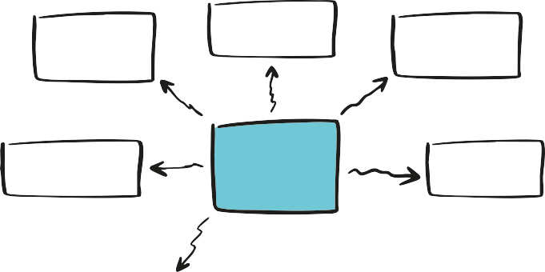
        - Defending those who are being bullied.

Stop Bullying
        - Talk to a trusted adult.
        - Do not forward harmful messages.
        - Approach the victim and show support.
        - Talk to supporters or the offender.
        - Intervene and say STOP.
        - Document incidents (screenshots).

      - Rank the proposals with the group:
        - What each individual can do.
        - What the class can do.
        - What to do on the internet

      - Write a short "pact" or list of conclusions on the blackboard.
        - Check if the class already has rules. Compare them with the new ideas.
        - Ask: “Are our current rules enough to prevent bullying and cyberbullying? What should we add?”

      - Closing reflection
        - “Bullying is not only a problem for one person, but also a challenge for everyone. As a class, we can take responsibility for protecting and supporting each other.”

Approach the victim and show
support.
Defending those who are being
bullied.
Stop Bullying

Talk to a trusted adult.
Talk to supporters or the offender.
Do not forward harmful messages.

Intervene and say STOP.
Document incidents (screenshots).

Teacher’s note
- If time permits, turn it into a mural to be displayed in the classroom.
- Start by asking what rules already exist ivn the classroom to recognise what works.
- Avoid turning it into a 'moralistic' list: guide them to come up with realistic strategies that they can actually implement.
- Encourage them to write the strategies in their own words (not in adult terms).
- If there are many ideas, sort them into three columns: individual - group - online so that the scope is clear.
- Reinforce that not everyone has to confront the aggressor directly: seeking help is also a valid strategy.
- Suggest that the mural or list be hung up in class so that it can be reviewed later.

Activity 6: Closing Circle – Self-love Cards
A6
(Approximately 10 to 15 minutes) Adapt it depending on available time.

Objectives
Materials
One circular card or self-love card per student.
Colored markers.
(Optional) Tape to hang the cards on the classroom wall.
      - End the module with a positive experience of mutual recognition.
      - Reinforce an atmosphere of trust, care, and group support.
      - Foster self-esteem and empathy through compli-ments.

Steps to facilitate the activity
      - Preparation: Give each student a paper plate or circular card. Ask them to write their name clearly in the center.

      - Instruct them to write a message of self-love or a positive reminder.
        - Examples: "I am strong", "I am valuable", "I am glad I exist".
        - Optional: let them decorate the card with colours or symbols.

      - Compliment round:
        - Students circulate around the classroom, passing the cards from hand to hand.
        - Everyone writes a positive message on each other's card.
        - Make sure everyone gets at least one message from each partner.

      - Personal reading
        - When finished, students collect their own card and read the compliments silently.
        - Allow a few minutes of silence for them to enjoy the messages.

      - Short closing round:

        - Each student can share (if they wish) their card with the group or keep it as a personal memento.

You are very I admire your intelligent
courage.

"I am a very good friend".
You are so funny

I love your smile

You are beautiful.

      - End with verbal reinforcement:
        - "Today we have seen that words can hurt, but also heal. Let's use them to support each other and create a climate of respect".

Teacher’s note
- Remember that this exercise is not about art, but a personal symbol. It can be repeated at any time during the course.
- Have examples of self-love messages (e.g. "I am important", "I have good things to contribute") ready to inspire the group.
- If a student does not want to write about him/herself, he/she can write a general positive sentence and then transform it into a personal one.
- Make sure that the sentences do not become jokes or ironies: ask that they are respectful and sincere.
- If time permits, encourage decorating the cards: this reinforces the sense of ownership of the message.
- You can suggest that they keep the card in their pencil case or diary to look at during difficult times.
- Finish by thanking them for their participation and reinforce the message: "We all have the right to feel valued. Respect starts with ourselves and multiplies when we share it with others.

AC1

Objectives
Complementary activities. (40m total duration)
Activity 1: The Anonymous Message Box (Approximately 15 to 20 minutes + periodic reviews. )


      - Provide a safe space to express emotions and experiences without fear of judgment.
Teacher’s note
- Always maintain anonymity: never try to guess who wrote what.
- Use the messages as a starting point for group reflection, not for accusations.
- If serious messages appear (violence, threats, explicit exclusion), address them with seriousness and privately, outside the group.
- Reinforce that asking for help is not snitching, but seeking solutions.
- You can keep the box as an ongoing tool during the school year and review it weekly.
23
Materials
A decorated box or mailbox (physical or virtual).
Small slips of paper.
Pens or pencils.
      - Foster empathy and respect for classmates’ privacy.
      - Identify common concerns within the group

Steps to facilitate the activity
      - Place the box in a visible and accessible spot in the classroom.

      - Explain that anyone can use it anonymously to leave messages about how they feel, something unfair they have seen, or to share advice or a positive message.

      - Dedicate a moment in class for everyone to write something (real or invented) and put it in the box.

      - Open some messages at random and read them aloud (without identifying authors).

      - Lead a short reflection on what was shared:
        - “What can we learn from these messages?”
        - “What things should we improve as a group?”

      - Close by reinforcing that this space is meant to support and improve coexistence.

AC2

Objectives

Activity 2: The Web of Trust (Approximately 15 to 20 minutes)

      - Visualize the importance of group unity.
Materials
A ball of yarn or string.
Enough space for the group to form a circle.
      - Reinforce the idea that the class is stronger when it acts together.
      - Encourage trust, respect, and cooperation among classmates.

Steps to facilitate the activity

      - Ask the group to sit or stand in a circle.

      - Hold the end of the yarn and say a positive quality or a supportive message to a classmate.

      - Throw the yarn ball to that person while keeping hold of your end.

      - The classmate repeats the dynamic: says something positive to another person and throws the yarn ball, holding onto their part of the thread.

      - The process continues until everyone has participated and a visible web forms in the center.

      - Ask everyone to pull the thread at the same time to feel the strength of the web.

      - Have one student let go of their thread and reflect on how the structure weakens.

      - Close by highlighting that every person is important for the group to remain strong and protected.

Teacher’s note
- Encourage messages to be positive, sincere, and specific (no jokes or ambiguous comments).
- If a student doesn’t know what to say, suggest examples: “I like how you help me in class,” “You are someone I can trust.”
- Participate in the dynamic yourself to model the positive tone.
- Keep the yarn ball as a symbol: you can repeat the activity later to compare how the group’s trust has evolved.
- Reinforce the idea that each thread represents a real connection: when someone is missing or doesn’t feel supported, the entire web loses strength.

Checklist material by activity
Day 1. Bullying in General

Introduction and Presentation
Classroom arranged in a circle of chairs (Optional) Blackboard/flipchart and markers
Introduction Round – Positive Qualities
Classroom organised in a circle of chairs
Display Game – Yes / No
Large poster with “YES” Large poster with “NO”
Wide space in the classroom to move around
Video Activity – “The Impact of Words”
Projector or screen with sound Internet access to play the video [YouTube – The Impact of Words]
Blackboard or flipchart to note down key ideas
Paper Cards – Feelings During Bullying
Cards with written roles
(victim, bully, follower, bystander, teacher, parent, etc.)
Large space to form a circle and place the cards on the floor
Day 2. Cyberbullying and Support Strategies

Review Circle – Remembering the Previous Day
Classroom in a circle of chairs Blackboard/flipchart and markers (optional)
Video – No Hate Speech + Debate
Projector or screen with sound
Internet access to play the video No Hate Speech Blackboard or flipchart to collect key ideas
Game – Common Messages
A doll or stuffed animal
Laminated cards with mobile phone messages (negative and positive)
Circle space with chairs
Exercise – Silent Steps Forward
Large space for the whole group to form a big circle
Strategies Against Bullying – Review of Classroom Rules
Blackboard/flipchart and markers
Closing Circle – Self-Love Cards
Circular cardboards or self-love cards (one per student)
Colored markers
(Optional) Adhesive tape to hang the cards

Complemantary activities

The Anonymous Message Box
Decorated box or mailbox (can be physical or virtual) Small pieces of paper Pencils or pens
The Web of Trust
A ball of yarn or string
Large space for everyone to form a circle

Printable Activity 3: Movement Game - “Yes / No”

26

27



Printable Activity 5: Feelings During Bully

Victim

28




Bystander
29




Bystander
30




Follower
31

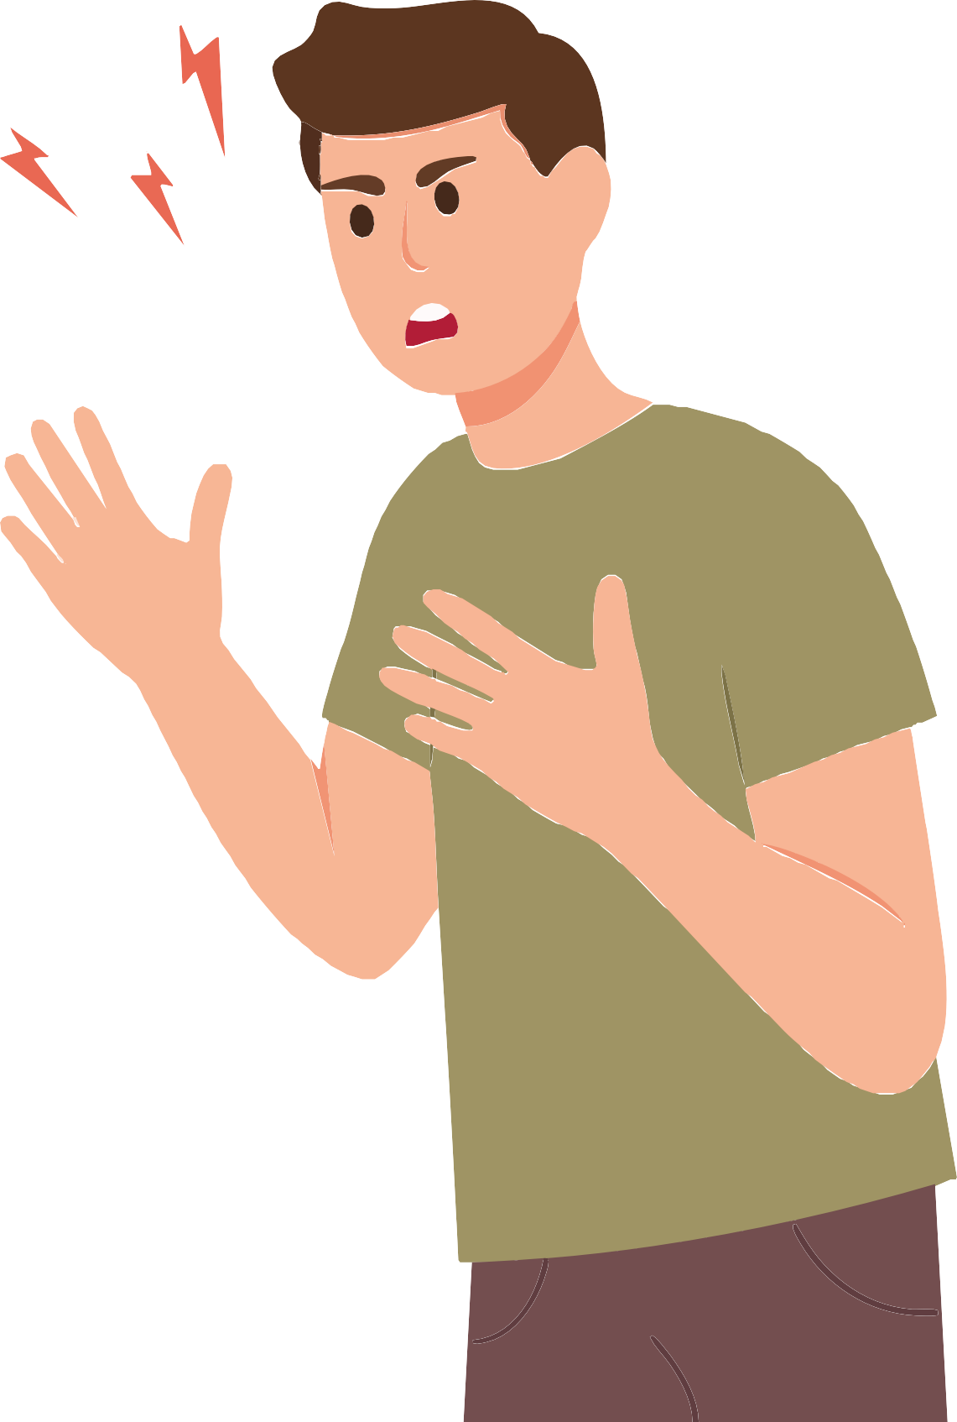


Bully
32




Teacher

33



34

Teacher












Bully’s parents
35

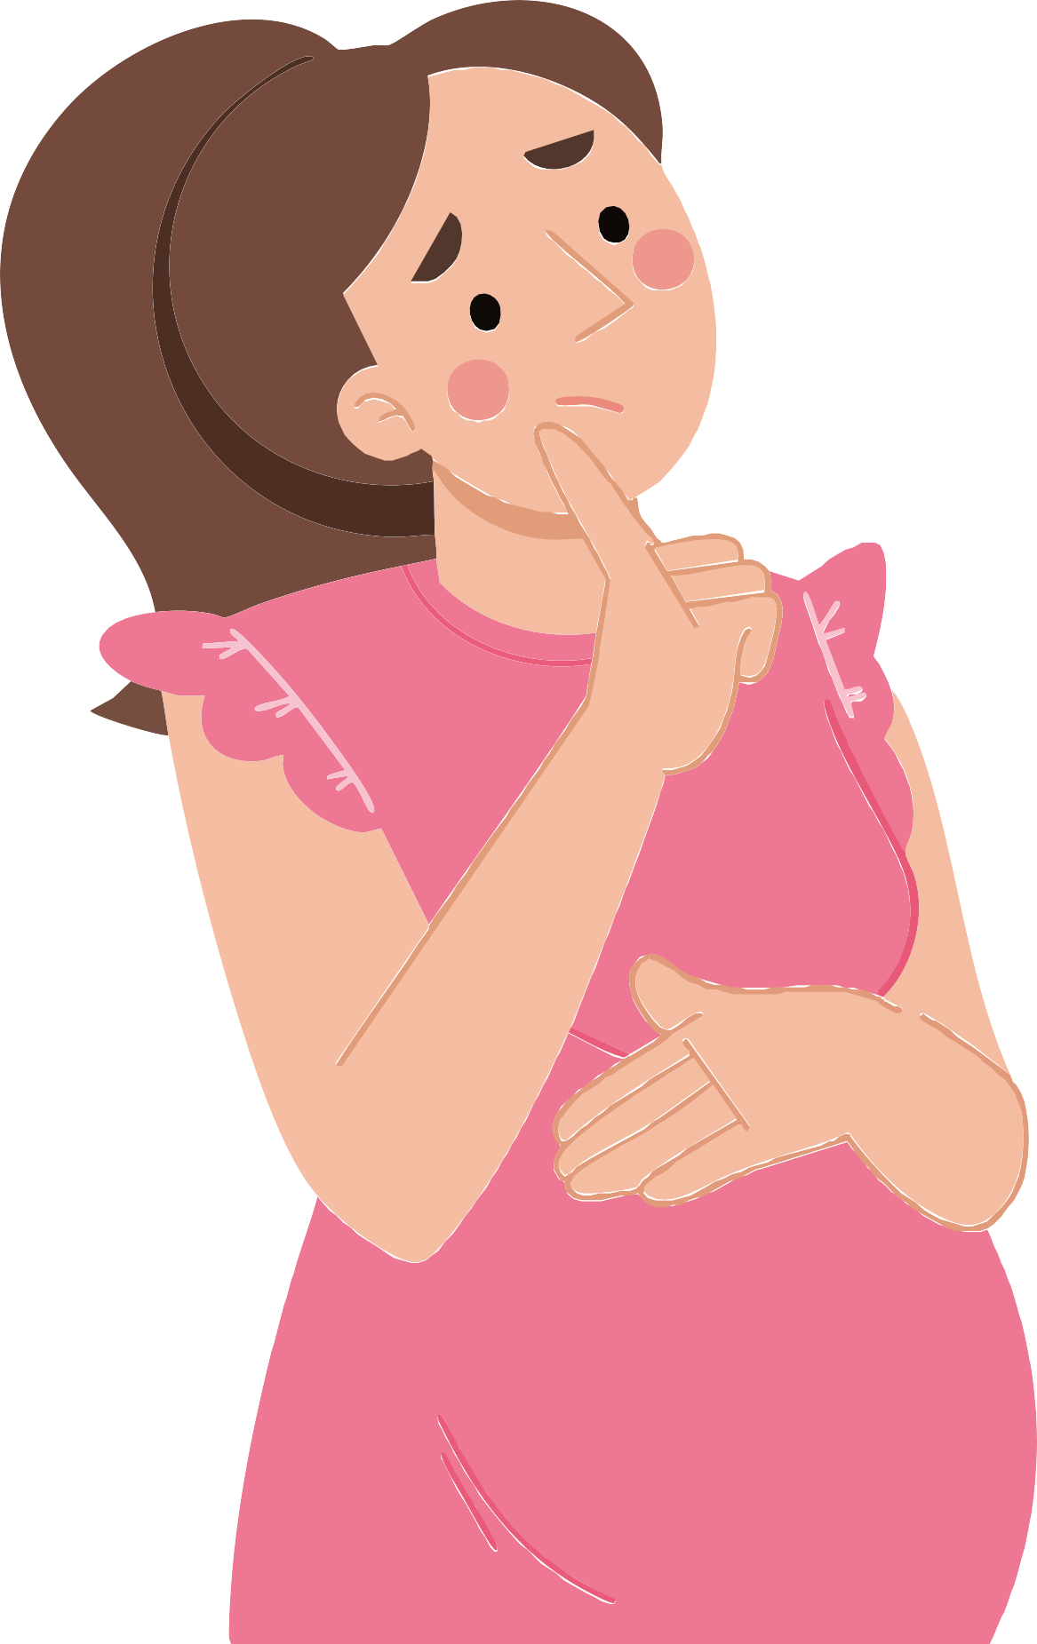


Victim’s mother
36

Printable Day 2 Activity 3: Game - “common Messages”

I hope you're not coming on a trip!

I know where you live!

You are so stupid!
Everyone in the class hates you!

You're no good at all!
Tomorrow we'll kick your ass!

We don't want you here!
I hope you change schools!

Everyone laughs at you!

You'll never have friends here!

Don’t let anyone dim your light.
There’s nothing wrong with you.

You have incredible strength.
You are enough, just as you are

You can count on me
Your voice matters.

I’m proud of you.
You’re stronger than you think.

I’m with you.

You deserve peace and happiness



Printable Day 2 Activity 6: Self-love Cards





I admire your courage.
You are very intelligent


43

"I am a very good friend".
You are so funny

I love your smile

You are beautiful.







Erasmus+

Enriching lives, opening minds.


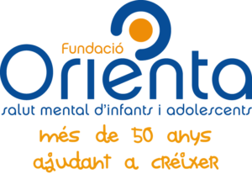

Carl von Ossietzky

Universitat Oldenburg



e.V.



