Adolescents' rights
Teacher’s Guide
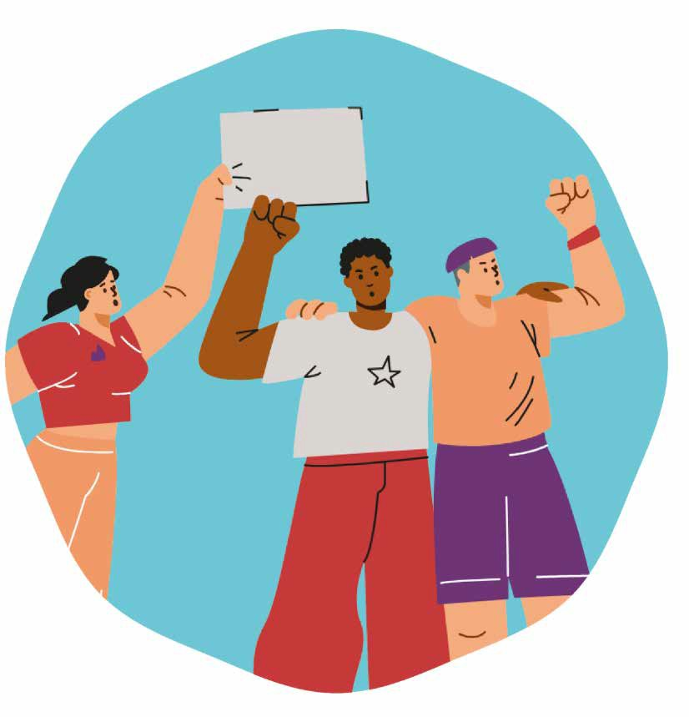
Secondary education activities

CONTENTS
- Introduction 3
- Objectives: Module focus and pedagogical principles 4
- Recommendations for the teacher: What this workshop is and what it is not 5
- Day 1 — Rights in daily life
  - Activity 1 — Hidden image and critical reading 6
  - Activity 2 — Identifying rights in real-life scenes 8
  - Activity 3 — Ethical dilemmas of everyday life 10
- Day 2 — Rights around the world
  - Activity 1 — "What if...?" — Questions to awaken global awareness 12
  - Activity 2 — Real stories of adolescents around the world 14
  - Activity 3 — Critical analysis — Causes and consequences 17
- Day 3. Support network
  - Activity 1 — "Which rights are lived here?" 19
  - Activity 2 — "Our school with more rights" 22
  - Activity 3 — "Which right is essential for me?” 24
- Complementary activities
  - Complementary Activity 1 — Map of Everyday Injustices 26
  - Complementary Activity 2 — Rights Tribunal 28
- Printable materials and resources
  - Session materials checklist 30
    - Day 1
▫ Activity 1.1 Hidden image 32
▫ Activity 1.2 List of rights + Short dilemmas 33
    - Day 2
▫ Activity 2.1 What if...? 35
▫ Activity 2.2 Real stories 36
▫ Activity 2.2 and 2.3 Critical analysis template 37
▫ Activity 2.3 Key concept cards 38
▫ Activity 3.3 Observation sheets 39
    - Day 3
▫ Activity 3.2 Guide template 40
    - Complementary activities
▫ Activity 1. Micro-injustices 41
▫ Activity 2. Short cases + roles 42

INTRODUCTION

Adolescents’ rights: understanding, questioning and transforming

Adolescents experience situations every day where their rights — to education, equality, protection, participation, or well-being — are present, although many times they do not identify them as such. In this developmental stage, they begin to develop critical thinking, questioning what they consider unfair and seeking to better understand the world around them. This module harnesses that natural impulse to delve deeper into Adolescents’ rights from a broader, ethical, and global perspective.

Unlike the Primary school approach, students here are invited to analyse how rights manifest in their daily lives, how they vary between different global realities, and what role they can play as agents of change. Through images, dilemmas, real stories of adolescents from other countries, and spaces for debate, students understand that rights are not just legal concepts: they are tools that allow them to live with dignity, safety, and opportunity.

The module proposes a journey in three phases:

Rights in everyday life:
01
Starting from familiar scenes (classroom, friendships, social media, coexistence), students identify subtle or explicit violations, reflect on individual and collective responsibility, and begin to formulate ethical questions.
02

Rights in the world:
Through real stories (Bangladesh, Vietnam, Turkey, Syria, Bolivia, Ethiopia...), they analyse how economic, cultural, or political factors influence the lives of other young people.
This contrast fosters empathy, global awareness, and a deep understanding of inequality.

Rights in action:
03
Finally, students diagnose their own school, propose real improvements, and design small actions or projects that can transform their immediate environment. The aim is for them to experience an active, responsible, and participatory role.

Altogether, this module helps build a more critical, supportive, and committed vision of human rights, developing skills for ethical reflection, argumentation, cooperation, and active citizenship.

Module Objectives

- Understand what Adolescents’ Rights are and why they exist.
- Analyse how they are applied — or violated — in daily life and in different global contexts.
- Reflect on the causes and consequences of inequalities.
- Debate real situations from different points of view.
- Recognise ethical dilemmas and formulate reasoned arguments.
- Develop empathy and sensitivity towards diverse realities.
- Value the impact of individual and collective actions.
- Practise active listening, respect, and democratic participation.
- Identify areas for improvement in the school.
- Design proposals or projects that promote rights.
- Assume a responsible role in the coexistence of the group and the school.

Expected results for module 9

Keywords
- Adolescents rights
- Convention on the Rights of the Child
- Protection
- Equality
- Safety
- Education
- Health
- Play and leisure
- Participation
- Respect
- Responsibility
- Empathy
- Justice
- Care
- Coexistence
- Child's voice / Being heard
- Well-being
- Basic needs
- Community / school

By the end of this module, students will recognise their rights, understand why they are important, and know how to protect them in their daily lives.

Recommendations for the teacher

- Adolescents react better when themes connect with their reality: friendship, social media, peer pressure, equality, discrimination, participation, school environment.
- This module relies on critical thinking: facilitate open questions and allow students to build their own interpretations.
- Use the real cases in the document to spark empathy and broaden the global outlook.
- Avoid moralising: encourage analysis, dialogue, and argumentation.
- Accept humour or emotional distance as mechanisms typical of adolescence, but redirect them towards reflection.
- The module can culminate in a small classroom or school project: mural, campaign, video, improvement proposal, etc.

The proposals in this module are designed as a flexible guide to work with naturalness and sensitivity. You can adapt the dynamics to the pace and needs of your group: Each
session can last between 50 and 60 minutes or be divided according to the school's structure.

Use this material as a starting point and adjust it to the reality of your classroom.
You know your students better than anyone and will know how to support them in the most appropriate way.

Day 1. Life Rights (55 minutes duration)
A1
Activity 1: Hidden image and critical reading (10 - 15 minutes).

Materials
Resource image (projected or printed). Whiteboard or digital board.
Classroom in a circle or semi-circle.

Objective:
      - To develop critical observation and interpretive thinking.
      - To recognise signs of well-being or rights violations in real-life scenes.
      - To connect the image with own experiences of coexistence, social media, and school life.
      - To trigger ethical reflection without introducing theoretical concepts yet.


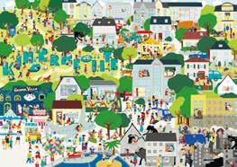
1.1.2. Activity procedure:
- Silent observation (30-45 seconds)
  - Project the image in silence. Say:
    - "Look at the image without commenting for now. Observe details, expressions, objects, relationships, and the environment."

- First impressions: What feeling does it convey?
  - Ask for quick, emotional responses:
    - "What does this image convey to you?"
    - "What do you think is happening?"
    - "What word comes to mind when you see it?"
  - Do not correct anything: collect all interpretations.

- Guided critical reading: Ask questions that connect with rights, equality, and coexistence
- "Who seems to be doing well in this scene and who doesn't?"
- "What signs make you think someone might need help?"
- "If you were part of this situation, how would you feel?"
- Optional: divide the group into pairs for a mini-reflection before sharing with the group.

- Connection with their adolescent reality: guide towards a familiar context
  - "Have you seen similar situations at school, in your group of friends, or on social media?"
  - "What usually happens when nobody says anything?"
  - "What could change if someone acted differently?"

- Collective construction of meaning
  - On the whiteboard, collect key concepts they mention (without explaining rights yet):
    - Respect – exclusion – inequality – pressure – support – silence – courage

Teacher's note

- Do not reveal yet which right is at stake; allow the adolescents to generate their own hypotheses.
- Normalise divergent interpretations: they are developing abstract thinking.
- Accept humour or distance as a natural mechanism, but redirect towards reflection.
- If something sensitive arises, validate without delving deeper: "Thank you for sharing that, we will keep it in mind as we continue analysing."

Activity 2: Identifying rights in real-life scenes (15 - 20 minutes).
A2
Materials
Printed or projected sheets. Visible list of Children’s Rights. Cards with short dilemmas.
Whiteboard or flipchart. Markers.

Objective:
      - To recognise which rights are involved in everyday situations.
      - To develop critical interpretation of ambiguous or complex scenes.
      - To connect visual scenes with real social experiences (friendship, social media, school coexis-tence).
      - To introduce the language of rights in a natural way.

1.2.2. Activity procedure:
- We observe the scenes
  - Project 2-3 scenes and ask the group to look at them carefully.
  - Guiding questions:
    - "What is really happening here?"
    - "Who has power in the scene and who doesn't?"
    - "What emotions do you detect?"
  - Allow different interpretations: it is part of the depth of the exercise.

- Initial identification: Which right could be at stake?
  - Show the list of Children’s Rights now.
  - Ask them to choose one or two rights they think are related to each scene.
  - Examples that may arise:

Right to equality Right to privacy
Right to good treatment
Right to be heard Right to participate Right to education

  - Question:
    - "Which specific part of the scene makes you think of that right?"

- Mini-debate in pairs:
  - Ask them to work in pairs and answer these questions:

Right Evidence Consequence

Which one do you think is respected or violated?
What detail demonstrates it?
What might the affected person feel or think?

  - Afterwards, share with the large group

- We introduce short dilemmas
  - Hand out cards with everyday situations, for example:






A student falls behind in their work because they do not have access to the same resources as others.

During an important class decision, only the most popular students speak.

A female student proposes an idea, but the group ignores her until another student says the same thing.
  - Ask them to choose which rights are involved and justify why.
  - You can use questions such as:
    - "What would have to change for this right to be respected?"
    - "Who could intervene and in what way?"

- We create a map of everyday rights
  - On the whiteboard, create a table with three columns:

Scene
Right involved
Evidence / Reason

  - Fill it with contributions from the group.
  - Close with a key idea:
    - "Rights are in situations as small as a conversation, a match, a photo, or group work."

Teacher's note

- Allow adolescents to connect spontaneously with their real world (friendships, social media, social dynamics).
- Avoid giving "correct answers": the important thing is the argumentation.
- Redirect if personal judgements appear: "Let's talk about situations, not people."
- If conflict arises between students, use it as pedagogical material while always maintaining emotional safety.

A3 Activity 3: Ethical dilemmas in everyday life (15 - 20 minutes).
Materials
Cards with ethical dilemmas related to adolescence Visible list of rights (for reference)
Chairs organised for debate in small groups or a "Socratic circle" Whiteboard to record conclusions

Objective:
      - Analyse ambiguous situations where several rights may be involved.
      - Develop critical thinking, argumentation, and active listening.
      - Recognise individual and collective responsibility.
      - Practise ethical decision-making in everyday contexts.

1.3.2. Activity procedure:
- Presentation of the dilemmas: "There is no single correct answer"
  - Explain to the group:
    - "We are going to analyse real-life situations from daily life. We are not looking for heroes or villains, but to understand which rights might be at stake and how we can make better decisions."
  - Hand out the dilemmas (or project them one by one).
  - Examples:

A student does not understand the topic but is ashamed to ask and no one notices.

A student tries to explain their point of view in a discussion, but they are interrupted or not taken seriously.

In a group project, some people decide everything and do not let the others participate.

They make 'jokes', but they are always about the same person and are no longer funny.

In a sports activity, they treat a teammate differently because of how they dress or where they come from.

A student reads out loud a private message from another person in front of the class.

- Analysis in small groups: right/conflict/options
  - Divide them into groups of 3–4.
  - Each group answers these three questions:
    - Which right/s are involved?
▫ (Privacy, Equality, participation, protection, good treatment, etc.)
    - Where does the ethical conflict appear?
▫ (Group power, social pressure, fear of rejection, inequality of treatment...)
    - What options would the affected person have?
▫ (Ask an adult, talk to the group, seek support, set boundaries...)
  - Ask them to write down brief ideas.

- Structured debate in the large group
  - Choose 2–3 dilemmas and open the dialogue.
  - Key questions:
    - "Why is this situation difficult to resolve?"
    - "What consequences does it have for each person?"
    - "What should carry more weight: protecting someone's right or following the group's opinion?"
    - "What makes someone decide to act or not to act?"
    - "If you were in that situation, what option would seem fairest to you?"
  - Remember: there are no single answers, but there are more solid arguments.

- Conclusions: building basic ethical principles
  - On the whiteboard, collect ideas arising from the debate.
  - Common examples:
    - We all deserve to participate.
    - Humour does not justify hurting someone.
    - Privacy matters.
    - Silence also affects the situation.
    - Helping is everyone's responsibility.
    - Equality begins with simple gestures.
  - Close with:
    - "These principles you have formulated connect with fundamental rights. Let's see how they work in other parts of the world."

Teacher's note

- Avoid moralising; encourage analysis and argumentation.
- Anticipate humorous or defensive comments: these are typical mechanisms for this age.
- If a dilemma arises that is too close to a real group conflict, redirect to more general levels to avoid personalising.
- Reinforce respectful interventions and active listening.

Day 2. Rights in the world (65 minutes)
A1
Activity 1: "What if...?" — Questions that awaken global awareness (10 - 15 minutes).
Materials
List of "What if...?" questions Whiteboard or flipchart paper Felt-tip pens
Classroom organised in small groups or a semi-circle

Objective:
      - Develop critical thinking from hypothetical scenarios.
      - Identify which rights are at stake in situations of global inequality.
      - Understand that rights are not experienced equally in all places in the world.
      - Prepare the group to analyse real stories of adolescents.

2.1.2. Activity procedure:
- Activation: we present the "What if...?" dynamic
  - Explain briefly:
    - "We are going to imagine situations that many adolescents in other parts of the world experience. We are not looking for perfect answers, but to reflect on how our lives would change if these things happened to us."

- We launch the key questions
  - Pose some of these questions at a steady pace:







What if you had to work before going to school?
What if you couldn't go to the doctor when you need to?
What if you had to walk for two hours to get to school?

What if you had to leave school to take care of your younger siblings?
What if you couldn't express what you think because it's dange-rous?

What if you had to change countries due to a conflict?

- Short group work: Impact/right involved/emotions
  - Hand out one question to each group or let them choose.
  - Ask them to respond to these three questions:

    - Practical impact:
▫ "How would your daily life change if this were real?"
    - Right involved:
▫ "Which right would be violated?"
    - Emotions:
▫ “How would you feel if you were that person?”
  - Give them 2–3 minutes to think and write down brief ideas.

- Plenary: contrast of experiences
  - Ask each group to share their reflection out loud.
  - Highlight differences and similarities between questions:
    - Some violate basic rights (health, education, protection).
    - Others affect equality, participation, or freedom of expression.
  - All generate intense emotions: frustration, fear, injustice, tiredness, helplessness.
  - Close this section with a transition phrase:
    - "Now that we have imagined these scenarios, we are going to get to know real stories of adolescents living in similar situations."

Teacher's note
- Prevent the activity from becoming a competition of "which is worse"; keep the focus on rights and empathy.
- Normalise intense emotional reactions.
- If the group disperses, return to specific questions: "Okay, but how would this affect your health? Your opportunities? Your future?"
- This exercise prepares emotionally and cognitively for the real narratives in the next exercise.

Activity 2: Real stories of adolescents from around the world (20 - 25 minutes).
A2

Materials
Real stories (printed or projected) Individual analysis sheets
Visual list of rights (optional)
Classroom prepared for reading in pairs or small groups

Objective:
      - Learn about the diverse realities of adolescents in different countries.
      - Identify which rights are respected or violated in each story.
      - Reflect on structural causes: poverty, conflict, gender inequality, migration.
      - Develop empathy, global awareness, and critical thinking.
      - Contrast their daily life with that of other young people in the world.

2.2.2. Activity procedure:
- Introduction to real narratives
  - Tell them:
    - "Now we are not going to imagine... we are going to get to know real stories of boys and girls your age. They are different lives, but we all share the same rights."
  - Explain that it is not about judging countries, but about understanding contexts.

- Reading stories in pairs or groups of 3
  - Hand out 3–4 different stories (for example):

- Ask them to read and underline:
  - Main problem
  - Details that show inequality
  - Emotions of the protagonist

- Critical analysis sheet
  - Each group fills in a sheet with four key questions:

  - Allow 5–7 minutes to prepare answers.


Critical analysis sheet
What is happening? | Which right/s are violated? | What could be the causes? | How do you think the person feels?
(concrete facts) | (education, health, protection, participation, equality, housing, freedom...) | poverty, war, inequality, culture, lack of resources, discrimination... | frustration, fear, tiredness, injustice, hope...

- Plenary
  - Each group briefly presents its story. Record on the whiteboard:
    - Name of the protagonist
    - Country
    - Main right affected
    - Key causes
  - Ask probing questions:
    - "Which part of this story impacted you the most?"
    - "What opportunity is this person losing?"
    - "What would need to change for this right to be fulfilled?"
    - "What things do we take for granted that these people do not have?"

- Comparative closure: "My day vs. their day"
  - Ask for a final reflection:
    - "Imagine your normal day... what things can you do because your rights are protec-ted?"
  - Allow 1–2 voluntary interventions.
  - Close with a transition phrase:
    - "Rights do not only protect individuals: they need systems, resources, and collective decisions. In the next activity, we will analyse why these inequalities occur."

Teacher's note

- Avoid falling into discourses that generate guilt; use the term "privileges" with sensitivity.
- Explain that the intention is not to compare who suffers more, but to understand contexts.
- If any stereotype arises, redirect: "Let's talk about structural causes, not cultures."
- This activity creates a strong emotional impact; validate emotions and maintain a supportive tone.

Activity 3: Critical analysis — Causes and consequen-ces (local and global) (20 - 25 minutes).
A3
Materials
Critical analysis templates (causes/consequences/actors/rights) Whiteboard or collaborative digital tool
Cards with key concepts (Printable Material) Stories worked on in A2. Real stories

Objective:
      - Understand that rights violations do not happen by chance: they have deep causes.
      - Differentiate between personal causes and structural causes.
      - Analyse how social, economic, and political decisions affect the lives of adolescents.
      - Develop critical thinking and argumentation skills.
      - Connect global inequalities with local challenges in the school or community environment.

2.3.2. Activity procedure:
- Activation: "Why does what happens, happen?"
  - Explain to the group:
    - "Now that you know real stories, we are going to analyse why these situations occur. We are not going to look for individual culprits, but to understand the mechanisms that affect rights."
  - Initial questions:
    - "Can a rights violation have several causes?"
    - "Are they always visible or do some go unnoticed?"

- Presentation of the analysis template
  - On the whiteboard or projector, show four columns:
    - Causes (What is happening and why?)
    - Consequences (What effects does it have?)
    - Actors involved (Who participates directly or indirectly and what do they feel?)
    - Rights affected (Which rights are violated?)
  - Students will use this structure to delve deeper into their assigned story.

- Small group work: breaking down the story
  - Each group takes the story they analysed in A2 (the previous one) and responds:

What is happening and why?

- Economic: poverty, lack of resources, unemploy-ment
- Social: inequality, discrimination, cultural norms
- Political: conflict, lack of laws, corruption
- Family: early responsibili-ties, migration, illness
What effects does it have?
In education, health, emotional well-being, future career, relations-hips...
Who participates directly or indirectly and what do they feel?
Family Community Government Companies Organisations
International Community
Which rights are violated?

Choose one or several.

  - Give them 6–8 minutes to complete it.

- Plenary: comparison between stories
  - Each group shares a key cause and a main consequence.
  - On the whiteboard, create a comparative table:

Country | Main cause | Main consequence | Right affected |

  - Reinforce common patterns:
    - Many problems are due to lack of resources, discrimination, conflict, distance from school, or labour burden.
    - Several consequences affect the future, education, mental health, or equality of oppor-tunity.

- Local connection: "Does something similar happen here?"
  - Ask questions to link global reality with the students' lives:
    - "In your environment, are there inequalities that affect certain classmates?"
    - "Are there people who have fewer opportunities? Why?"
    - "What decisions from the centre, the neighbourhood, or families influence these situa-tions?"
  - The goal is not to compare suffering, but to detect patterns of inequality.

- Conclusion: building a critical framework
  - On the whiteboard, write key ideas that emerged:
    - Rights depend on social conditions.
    - Inequalities are not an individual's fault.
    - The lack of rights has knock-on effects.
    - Education and participation help to transform them.

  - All young people have power of agency in their environment.
  - Close with this idea:
    - "Understanding the causes is the first step to changing them. And change also starts in small places: in the school, in the group, in your environment."

Teacher's note

- Avoid discussions that simplify complex contexts ("that country is bad", "that family doesn't care").
- Redirect towards structural explanations, with a critical and respectful focus.
- If a comparison with sensitive group realities arises, contain and reorient:
  - "I appreciate what you are sharing. Let's keep the reflection on how to improve the environment."
- Prepare emotionally for Day 3, where solutions and actions will be worked on.

Day 3. Support network (65 minutes)
A1
Activity 1: School centre diagnosis — “Which rights are lived here?” (15 - 20 minutes).

Materials
Cards or large list of Adolescents' Rights Observation sheets for students
Whiteboard or flipchart paper to create the “Centre's Rights Map” Classroom organised in a circle

Objective:
      - Analyse how rights are respected or violated within the school centre itself.
      - Develop critical observation of real dynamics: coexistence, participation, equality, well-being.
      - Recognise strengths and areas for improvement in the educational environment.
      - Prepare students to design proposals for action.

3.1.2. Activity procedure:
- Activation: “Bringing rights into our daily lives”
  - Brief Introduction:
    - “In previous days we talked about rights in imagined scenarios and in places around the world. Today it is time to look at our own environment: how are rights lived here, in our centre?”
  - Show the list of rights and explain that they will use them as an analytical lens.

- Guided observation of the centre (Individual or in pairs)

  - Hand out the observation sheet with questions such as:
Rights in my school
harassment?
18

Is the right to participation respected? | The right to equality? | The right to good treatment? | The right to play and rest?
Can students give their opinion? Are they listened to? | Are there excluded groups? Is everyone treated equally? | What are the interactions between peers and with teachers like? | Are they safe and accessible spaces?
The right to education? | The right to protection?
Does the centre feel like a safe place to learn? | What mechanisms exist to avoid situations of risk or

  - They can analyse: classrooms, corridors, break time, canteen, entrance/exit, toilets.
  - Give 5 minutes for light observation from their seat or by recalling recent experiences..

- Group work: we choose 3 key rights
  - Form groups of 4–5 and ask them to choose three rights:
    - One they believe is respected.
    - One that is sometimes yes, sometimes no.
    - One that needs to improve.
  - Each group writes:
    - Concrete evidence
    - Moments or places where it occurs
    - How it affects student well-being

- Construction of the “Centre's Rights Map”
  - On the whiteboard or flipchart paper, draw three columns:

Respected
Sometimes
Needs to improve

- Each group places its observations..
  - This generates a visual map of:
    - Centre strengths,
    - Inconsistencies,
    - Real challenges.
  - Observe if patterns appear:
    - “right to be listened to” in “needs to improve”
    - “good treatment” in “sometimes”
    - “Equality” in different columns
    - “participation” as a common challenge
    - “rest/play” as a rarely discussed right

- Debate: Why do some things work and others do not?
  - Launch questions:
    - “What makes a right be respected in some places and not in others?”
    - “Who has the power to improve these points?”
    - “What small actions are already working and could we strengthen?”
  - Allow short and respectful interventions.

- Diagnostic closure: we choose priorities
  - To prepare for the next activity, ask the group to choose 1–2 priority rights to work on real proposals for improvement.
  - Closing example:
    - “These are the rights we want to improve in our centre. Now we are going to think of real actions to make it possible.”

Teacher's note

- Ensure the session does not turn into complaints towards the centre or specific people.
- Redirect towards behaviours and dynamics, not individuals.
- If a sensitive social discussion arises, validate and redirect:
  - “What you're pointing out is important. Let’s think about how to transform it constructively.”
- This activity is excellent as a formative assessment and starting point for improvement proposals..

Activity 2: Design of improvement projects — “Our school with more rights” (25 - 30 minutes).
A2
Materials
Large cardboards or flipchart paper Felt-tip pens, pencils, colours, stickers Adhesive tape to display posters
Guide template with 4 sections (Right / Problem / Action / Impact) Space to work in groups of 4–6 students

Objective:
      - Transform the centre's analysis into real proposals.
      - Develop creative, cooperative thinking oriented towards solutions.
      - Understand that rights require concrete actions and participation.
      - Foster a sense of responsibility and active citizenship.

3.2.2. Activity procedure:
- We retrieve the “Centre's Rights Map”
  - Project or place the map created in the previous activity.
  - Ask brief questions:
    - “Which right appears most in ‘needs to improve’?”
    - “Is there a right that affects several areas of the centre?”
    - “Which right would you truly like to improve?”
  - Each group chooses one of those rights as the focus of their project.

- Explanation of the project mission
  - Each group will design a proposal that responds to four questions:


Centre's Rights Map

Which right do we want to improve?
What problem exists in the centre related to this right?
What action can we propose to improve this situation?
What impact would it have?

Choose one or several
- Lack of participation in class
- Closed groups or exclusions
- Unsafe break-time spaces
- Low visibility of student opinions
- Lack of respect at certain times
- Canteen organisation
- Unsupervised zones
- Create an “Ideas Box” for participation
- Organise mixed or rotating tables in the canteen
- Signpost break-time zones
- Propose student mediators
- Run “good treatment” campaigns
- Create a student rights committee

  - More participation
  - More equality
  - Fewer conflicts
  - More safety
  - Better coexistence

- Guided Brainstorming (5–7 minutes)
  - Groups generate proposals.
  - Guide with questions:
    - “Which solution would be truly useful?”
    - “What can we students do without depending entirely on adults?”
    - “What would we need for it to work?”
    - “What obstacles might we find?”
    - “Who would benefit from this action?”
  - Ensure all voices in the group participate.

- Creation of the project poster
  - Each poster must include:

Right to be listened to

- Right chosen
- Problem detected
- Proposed action
- Expected impact
- A slogan or group phrase
  - Examples:
    - “Your voice counts here.”
    - “Safe break times for everyo-ne.”
    - “Respect: the basis of our coexistence.”
    - “Equality in every corner of the centre.”
    - “To participate is to change.”
Sometimes
- Decisions are made without counting on everyone.
- Some opinions are ignored or ridiculed.
- There is a fear of speaking for fear of teasing or punishments.
- The same people always speak.
Expected impact:
- Everyone feels valued and respected.
- Coexistence in the group improves.
- There is more participa-tion and better ideas.
- Confidence and mutual respect increase.
Solutions:
- Listen without interrup-ting when someone speaks.
- Respect all opinions, even if we don't agree.
- Create speaking turns in class or in a group.
- Encourage those who speak less to participate.

“Speaking and listening unites us.”

  - Foster visual creativity: colours, drawings, symbols, icons.

- Classroom exhibition (1–2 minutes per group)
  - Each group presents its project to the rest. Probing questions:
    - “How would this idea work in practice?”
    - “What would you need to get it started?”
    - “What concrete problem would it solve?”
    - “Which year group, space, or moment would it affect most?”
  - Reinforce active listening and respect.

- Creation of the “Rights in Action Wall”
  - Posters are placed on a visible mural in the classroom or corridor.
  - Say: “These proposals are our group's commitment to improving how we live our rights in the school.”
  - Optional: Hold a vote to choose the most viable action and present it to the centre.

Teacher's note

- Prioritise the creation of realistic and applicable proposals.
- Avoid the activity centring on complaints towards the centre: redirect towards solutions.
- Validate emotions and concerns without delving into personal cases.
- You can use these proposals as a basis for a termly project or a coexistence plan.
- It is ideal for evaluating citizenship and coexistence competencies.

Activity 3: Final debate + commitment — “Which right is essential for me?” (10 - 15 minutes).
A3

Materials
Classroom in a circle
Individual rights cards (optional) Whiteboard for a word cloud Commitment sheet (optional)

Objective:
      - Integrate the learning from the module from a personal perspective.
      - Encourage emotional expression, critical thinking, and awareness.
      - Recognise that rights are not abstract: they influence the real lives of students.
      - Generate a sense of community, responsibility, and empowerment.

3.3.2. Activity procedure:
- Emotional activation: “What we have learned together”
  - Guide the group:
    - “We have spent three sessions analysing rights in our lives, in the world, and in our school. Now it’s time for something more personal: deciding which right is especially important to you.”
  - Have a joint breath together to focus attention.

- Choosing the right (with cards or mentally)
  - Options:
    - Hand out cards with different rights.
    - Project them on the whiteboard.
    - Or let each student choose it mentally.
  - Guiding questions:
    - “Which right makes you feel most protected?”
    - “Which one makes a real difference in your daily life?”
    - “Which right would you like to be always respected for all adolescents in the world?”
    - “Which one would you like to promote in your environment?”
  - Give them a few seconds for reflection.

- Voluntary participation round: expressing meaning
- Each student (only if they wish) shares briefly:
▫ “The most important right for me is because...”
▫ “This right helps me when...”
▫ “I would like this right to be more respected because...”
- To promote depth, ask:
  - “What would happen if this right were missing from your life?”
  - “What did this module teach you about that right?”
- Do not force anyone; validate every intervention.

- Collective construction: closing word cloud
  - On the whiteboard, collect the key words that emerge:
    - Safety – Freedom – Equality – Trust – Justice – Respect – Well-being – Participation – Emotions – Friendship – Hope – Protection – Voice – Opportunity
  - When the cloud is created, say:
    - “All these words summarise what rights mean to you. They are a reflection of what you value and want to protect.”

- Final commitment (symbolic or written)
  - Offer several options:

Option 1
Group oral commitment.

Everyone places their hand in the centre and says:

“We commit to looking after our rights and those of others.”

Option 2
Individual written commitment

On a card or post-it:

“From today, I commit to promoting the right to in my environ-ment.”

Option 3
Silent commitment.

Raising a thumb when they feel they are ready to take on that commitment.

- Module closure
  - Conclude with an inspiring phrase:
    - “Rights are not just written rules: they live in our decisions, in how we treat others, and in how we defend justice. Each of you has the power to make these rights be fulfilled a little more every day.”

Teacher's note

- Maintain a safe and pressure-free atmosphere.
- Do not delve into sensitive personal stories; acknowledge the emotion and move on.
- Observe which rights they choose: it is a very valuable qualitative assessment.
- You can revisit these commitments in future tutorials or coexistence sessions.

Complementary activities
AC1
Activity 1: “Map of Everyday Injustices” (20-25 minutes).

Objective:
Materials
Small cards or post-it notes Markers
A whiteboard or roll of paper for creating the map
Visual examples of micro-injustices (optional)
      - Identify everyday situations that violate rights in a subtle or normalised way.
      - Develop critical thinking regarding inequalities present in the school and social environment.
      - Reflect on forms of participation and defence of rights.
      - Promote empathy and collective responsibility.

4.1.2. Activity procedure:
- Activation: What is a micro-injustice?
  - Explain briefly:
    - “A micro-injustice is a small, everyday situation that may seem ‘normal’, but which affects someone’s rights.”
  - Common examples:
    - Not letting someone participate because “they always take too long”.
    - Making jokes about a classmate’s appearance or accent.
    - Ignoring someone’s opinion in group work.
    - Recording without permission.
    - Distributing turns unfairly.

- Individual work: “Write down a micro-injustice you have seen”


  - Each student writes down a situation they have observed (do not personalise, no names for anyone).
Constantly comparing grades, bodies, or popularity.
A classmate is called by a nickname they do not like.
  - They can choose:
    - Classroom,
    - Break Time,
    - Social Media,
    - Community,
    - Sports Activities.


Minimising the fear or sadness of another person.
Ignoring an idea until someone else says it.
“Harmless” comments that hurt.
Some never choose what to do because “it’s already decided”.

- Classifying on the “Map of Everyday Injustices”
  - On the whiteboard, create categories:

| Participation | Equality | Privacy | Good treatment | Justice | Protection |

  - Each student places their card where they think it belongs.

- Guided debate: Why do they happen? How do they affect us?
  - Key questions:
    - “Why do you think these situations happen so often?”
    - “What emotions do they generate in the affected person?”
    - “Which right is violated in each case?”
    - “What could an observer do to improve the situation?”

- Closure: choosing a mini-commitment
  - Each student selects a micro-injustice from the map and proposes an individual action:
    - “Listen more.”
    - “Not laughing at hurtful jokes.”
    - “Inviting others to participate.”
    - “Not recording without permission.”
    - “Helping when someone is alone.”

Teacher's note

- Ensure no one points out specific classmates.
- Emphasise that the goal is to transform the environment, not to judge people.
- This activity is ideal for tutorials, coexistence, and ethics education.

AC2

Objective:
Activity 2: "Rights Tribunal (25 -30 minutes).

      - To develop argumentation skills, oral expression, and critical thinking.
Materials
Cards with brief cases
Role cards: lawyer, rights representative, student, teacher, observers
Rights posters
Chairs to set up the "tribunal"
      - To understand conflicts between different rights.
      - To practice informed decision-ma-king.
      - To promote respect for different opinions and active listening.

4.2.2. Activity procedure:

- Presentation of the "tribunal"
  - Explain that each group will analyse a case and must answer:
    - Which right is in conflict?
    - Which decision would be the fairest?
    - Which arguments support that decision?

- Allocation of roles in each group
  - Lawyer for the right: defends the affected right.
  - Involved student: explains their version.
  - Teacher: provides the school context.
  - Observers: evaluate arguments and propose improvements.

- Brief cases (choose 2-3):





Case 1
Privacy.
Case 2
Equality
A student records a video in class without permission and uploads it to social media.
In PE, a group always excludes the same person.
Case 3
Freedom of expression vs. respect.
Case 4
Protection.
A student gives their opinion in class, but others laugh at them or dismiss it.
A boy receives offensive messages in a private
group.
Case 5
Participation

In a group project, two people decide everything without consulting the others.
27


- Mini-trial: each group presents its case
  - The "tribunal" responds:
    - Which right was violated?
    - What should be done to rectify the situation?
    - Who should intervene?
    - What preventative actions can we take?

- Final vote: which decision is the fairest?
  - Each group votes between:
    - Solution A
    - Solution B
    - Solution C
    - Other proposal (created by the group)

- Reflective closure
  - Final questions:
    - "Is it easy to decide what is fairest?"
    - "What did we learn about responsibility and coexistence?"
    - "What would you do differently if you experienced one of these cases?"

Teacher’s Note

- Avoid it becoming a real trial between students.
- Keep the focus on argumentation, not on guilt.
- You can record the "mini-trials" for later reflection (if the school permits).

28

Material Checklist - All Activities
Day 1: Rights of life

  - Hidden image + critical reading
Printed or projected images. Whiteboard or panel to collect ideas. Felt-tip pens.
Classroom arranged in a circle or semi-circle.
  - "Which rights do you see here?"
Picture (image).
Visible list of children's rights. Brief dilemma cards.
Whiteboard or flipchart. Felt-tip pens.
  - Rights dilemmas in daily life
Cards with daily dilemmas (social media, friendships, classroom, coexistence).
Role cards (optional). Chairs to form small groups. Whiteboard for conclusions.
Day 2: Rights in the world

  - "What if...?" – Problem-solving questions
List of "What if...?" questions. Whiteboard or flipchart.
Felt-tip pens.
Space for small group work.

  - Real stories of teenagers around the world
Printed or projected real stories. Individual case analysis sheets.
Brief visual rights dictionary (optional). Classroom prepared for group reading or
station work.
2.3 Session closure
Critical analysis templates. Whiteboard or digital tool.
Felt-tip pens or devices for collaborative work.
World maps (optional).
Key concept cards: discrimination, poverty, conflict, migration, gender inequality, access to resources.

Day 3: Support network

  - "Which rights are lived here?"
List or cards of children's rights. Observation sheets for students.
Whiteboard/flipchart to create the "School Rights Map".
Felt-tip pens.
  - "Our school with more rights"
Large card or A3 paper for projects. Felt-tip pens, pencils, colours, stickers. Adhesive tape for display.
Guide template with 4 blocks.
Space to work in groups of 4-6 students.

  - Role-play: Practising how to help
Scenario cards (1 per group). Clear space for acting.
Note sheets (optional).

  - "Which right is essential to me?"
Circle of chairs.
Individual rights cards (optional). Whiteboard for final word cloud. Personal commitment sheet (optional).
Complementary activities

  - "Map of Everyday Injustices"
Small cards or post-its (min. 1 per student). Felt-tip pens or pens.
Large flipchart or whiteboard. Adhesive tape (if using post-its).
Visible list of Children's Rights. (Optional) Images or visual examples of micro-injustices.
(Optional) Cards categorised by type.

  - "Rights Tribunal"
Cards with brief cases (2-5 lines per case). Role cards (explained in the activity).
Posters with the main Children's Rights. Chairs to organise the "tribunal space". Stopwatch or visible clock.
(Optional) Evaluation sheet for observers. (Optional) Symbolic judge's gavel. (Optional) "Case 1", "Case 2" posters, etc.

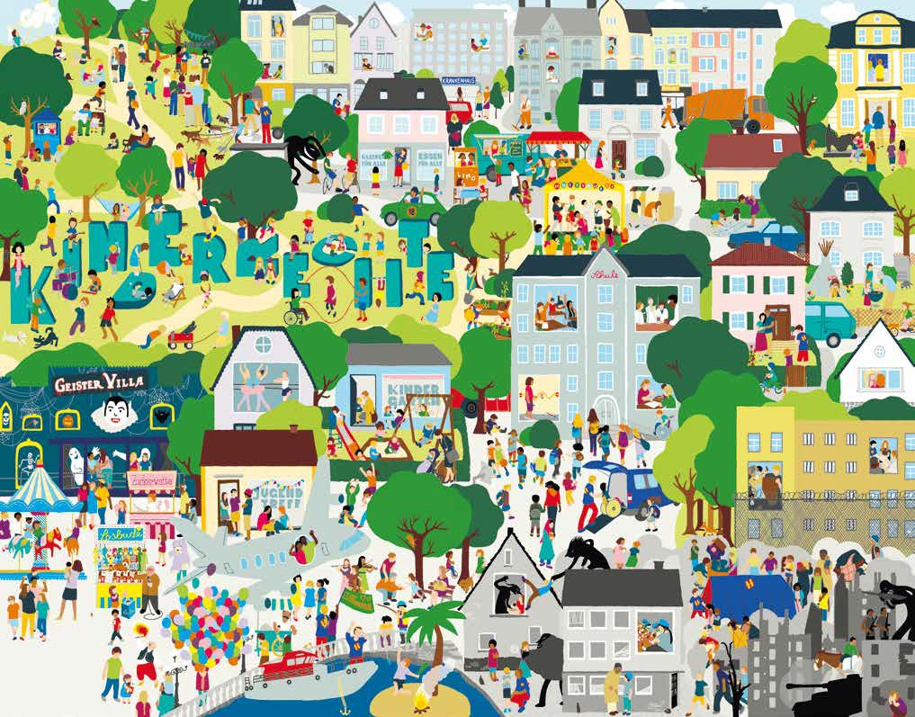
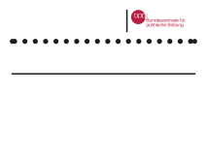
FaClhteilrdrKeinn'dseRrirgehcths te
AuMfadniyescehmildrBeilnd's vriegrhsttseacrkeehnidsdicehnvinietlheisKiminadgeerr. echte. FinCdaensytoduufinside?th(eAmufl?ö(SsoulnutgioanuofndtehreRbüacckks)eite)
——ZLeeicgheennderklärung
Die „Helferinnen und Helfer“ (sozialpädagogische
FacThhkerä"fhtee, tlpheerrasp" e(suoticsciahel swFoacrkhepresr,stohnealr,aFpacishtks,räfte
derTShoezyialceannArbbeeiti)dsetenhtiefinefdürbstyaathtliech"He "Uontnertshteütirzung. Erkte-nshnibrtasr.an dem „H“ auf ihren T-Shirts.
social workers) represent state support.
Printable Day 1 Activity 1: Hidden Picture
31

A B C D

E F G H

I J K L

M N O P

Printable Day 1 Activity 2: List of Rights
Right to equality Right to privacy
Right to good treatment Right to be heard Right to participate Right to education

Printable Day 1 Activity 2: Brief Dilemmas

In class, the same people are always chosen to represent the group, and others are never given the opportunity.

A classmate shares a photo of another person in the group without asking first.

On social media or in class, they make comments that ridicule a classmate and make them feel bad.

A student tries to explain their point of view in a discussion, but they are interrupted or not taken seriously.

In a group project, some people decide everything and do not let others participate.

A student does not understand the topic but is ashamed to ask, and nobody notices.

During a sports activity, they treat a classmate differently because of how they dress or where they come from.

A student reads out loud a private message from another person in front of the class.

They make "prank" jokes, but always about the same person, and they are no longer funny.

A female student proposes an idea, but the group ignores her until someone else says it.
During an important class decision, only the most popular students speak.
33

A student falls behind in their work because they do not have access to the same resources as others.

Printable Day 2 Activity 1: What if...?

What if you had to work before going to school?

What if you couldn't go to the doctor when you need to?

What if you had to walk for two hours to get to school?

What if you had to leave school to care for your younger siblings?

What if you couldn't express what you think because it's dange-rous?

What if you had to move countries due to a conflict?

What if you didn't have internet access to do homework or learn?

What if you were discriminated against because of your lan-guage, gender, or culture?

What if you couldn't go to school every day?

What if there was no adult to care for you when you are ill?

What if others decided important things for you?

What if nobody defended you when you need it?

Printable Day 2 Activity 2: Real Stories
Bangladesh
Amina works in a factory to help her family.
Vietman
Linh must leave school to care for her siblings.
Ethiopia
Dawit takes more than two hours to get to school.
Syria
Ahmad is displaced due to an armed conflict.
Bolivia
Sofía is discriminated against for speaking another language.
Turkey
Eren cannot give his opinion freely in his environment.
Ukraine
Olena follows online classes but sometimes cannot connect due to power cuts.
México
Valeria misses’ school some days because there is no water in her community.
Greece
Amir lives in a shelter and does not know if he can continue his studies.
Brazil
Lucas cannot play outdoors due to violence in his neigh-bourhood.
Argentina
Martina feels constant pressure on social media, affecting her self-esteem.
Chile
Camila is not listened to when she reports sexist comments in class.
Francia
Sami is excluded from activities for not being fluent in the language.
USA
Jordan fears expres-sing his ideas for fear of online attacks.
Spain
Yassin suffers online bullying because of his origin and stops participating in class.

Critical analysis sheet
Printable Day 2 Activities 2 and 3: Critical Analysis Template

What is happening? | Which right/s are violated? | What could be the causes? | ¿Cómo crees que se siente la persona?
36

Printable Day 2 Activity 3 – Key Concept Cards

Social in-equality

Armed con-flicts

Freedom of expression

Impact of climate change
Emotional wellbeing and mental health

Poverty

Child labour

Cultural and linguistic dis-crimination
Migration and forced displace-ment

Access to education

Digital divide

Right to par-ticipation

Child protec-tion

Access to healthcare

Social exclu-sion

Rights in my school
Printable Day 2 Activity 3: Observation Date
38

Is the right to participation respected? | The right to equality? | The right to good treatment? | The right to play and rest?
The right to education? | The right to education?

School Rights Map
Printable Day 3 Activity 2: Guide template

Which right do we want to improve? | What problem exists in the school related to this right? | What action can we propose to improve this situation? | What impact would it have?
39

Printable Complementary Activity 1: Micro-injustices

Distributing tasks without including those who are absent.

Reading other peo-ple's messages "out of curiosity".

Saying "it's not a big deal" when someone expresses how they feel.

Ignoring an idea until someone else says it.

Minimising the fear or sadness of another person.

It is assumed that someone won't know how to do something "because they always make mistakes".

Interrupting someone every time they try to speak.

"Well-intentioned" comments that hurt.

Excluding someone from a group chat without explanation.

Mocking someone when they ask an "obvious" question.

Leaving someone out of an online work group.

Constantly comparing grades, bodies, or popularity.

Calling a classmate by a nickname they don't like.

Sarcastic comments that hurt.

Some people never get to choose what to do "because it's already been decided".

Printable Complementary Activity 2: Roles
LAWYER
STUDENT
TEACHER
OBSERVER

Printable Complementary Activity 2: Brief Cases
Case 1
Privacy.
A student records a video in class without permis-
sion and uploads it to social media.
Case 2
Equality
In Physical Education (PE), a group always
excludes the same person.
Case 3
Freedom of expression vs. respect
A student gives their opinion in class, but others
laugh at them or dismiss it.
Case 4
Protection
A boy receives offensive messages in a private
group.
Case 5
Participation.
In a group project, two people decide
everything without consulting the others.


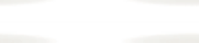




Erasmus+

Enriching lives, opening minds.

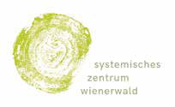
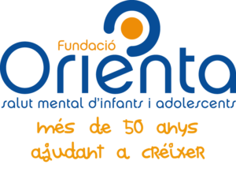

Carl von Ossietzky

Universitat Oldenburg



e.V.

