Workshop “Bullying”
Teacher's Guide

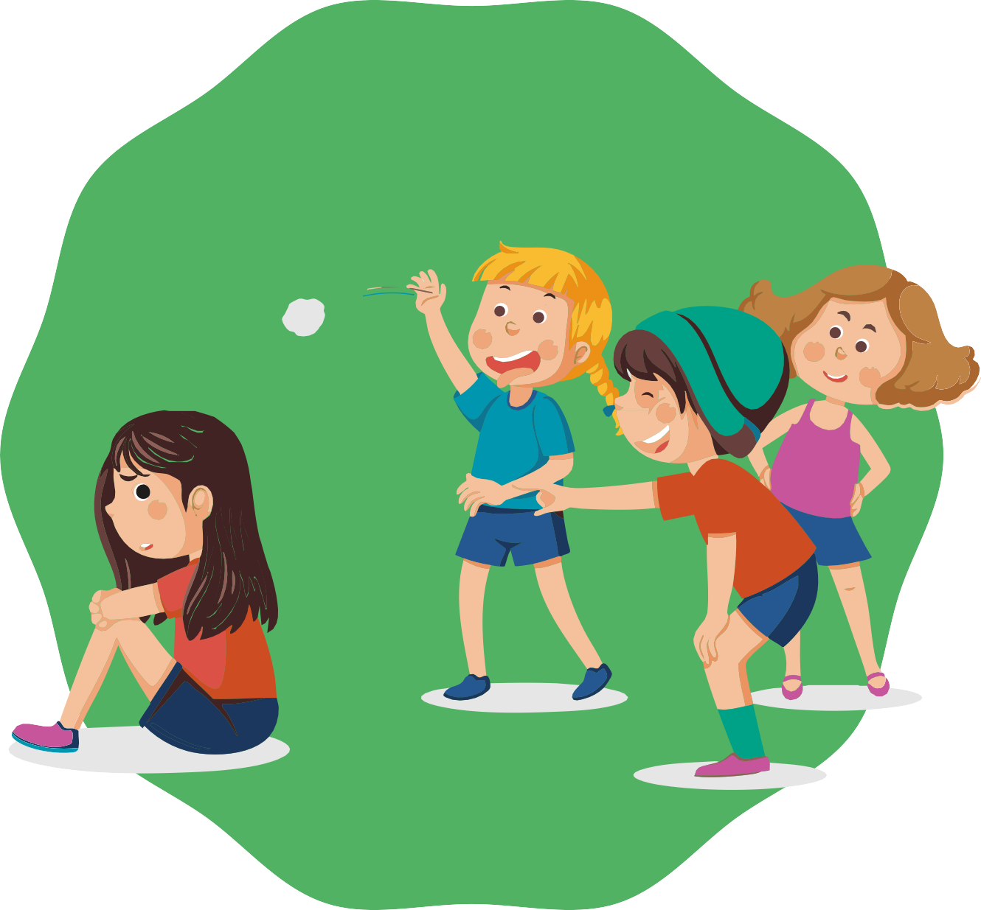

Primary School

INDEX
- Introduction and objectives 3
- Key points for the teacher 4
- Day 1
  - Activity 1: Introduction and presentation 5
  - Activity 2: Introduction round – Positive qualities 6
  - Activity 3: Movement game – "All those who..." 7
  - Activity 4: Movement game – "Yes / No" 8
  - Activity 5: Input – What is bullying? 10
  - Activity 6: Story "I don't want to go on the school trip" – Identifying roles in bullying 12
  - Activity 7: Body silhouettes – Emotions and consequences of bullying 14
  - Activity 8: Letter to families – Sharing what we have learnt 16
- Day 2
  - Activity 1: Review circle – Remembering the previous day 18
  - Activity 2: Activation game – The imaginary ball 19
  - Activity 3: Debate on family questionnaires 20
  - Activity 4: Brief input – What is cyberbullying? 22
  - Activity 5: Game – "Common Messages" 24
  - Activity 6: Debate – Golden Rules for the Internet (STOP – BLOCK – TELL) 26
  - Activity 7: Anti-Bullying strategies – Class Agreement 28
  - Activity 8: Closing circle – "The plate of compliments" 30
- Supplementary activities
  - Activity 1: The anonymous message box 32
  - Activity 2: The web of trust 33
- Printable materials and resources
  - Materials checklist per session 34
- Day 1
  - Activity 4: Movement game – "Yes / No" 36
  - Activity 6: Story "I don't want to go on the school trip" 38
- Day 2
  - Activity 5: Game – "Common Messages" 39
  - Activity 6: Debate – Golden Rules for the Internet (STOP – BLOCK – TELL) 43
  - Activity 8: Closing circle – "The plate of compliments" 46

INTRODUCTION
Bullying and cyberbullying significantly affect the school and emotional lives of children. This module is designed to raise awareness, identify roles, and generate collective strategies that allow students to understand what bullying is, how it manifests, and what they can do to prevent or address it.

Throughout the sessions, students will engage in games, group dynamics, stories, and debates that help them recognize the impact of words and actions both in the classroom and in digital environments. The module seeks to strengthen empathy, shared responsibility, and group cohesion, while offering a safe space to talk about their experiences and reflections.
Objectives

- Understand what bullying is through a clear scientific definition (Olweus) and distinguish it from isolated conflicts.
- Identify the roles in bullying (victim, perpetrator, followers, bystanders, defenders, and the role of the group/class).
- Recognize the emotions and consequences experienced by people involved in bullying situations.
- Reflect on the impact of cyberbullying, its specific characteristics (anonymity, availability, reach, and simplicity), and its emotional and legal consequences.
- Develop prevention and response strategies, both individually and collectively, by creating a class pact.
- Promote a climate of respect and trust, where positive messages and mutual recognition strengthen group cohesion.

The ideas we share in this workshop are simply suggestions on how you might use the material. Feel free to adapt it to your needs: you can divide the workshop into two parts,
spread it over several days, or complete it all in one session — whatever works best for you. You know your students and what suits them best.

Likewise, the materials can be used either in printed or digital format, depending on what is most convenient for you.

Expected results module 5

Key words
- Basic emotions
- Empathy
- Friendship
- Coexistence
- Respect
- Diversity
- Caring words
- Listening
- Mutual aid
- Conflict resolution
- Feeling safe
- Strengthening the group
- Kindness (Buen trato)
- Self-care
- Co-operative games

By the end of this module, it is expected that students will recognise the importance of kind-ness in school coexistence, develop skills to interact based on respect and empathy, and feel like an active part in the creation of a safe and welcoming classroom.

Key Guidelines for Teachers

- Create a safe environment: remember that talking about bullying may bring up personal experiences. Avoid putting a student in the role of victim or aggressor; always use symbolic resources (doll, cards, stories).
- Use fictional or anonymous examples: this helps to foster understanding without pointing to real cases in the class.
- Observe the group carefully: pay attention to silences, nervous laughter, or reactions that may reveal hidden experiences.
- Manage time and energy: alternate reflective activities with movement-based ones to maintain attention.
- Involve families: through the letter home or by sharing conclusions, encourage discussions about bullying to continue in the family environment.
- Positive reinforcement: close activities with recognition and support dynamics so that students leave with a constructive group experience.
- Important: emphasize that cyberbullying is not a trivial matter; it has serious consequences and can be a criminal offense. It is essential to teach students that they are not alone, that they must speak to a trusted adult, and that it is useful to save evidence (screenshots, messages, photos) in case of a report.


Day 1. Bullying in General (2h total duration)
A1

Activity 1: Introduction and Presentation
(Approximately 5 minutes) Adapt it to the pace and needs of your group.

Objective
Materials
Classroom with chairs arranged in a circle.
Blackboard/flipchart (optional).
      - Welcome the group and explain the proce-dure of the workshop.
      - Create an atmosphere of trust and openness.
      - Introduce the topic of school bullying.

Steps to facilitate the activity:
      - Arrange all the chairs in a circle.

      - Explain how the workshop will be conducted:
        - It indicates that there will be activities, debates, breaks and a space for questions or comments.
        - Reinforce that the space is safe to share ideas and opinions, always with respect.

      - Introduce the topic:
        - “Today we are going to work on how we want to treat each other in the class and what school bullying means.”

      - Ask the key question and present the definition:
        - “What is bullying?” and share Dan Olweus’ definition (repetition, duration, and imbalance of power).

      - Launch a brief reflection:
        - “Can bullying make someone sick?”

Note for the teacher:
- Keep the explanation short and clear to quickly move on to the activities.
- Validate all initial answers and use a friendly tone that encourages participation (without adding new content at this stage).
- If you detect confusion about the definition, remember that it will be expanded in the later input activity. (The full definition will be worked on later).


Activity 2: Introduction Round – Positive Qualities
“I’m Alan”
“I’m a good friend”,
“I’m enough, just as I’m”
“I deserve respect”
6
A2
(Approximately 10 minutes) Adapt it according to the number of students.

Objective
Materials
Space to maintain the circle of chairs.
      - Encourage integration and participation from the beginning.
      - Recognize and value positive personal quali-ties.
      - Create an atmosphere of trust that makes it easier to talk about sensitive topics such as bullying.

Steps to facilitate the activity:
      - Explain the instruction:
        - “Now we are going to introduce ourselves in a special way. Each person will say their name and one positive quality they think they have. It can be something they are good at, a characteris-tic of their personality, or something they like about themselves.”
          - Examples: “I am Marta and I am a good friend,” “I am Alex and I am good at drawing.”

      - Model the dynamic: start yourself as the teacher to set the example, sharing your name and a real positive quality.

      - Carry out the complete round: the turn goes around the circle until everyone has introduced themselves.

      - Optional – Reinforcement variation: after each student says their quality, the group can respond with a simple gesture of recognition (a short applause, a thumbs-up, a smile).

Note for the teacher:
- Encourage students to be specific and genuine in their qualities.
- If a child feels uncomfortable or doesn’t know what to say, suggest simple examples or allow them time to think.
- Emphasize the importance of respecting and listening to each intervention, without mockery or interruptions.

Activity 3: Movement Game – “All Those Who…”
A3
(Approximately 10 to 15 minutes) Adapt it according to the group’s energy level.

Objectives
Materials
Chairs for all participants (one fewer than the number of students).
Spacious area to move chairs and form a circle.
      - Energize the group and create a playful atmosphere.
      - Encourage interaction and recognition of similarities among classmates.
      - Strengthen group cohesion before addressing the topic of bullying.

Steps to facilitate the activity:
      - Prepare the space: arrange all chairs in a circle, facing inward. Leave the center empty. There should be one fewer chair than the number of participants.

      - Explain the instruction: one student stands in the center and says out loud a phrase that begins with “All those who…”.
        - Examples:
          - “All those who have an older brother.”
          - “All those who drink milk for breakfast.”
          - “All those who are wearing sneakers today.”

      - Movement: all the students for whom the statement applies must stand up and change seats.

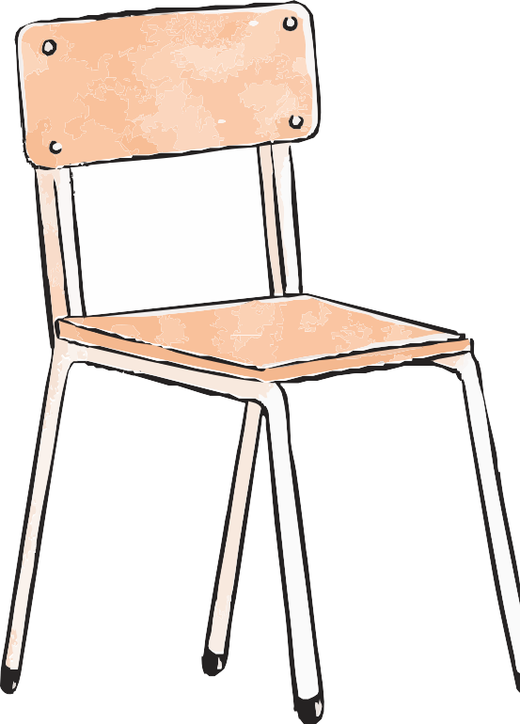
      - New round: the student who is left without a chair goes to the center and starts a new phrase.

      - Continue the dynamic: repeat several rounds until everyone has had the chance to be in the center.

Note for the teacher:
- Avoid statements that may generate teasing or discomfort
(e.g., physical traits, grades, etc.).
- If necessary, suggest neutral and positive phrases to maintain the playful climate.
- Observe participation: this type of dynamic shows affinities within the group and helps detect possible exclusions.

Activity 4: Movement Game – “Yes / No”
A4
(Approximately 10 to 15 minutes) Adapt it according to the group.

Objectives
Materials
Large sign with “YES.” Large sign with “NO.”
Spacious area in the classroom to move around.
      - Physically activate the group in a playful environ-ment.
      - Observe similarities and differences of opinion among students.
      - Briefly reflect on attitudes and beliefs related to bullying

Steps to facilitate the activity:
      - Prepare the space
        - Place the “YES” sign at one end of the classroom and the “NO” sign at the opposite end.

      - Explain the instruction
        - “I am going to read a series of statements. If you agree, move to the YES side; if you do not, go to the NO side. If you are unsure, you may stay in the center and explain your position.”

      - Present statements to the group:

"If I see another child being made fun of, I'd rather walk away."
01
        - Why do you prefer to walk away?
        - Because you might be teased too?
        - How could you protect yourself?

"If you are a leader, you have the right to disturb others."
03
        - What is the true job of a leader?
        - “Who is your leader? Your teacher?”).

“I am afraid I might also be picked on if I help another child.”
        - Briefly explain this idea if necessary, reinforcing that it is a common fear.
02

“If someone is always being teased and goes to an adult for help, then they are a tattletale.”
04
Explain the difference between tattling and asking for help:
        - Asking for help: when someone feels bad and needs support.
        - Chivarse: when no one is being harmed (e.g., someone cheats on homework or chews gum in class).

05 “I would talk to my parents or my teacher if I felt uncomfortable or mistreated in class.”

- Who could you turn to if you don’t want to talk to your parents? (e.g., teachers, school support system).
Emphasize how important it is to talk about concerns so they do not turn into a “knot in the stomach” and affect health. Also ask:

- Optional question: “I have seen someone in my class being constantly teased or excluded.”
  - Normalize the answer: most will say yes, which shows that the problem affects all of us.

      - Brief dialogue
        - After each statement, invite 2–3 volunteers to explain why they chose YES or NO.
        - Keep the exchanges short so several statements can be covered.

      - Closing the activity
        - Summarize with a key idea:
          - “Opinions may differ, but the important thing is to reflect on which attitudes help us take care of each other as a group and prevent bullying.”

Note for the teacher:
- Observe how students position themselves and pay attention to laughter or comments; these may reveal the group’s climate.
- Do not force responses: the option of staying in the center allows hesitant students to participate as well.
- Use the statements related to bullying as opportunities to clarify misunderstandings and reinforce key learning points.

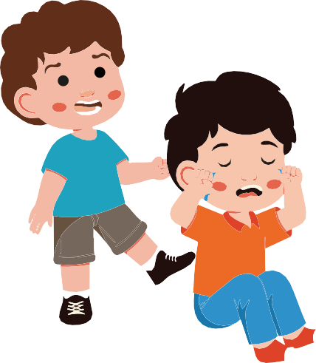





Activity 5: Input – What is Bullying?
10
A5
(Approximately 5 minutes) Adapt it according to the group’s attention span.

Objective
Materials
Blackboard or flipchart. Markers or chalk.
      - Explain briefly and clearly what bullying means.
      - Identify who participates and what roles they play.
      - Reflect on the emotional and collective conse-quences of bullying

Steps to facilitate the activity:
      - Opening question;
        - “What is bullying? What do you think it means?”
          - Listen to a few quick answers.

      - Clear definition
        - Present Dan Olweus’ definition:
          - “A student is bullied when someone bothers or harms them repeatedly and over a long period of time.”
        - Highlight the two key ideas: repetition and duration.

      - Participants in bullying:
        - Explain that several figures are involved in bullying:
          - Perpetrator or aggressor.
          - Victim.
          - Followers or helpers of the aggressor.
          - Bystanders.
        - Emphasize the key message:
          - “In reality there are no passive bystanders: everyone who watches has an influence on the situation, whether by supporting, laughing, or staying silent.”

      - Effects on the class
        - Ask: “What effect does a case of bullying have on the class?”
        - Explain: it generates stress, worsens the class climate, and in fact affects everyone, not only the victim.

      - Possible reasons for bullying
        - Ask: “Why does someone bully others?”
        - Explain some reasons:
          - Boredom.
          - Attempt to humiliate others in order to feel stronger.
          - Personal problems that are taken out on others.
          - A false sense of temporary relief.

      - Feelings involved
        - Reflect out loud and ask the group:
          - “How does the victim feel?”
          - “How does the aggressor really feel?”
          - “And those who are watching?”

      - Transition to the next activity
        - “Now that we know what bullying is and how the people involved feel, we are going to hear it through a story.”

Note for the teacher
- Keep the tone simple and brief; this activity is only meant to give an initial framework.
- Reinforce that bullying is not a game or a problem between just two people, but rather affects the entire class.
- Do not bring up personal examples of the students: use this activity only as preparation for the following story.

11

Activity 6: Story “I Don’t Want to Go on the Field Trip” – Identifying Roles in Bullying (Approximately 30 to 40 minutes) You may extend it if valuable contributions emerge.
A6

Objectives
Materials
Printed copies of the story “I Don’t Want to Go on the Field Trip”.
Blackboard or flipchart to collect ideas. Paper and pens for the groups.
      - Understand how bullying arises in everyday situations.
      - Identify the different roles involved (victim, perpetrator, follower, group/class).
      - Reflect on the emotions of each character and possible alternatives for action.

Steps to facilitate the activity:
      - Presentation of the story
        - Explain that you are going to read a story that shows how a child feels when they start to experience bullying.
        - Adapt the story to the characteristics of your class if you consider it necessary.
        - Read the story “I Don’t Want to Go on the Field Trip” (printed or from the module presenta-tion).

      - Initial reflection in plenary
        - Ask: “What happened in this story? Which characters appear and what did they do?”
        - Write down students’ ideas on the board.

      - Explicit identification of roles
        - Ask: “Who appeared in the story and what role did each one have?”
          - Kim ➔ Affected person (victim).
          - Malik ➔ Perpetrator.
          - Samu ➔ Follower.

        - Then ask:
          - “Are these three the only ones involved in bullying?”
          - “Imagine this story happened in your class… would it have nothing to do with you?”
        - Lead the group to identify the missing role: the group/class as an active part of the situation, even if it does not appear directly in the story.

12

      - Work in small groups
        - Divide the class into teams of 4–5 students.
        - Each group reflects and answers:
          - How does Kim feel?
          - What is Malik looking for with his actions?
          - What does Samu do and why does he follow Malik?
          - What could the rest of the class do to change the situation?

      - Sharing in plenary
- Each group shares their conclusions.
- The teacher completes a diagram on the board with the basic roles in bullying:
  - Victim – Perpetrator – Followers – Bystanders – Defenders – Class as a group.

      - Closing the activity
        - Reinforce the idea:
          - “In bullying there is not only a victim and an aggressor. There are also followers, bystanders, and the entire class. Everyone has a role and everyone can do something to change the situation.”

Teacher’s Note
- Use the story as a starting point to work on group awareness: bullying cannot exist without an environment that either allows it or stops it.
- Avoid personalizing too much: talk in terms of roles, not individual blame.
- Reinforce the idea that students, as a group, have an active role in creating a respectful climate.

Activity 7: Body Silhouettes – Emotions and Consequences of Bullying
A7
(Approximately 30 minutes) Adapt it to the age and number of students.

Objectives
Materials
Large paper rolls or poster boards. Colored markers.
Adhesive tape to stick the silhouettes on the wall.
      - Express emotions related to bullying in a visual and creative way.
      - Understand the emotional and physical consequences for the people involved.
      - Promote empathy by recognizing how the different roles feel.

Steps to facilitate the activity:
      - Form small groups
        - Divide the class into teams of 4–5 students.
        - Each group receives a poster board or a large sheet of paper.

      - Draw the body silhouette
        - Ask one student to lie down on the paper so classmates can trace the outline of their body.
        - This creates a life-size body silhouette.

      - Assign one role per silhouette
- Each group is assigned one of the roles from the story:
  - Victim (Kim).
  - Perpetrator (Malik).
  - Follower (Samu).
  - The class/group.

      - Express emotions in the silhouette:
        - Inside the silhouette, students draw or write words that represent what that person feels in the bullying situation.
        - Outside the silhouette, they draw or write what consequences that role may have in their daily life (emotions, body, relationships).
          - Examples:
▫ Inside Kim’s silhouette: sadness, fear, stomachache, loneliness.
▫ Inside Malik’s silhouette; power, anger, desire to bother others.
▫ Samu’s silhouette: insecurity, peer pressure, fear of rejection.
▫ Class silhouette: indifference, fear of intervening, shared responsibility.

Sadness Anger
Stomachache fear
Loleliness


Insecurit�

      - Sharing in plenary:
- Each group presents their body silhouette to the rest of the class, explaining what they drew inside and outside.
- The teacher moderates with questions:
  - “What did you discover by putting yourself in this role’s shoes?”
  - “What emotions are repeated across all the characters?”
  - “What consequences can not acting against bullying have?”

      - Reinforce the idea that everyone involved feels something.
        - Ask: “What can you do?”
        - Use this example:
          - “Draw on the board: one little fish is afraid of being eaten by the shark, but if many little fish join forces, the shark has no chance. This is how many animals living in groups protect each other.”
        - Encourage keeping the silhouettes to hang them in the classroom as a visual reminder of the work done.

Key points for the teacher
- Prevent insults or humiliating drawings; guide them toward an empathetic reflection.
- Give each group enough time to complete their silhouette, but manage time so all can present..
- Remember: the goal is not only to identify negative feelings but also to reflect on what could be done differently to change those roles.

Activity 8: Letter to Parents – Sharing What We Learned (Approximately 15 to 20 minutes). Adapt it to your group’s pace.
A8

Objectives
      - Connect what was worked on in class with the home environment.
      - Encourage personal reflection on what was learned.
      - Involve families in the prevention and detection of bullying.

Materials
Sheets of paper or letter templates.
Pencils or pens.
(Optional) Envelopes to take the letter home.

Steps to facilitate the activity
      - Explain the dynamic
        - “Now we are going to write a letter to our parents or guardians. We want to tell them what we worked on today about bullying, what we learned, and why it is important.”

      - Offer a simple structure (write it on the board as a guide):
        - Opening greeting.
        - One sentence about what bullying is.
        - Something I learned today.
        - Why I think it’s important to talk about this topic in class.
        - Closing.
          - Example:
▫ Dear Mom and Dad,

Today in class we learned what bullying is: when someone repeatedly bothers and excludes another person and there is an imbalance of power.
We read a story and talked about how the victim feels and also how others feel.
I think it is important that we talk about this at home so that we can all help ensure that no one feels bad at school.

With love, [name].

      - Time to write
        - Allow each student to write their own letter.

      - Optional – Sharing in group
        - Those who wish may read part of their letter out loud.

      - Delivery
        - Each student takes the letter home in an envelope, or the school organizes its delivery.

Teacher’s note
- Encourage writing the letter in a simple and personal tone, without focusing on spelling perfection.
- Reinforce the idea that bullying is not just a school issue; families are also involved.
- If the group is small or trusting, students may read letters aloud, but never force it: it must be voluntary.
- This activity helps open dialogue at home, not evaluate students’ writing skills.

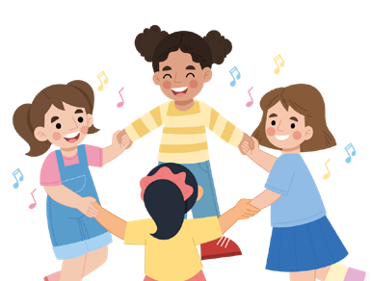
Day 2. Cyberbullying and Support System (2h 30m total duration)
A1
Activity 1: Review Circle – Remembering the Previous Day (Approximately 10 to 15 minutes). Adapt it according to the group’s participation.

Objectives
Materials
Chairs arranged in a circle. Blackboard or flipchart (optional) to note down key words.
      - Recall what was learned in the first session about bullying.
      - Reinforce the memory of the roles discussed (victim, perpetrator, follower, class).
      - Activate students’ emotional memory to connect with the theme of Day 2: cyberbullying and support strategies.

Steps to facilitate the activity
      - Form the circle: organize the group seated in a circle with chairs.

      - Introduce the dynamic:
        - “Before we continue, let’s remember together what we did yesterday. What do you recall from the stories, games, or reflections?”

      - Open the dialogue with guiding questions:
        - “What is bullying?”
        - “What roles did we discover exist in a bullying situation?”
        - “How did Kim feel in the field trip story?”
        - “What did we learn about the role of the class in a bullying situation?”

      - Collect key words: write down on the board the ideas that students share (e.g., fear, respect, support, group, exclusion, bystanders…).

      - Brief closing:
        - “Today we are going to look at another type of bullying, the one that happens through cell phones and the internet. And we will also think about what we can do to support each other.”

Teacher’s note
- Allow everyone to participate, but without dragging it out. The goal is to activate collective memory, not to repeat the entire previous session.
- Especially reinforce the idea that the class as a group always has a role, because this will be fundamental for addressing the strategies in Day 2.

Activity 2: Activation Game – The Imaginary Ball (Approximately 10 minutes).
A2
Adapt it according to the group’s energy.

Objectives

Materials
Free space in the circle to play.
No physical material is needed (the ball is symbolic/imaginary).
      - Activate the group’s attention and move-ment in a playful way.
      - Encourage concentration and cooperation.
      - Prepare students for the more reflective work of the day.

Steps to facilitate the activity

      - Explain the dynamic:
        - “We are going to play by passing an imaginary ball. The ball does not really exist, but we are all going to imagine it together.”
        - “Each time you pass the ball, you must look at the person you are throwing it to and call them by their name.”

      - Start the game:
        - Make the first pass yourself, naming a student and pretending to throw the ball with your hands.
        - That student receives the imaginary ball, makes a catching gesture, and then throws it to another classmate, always saying their name.

      - Variations:
        - Change the size or weight of the ball with imagination: a very heavy ball, a very small one, a rubber ball that bounces, etc.
        - You can introduce several balls at the same time to increase difficulty and attention.

      - Group observation:
        - Emphasize how attention and respecting turns are key for the game to work.

      - Brief closing:
        - “This game reminds us that when we pay attention to others and collaborate, everything flows better. Just like in daily life and in the classroom.”



Teacher’s note
- Encourage students to exaggerate the gestures of throwing and catching to make it more fun.
- Reinforce the importance of naming the classmate: it helps with attention and inclusion.
- If a student feels insecure, start by throwing them the ball yourself to integrate them naturally.
19

Activity 3: Debate on Family Questionnaires (Approximately 10 to 15 minutes).
A3
Adapt it according to the level of group participation.

Objectives

Materials
Results or examples of responses from the questionnaires previously completed by families (if available).
Blackboard or flipchart to note down key ideas
      - Connect the families’ perspective with that of the students.
      - Reflect on how adults perceive bullying and what they expect as a response.
      - Give students a voice regarding the diffe-rences or similarities with their own experien-ce.

Steps to facilitate the activity

      - Introduction to the debate
        - Explain that families have answered a questionaire about bullying and coexistence.
          - “Let’s think together about what our parents believe about bullying and how they see it from outside the school.”

      - Presentation of key points
- Share some examples of general responses (without names, anonymously).
  - Example: “Some families believe bullying is easy to detect, while others say it often goes unnoticed.”

      - Guided debate
- Ask open-ended questions to invite reflection:
  - “Do you agree with what families think?”
  - “What things do adults see that we don’t?”
  - “What things do we as students know that adults don’t always understand?”
  - “How can we encourage more dialogue between families and students about this issue?”

      - Collect conclusions
        - Write the main ideas from the debate on the board.
        - Highlight common points and differences in perception.

      - Closing
- Reinforce the idea:
  - “To prevent and stop bullying, it is important that both families and students talk about it and share how they see it.”

Teacher’s note
- Ensure a climate of respect towards the opinions of both families and students.
- If no previous questionnaires are available, you can simulate: ask students to imagine how they think their parents would respond to certain questions.
- Use this debate as a bridge to introduce the next topic: cyberbullying, which adults often perceive differently than young people.

Activity 4: Short Input – What is Cyberbullying? (Approximately 10 minutes).
A4
Adapt it according to the group’s attention.

Objectives

Materials
Slide presentation with the key ideas. Blackboard or flipchart to note down a final conclusion.
      - Explain in a simple and clear way what cyberbullying is.
      - Show why it is so dangerous.
      - Raise awareness about the importance of asking for help and keeping evidence.

Steps to facilitate the activity

      - Opening question (1 min):
        - Ask: “Does anyone know what the word cyberbullying means?”
        - Collect 2 or 3 quick ideas.

      - Presentation of key ideas (6–7 min):
        - Use the slides to briefly show:
          - Simple definition:
▫ Cyberbullying is a type of bullying that happens through cell phones, the internet, online games, or social media.
▫ Just like traditional bullying, it is repeated, lasts over time, and there is a power imbalan-ce.
Legal importance:

- Cyberbullying is not a trivial offense; it can have serious consequences.
- It is also a criminal offense.
- Therefore, it is always important to talk to someone you trust.
- In addition, it is useful to take screenshots or save files (messages, photos, videos) to use in case of a report
Main characteristics:

- It can happen at any time.
- It spreads quickly and reaches many people.
- It can be anonymous.
- It leaves traces (messages, photos, videos).
- It even invades the home.
The most dangerous aspecs are (in simple words):

- Anonymity → you don’t always know who is behind it.
- Availability → it can happen at any time of the day.
- Reach → many people see it very quickly.
- Simplicity → it is easy to cause harm with just one click.

      - Closing reflection (2 min):
        - Ask: “Why do you think it is important to talk about cyberbullying?”
          - Write 2–3 student sentences on the board and close with the idea:
▫ “Cyberbullying is just as harmful as in-person bullying, and sometimes even more dange-rous. That’s why we need to recognize it, talk about it, keep evidence, and ask for help to stop it.”

Teacher’s note
- Emphasize the legal dimension in a simple way: not to frighten, but to show that it is serious.
- Use slides with short and clear sentences; avoid overcrowding with text.
- Always reinforce: they are not alone: talking to a trusted adult is the first step.

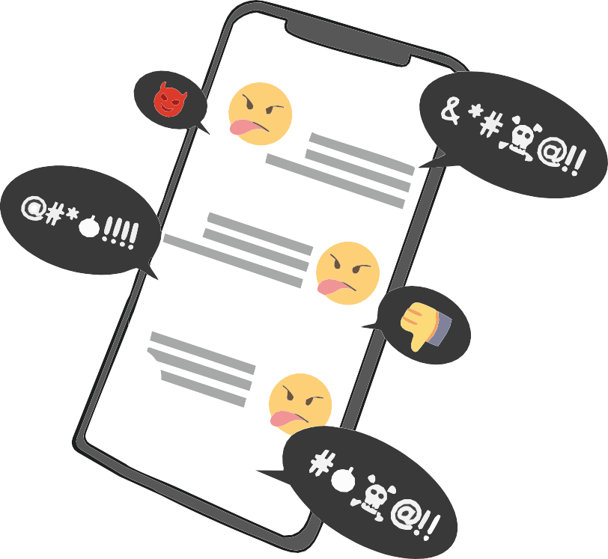

Activity 5: Game – “Common Messages” (Approximately 20 to 25 minutes).
A5
Adapt it according to the size and participation of the group.

Objectives
Materials
A doll or stuffed animal representing the person receiving the messages.
Mobile phone cards with messages (preferably laminated).
- Some messages are negative (e.g., insults, mockery, exclusion).
- Others are positive (e.g., support, encouragement, recognition).
      - Experience how messages circulating in a group affect someone.
      - Reflect on the difference between recei-ving negative and positive messages.
      - Show that cyberbullying leaves a mark and that the group has the power to harm or to care.

Steps to facilitate the activity

      - Preparation of the circle
        - Arrange the chairs in a circle and place the doll or stuffed animal in the center.
        - Explain that the doll represents a real person who is receiving messages on their phone.
        - Key note: never put a student in the center. Always use the doll to avoid exposing anyone.

      - Narrative context
        - Tell a short situation to activate empathy:
          - “Let’s imagine this doll had a bad day, is alone in their room, and picks up the phone. Suddenly, they start receiving messages… some unpleasant and others that may help.”

      - Reading negative messages
        - Distribute the message cards to students (one each or several if the group is small).
        - In turns, students read their message out loud to the doll in the center.
        - After several rounds, stop the exercise and ask:
          - “How do you think the doll feels now?”
          - “Is it different when the messages seem anonymous or when they come from someone known?”

Everyone laughs at you!
You deserve peace and happiness
24

      - Brief reflection on impact
- Explain:
  - “On the internet, negative messages are not easily erased: they are saved, can be forwar-ded, and reach many people. Even if it seems like a game, they have real consequences.”

      - Final round of repair (positive messages)
        - Now ask each student to think of and say a positive message to the doll.
        - Examples: “You are a good friend”, “I like playing with you”, “You can count on me.”
        - Reinforce the idea that positive messages can also be shared and make a person feel better.

      - Closing the activity
        - Guide a brief reflection in plenary:
          - “What did you notice in yourself when saying negative messages? And when saying positive ones?”
          - “What do we learn from this about how we use our phones or social networks?”
        - Summarize with the key idea:
          - “Just like in this game, on the internet messages are repeated and spread quickly. They can hurt or they can help. Each of us decides what kind of message we want to share.”

Teacher’s Note
- Avoid improvising real student messages: always use the prepared cards.
- Remember that the goal is not to dramatize excessively, but to highlight the effect of messages.
- Reinforce that positive messages also circulate and have a powerful impact on self-esteem and the group’s atmosphere.
- This activity connects with the next one: the “golden rules on the internet” (STOP – BLOCK – TELL).

Activity 6: Debate – Golden Rules on the Internet (STOP – BLOCK – TELL)
A6
(Approximately 15 to 20 minutes). Adapt it according to the group’s participation.

Objectives
Materials
Blackboard or flipchart to write down the rules.
Cards or slides with the three key words: STOP – BLOCK – TELL.
(Optional) Examples of fictional screenshots of chats or social networks.
      - Reflect on how to react to cyberbullying.
      - Identify simple and practical strategies to protect oneself.
      - Give students clear resources to stop digital bullying.

Steps to facilitate the activity

      - Introduction
        - Connect with the previous activity:
          - “We already saw how messages can cause harm on the internet. Now let’s think: what can we do if we receive unpleasant messages or see that someone else receives them?”

      - Present the three golden rules
        - Write them in large letters on the board or show them on the presentation:

STOP:
Don’t reply, don’t play along.
BLOQUEA:
Cut contact with the person bothering you (block on social media, WhatsApp, games).
CUENTA:
Talk to a trusted adult (parents, teachers, school counselor).

      - Practical examples
        - Present short situations and ask: “What would you do?”
        - Example 1: Someone creates a group and adds you only to insult you.
        - Example 2: They share a photo of you without permission.
        - Example 3: A stranger sends you strange messages in an online game.
        - The group responds by applying the three rules.

      - Closing the debate
        - Summarize out loud with the group:
- “None of us has to endure cyberbullying. There is always something we can do: stop, block, and tell. The faster we act, the less harm it can cause.”

Teacher’s Note
- Reinforce the idea that not reacting (STOP) doesn’t mean being weak, but being smart: it cuts the bully’s game.
- Clarify that blocking is not disrespectful, but a right to protect oneself.
- Highlight that telling is not “snitching,” but asking for help to solve a problem.
- You may ask students to invent an additional rule to feel even safer online.

Activity 7: Anti-Bullying Strategies – Class Agreement
A7
(Approximately 20 to 25 minutes). Adapt it according to the group size and available time.

Objectives
Materials
Blackboard or flipchart. Large poster board or mural. Colored markers.
(Optional) Small cards so each student can write a proposal.
      - Identify collective strategies to prevent and stop bullying and cyberbullying.
      - Involve the group in creating a shared commitment.
      - Encourage shared responsibility and the sense of belonging to the class.

Steps to facilitate the activity
      - Introduction
        - Say: “We have already seen what bullying and cyberbullying are, and how they affect people. Now let’s think together: what can we do as a class to make sure this doesn’t happen or to stop it if it does?”

      - Brainstorming
        - Ask students to share concrete strategies and write them on the board.
          - Examples:
          - Defend someone who is being bothered.
          - Don’t share harmful messages.
          - Tell a trusted adult.
          - Use supportive words.
          - Include someone who is alone.

      - Group synthesis
        - Classify the ideas into categories with the help of students:
          - What to do as an individual.
          - What to do as a group/class.
          - What to do if it happens online.

      - Creation of the agreement
        - Write a common anti-bullying agreement with the class on poster board or a mural.
        - Each student can sign it, draw a symbol, or leave their handprint (e.g., with painted fingers).

      - Closing
        - Hang the agreement in a visible place in the classroom as a reminder.
        - Reinforce with a commitment phrase:
          - “Bullying is not just one person’s problem, it is everyone’s challenge. As a class, we commit to taking care of each other and offering support.”

Approach the victim and show
support.
Defending those who are being
bullied.
Stop Bullying

Talk to a trusted adult.
Talk to supporters or the offender.
Do not forward harmful messages.

Intervene and say STOP.
Document incidents (screenshots).

Teacher’s Note
- Avoid making the agreement look like an external list of rules: encourage it to be the group’s real creation, in their own words.
- Reinforce that the commitment is not symbolic, but a tool the class can remember and apply throughout the school year.
- You may revisit the agreement later (after a few weeks) to check if it is being followed or needs updating.

Activity 8: Closing Circle – “The Compliments Plate”
A8
(Approximately 15 to 20 minutes). Adapt it according to the available time.

Objectives

Materials
One paper plate or large circle-shaped piece of card per student.
Colored markers.
Adhesive tape (optional) to stick the plates on the wall at the end.
      - Conclude the module with a positive experien-ce of mutual recognition.
      - Reinforce the climate of trust, care, and support in the group.
      - Foster self-esteem and empathy through com-pliments.

Steps to facilitate the activity
      - Preparation
        - Give each student a paper “plate” (or card in the shape of a circle).
        - Ask them to write their name in the center.

      - Explanation of the dynamic
        - Say: “Now we are going to give each other compliments and positive messages. Each of you will write a positive message on your classmates’ plates.”
        - Examples: “Thanks for your smile”, “I like how you play with me”, “You are a good friend.”

      - Compliment round
        - Students move around the classroom, passing plates from hand to hand, and each one writes something positive on each classmate’s plate.
        - Make sure that everyone receives at least one message from each classmate.

      - Personal reading
        - At the end, each student gets their plate back and silently reads the messages they received.
        - Give a few minutes for students to enjoy the moment.

      - Group closing
        - Invite some volunteers to share out loud a compliment that made them especially happy.
        - End with a reinforcing phrase:
          - “Just as words can hurt, they also have the power to make us feel good and unite us as a group. Let’s remember to use our words to build and support.”

Teacher’s Note
- Reinforce that the messages must be sincere, respectful, and positive.
- Avoid students writing generic phrases like “you are nice”; encourage them to be specific.
- This activity not only serves as the closure of the module but can also be repeated during the school year as a reminder of mutual support.

Complementary activity (40m total duration)
AC1
Activity 1: The Anonymous Message Box (Approximately 10 to 15 minutes).
Plus periodic review.

Objectives

Materials
A decorated box or mailbox (can be physical or virtual).
Small pieces of paper. Pencils or pens.
      - Provide a safe space to express emotions and experiences without fear of being judged.
      - Promote empathy and respect for classmates’ privacy.
      - Identify common concerns within the group.

Steps to facilitate the activity
      - Preparation of the box
        - Place a decorated mailbox in a visible and accessible place in the classroom.
        - Explain to students that they can use it anonymously to leave messages about how they feel, if they have seen something unfair, or if they need help.

      - First writing
A. Dedicate class time for each student to write a message (real or invented) and place it in the box.

      - Periodic review
        - Once a week or at the end of the module, open some messages (keeping anonymity) and read them to the group.
        - Reflect together on what they express: concerns, fears, joys, needs.

      - Closing
        - Reinforce the value of confidentiality and respect.

        - Remind them: the content of the box is not used to point fingers at anyone, but to think about how to improve the classroom climate.

Teacher’s note
- This box can become a tool for continuous tutoring.
- If serious messages appear (violence, exclusion, explicit bullying), handle them with due seriousness and privately.
- Always reinforce the idea that asking for help is not tattling, but seeking solutions.

AC2

Objectives

Activity 2: The Web of Trust (Approximately 20 to 25 minutes).

      - Strengthen trust and group cohesion.

Materials
A ball of yarn or string.
Enough space to form a large circle.
      - Visualize that everyone is connected and that mutual support strengthens the group.
      - Promote respect and active listening.

Steps to facilitate the activity
      - Form the circle
        - Have all students sit or stand in a circle.

      - Start the web
        - One student holds the yarn ball, says the name of a classmate, and shares a positive quality or a message of support with them.
        - Then they throw the yarn ball while holding onto one part of the string.

      - Continue the web
        - The student who receives the yarn repeats the process: names another classmate, says some-thing positive, and throws the yarn while holding their part.
        - The game continues until everyone is connected and a web of yarn is formed in the center of the circle.

      - Group reflection
- Observe the web together.
- Ask:
  - “What does it mean that we are all connected?”
  - “How does it feel to know that others see positive things in you?”
  - “What happens if someone lets go of the string? And if everyone holds it tightly”

      - Symbolic closing
        - Reinforce the idea: “Each of us is important. If we support each other, the class is stronger. If someone is left out, the web becomes weaker.”

Teacher’s note
- Choose positive and concrete messages, avoid turning it into jokes.
- Save the yarn to repeat the activity later and compare if the group has grown in trust.
- This activity is ideal to close the module, reinforcing the positive climate and the group’s commitment.

Checklist material by Day

Day 1. – Bullying in General

Introduction and Presentation
Chairs in a circle. Blackboard/flipchart (optional).
Introduction Round – Positive Qualities
Chairs in a circle.
Movement Game – “All Those Who…”
Chairs in a circle.
(one fewer than the number of students). Free space to move around.
Movement Gamve – “Yes / No” Large sign with “YES.” Large sign with “NO.”
Spacious area to move.
Input – Definition of Bullying (Olweus) + Debate
Blackboard/flipchart. Markers or chalk.
Story “I Don’t Want to Go on the Field Trip”
Printed copies of the story (full and simplified versions). Blackboard/flipchart.
Paper and pens for the groups.
Body Silhouettes – Emotions and Consequences
Large sheets of paper or poster boards. Colored markers.
Adhesive tape.
Letter to Parents
Blank sheets or letter templates. Pencils or pens.
(Optional) Envelopes to take home.

Day 2. Cyberbullying and Support Strategies

Review Circle
Chairs in a circle. Blackboard/flipchart (optional).
Activation Game – Imaginary Ball
Free space in the circle.
(No physical materials required).
Debate on Family Questionaires
Questionnaire results/responses (if available). Blackboard/flipchart.
Input – Cyberbullying (Explanation and Debate)
Slide presentation or visual cards. Blackboard/flipchart.
(Optional) Projector.
Game – Common Messages
Doll or stuffed toy.
Phone cards with messages
(negative and positive, preferably laminated).
Debate – Golden Rules on the Internet (STOP – BLOCK – TELL)
Blackboard/flipchart.
Posters or slides with the 3 key words. (Optional) Fictitious examples of chats or social media.
Strategies Against Bullying – Class Pact
Blackboard/flipchart.
Large poster board or mural. Colored markers.
(Optional) Small cards.
Closing Circle – Compliment Plate
Paper plates or circular cards (one per student). Colored markers.
(Optional) Adhesive tape to hang them in the classroom.

Complementary Activities

The Anonymous Message Box
A decorated box or mailbox (physical or virtual).
Small pieces of paper. Pencils or pens.
The Web of Trust
A ball of yarn or string. Spacious area for the circle.

Printable activity 4. Movement Game - "Yes / No"

History "I don't want to go on the excursion".
-You're finally here!" Kim's aunt Amina shouts happily. Kim gets to spend the weekend with his favourite aunt, Amina, and normally he is always very happy when he goes to see her. This time, however, he does not hug Aunt Amina as enthusiastically as usual. Kim looks very sad when he approaches his aunt.

-Well, what's wrong with you," asks Aunt Amina.

-"Oh, nothing..." says Kim, but her favourite aunt knows something is wrong.

-No one can help me anyway. I only have problems at school. I used to get on well with everyone. I used to play with Samu and Malik in particular, but they haven't been my friends for a few weeks now. Malik always pushes me and calls me "stinky Kim". I don't even like going to school anymore".

Aunt Amina takes pity on Kim.
-That's so mean! Have you tried talking to Samu about how Malik treats you?

-No," says Kim, even sadder, "It's no use. Samu is next to Malik. Maybe he's happy because now he has Malik all to himself now...". Now Kim even starts to cry. Aunt Amina takes him in her arms and comforts him.

Kim sobs: "And everyone else in the class already has friends. I'll try to make myself as invisible as possible and hope that Malik forgets about me and doesn't make fun of me again. But you know what the worst thing is? Next week we're going on a class trip. I was really looking forward to it, but now I don't want to go. Maybe I'll get lucky and I'll get sick".

-It can't be because of Malik and Samu that you won't go on the trip," replies Aunt Amina.

-A trip like this is great! We should tell your parents and your teacher. If you want, I can go with you to school. If they always make fun of someone and exclude them, that's bullying. It's not your fault. And you shouldn't tolerate it under any circumstances.

I hope you're not coming on a trip!

I know where you live!

You are so stupid!
Everyone in the class hates you!

You're no good at all!
Tomorrow we'll kick your ass!

We don't want you here!
I hope you change schools!

Everyone laughs at you!

You'll never have friends here!

Don’t let anyone dim your light.
There’s nothing wrong with you.

You have incredible strength.
You are enough, just as you are

You can count on me
Your voice matters.

I’m proud of you.
You’re stronger than you think.

I’m with you.

You deserve peace and happiness



Printable day 2 activity 6: Golden Rules on the Internet (STOP - BLOCK - TELL)

...
w

You are very intelligent

I love your smile
I admire your courage.

"I am a very good friend".


Printable day 2 activity 8: “The Compliments Plate”
46
You are so funny

You are beautiful.











Erasmus+

Enriching lives, opening minds.


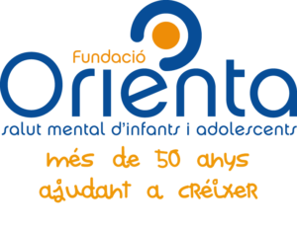

Carl von Ossietzky

Universitat Oldenburg


e.V.



