Young carers
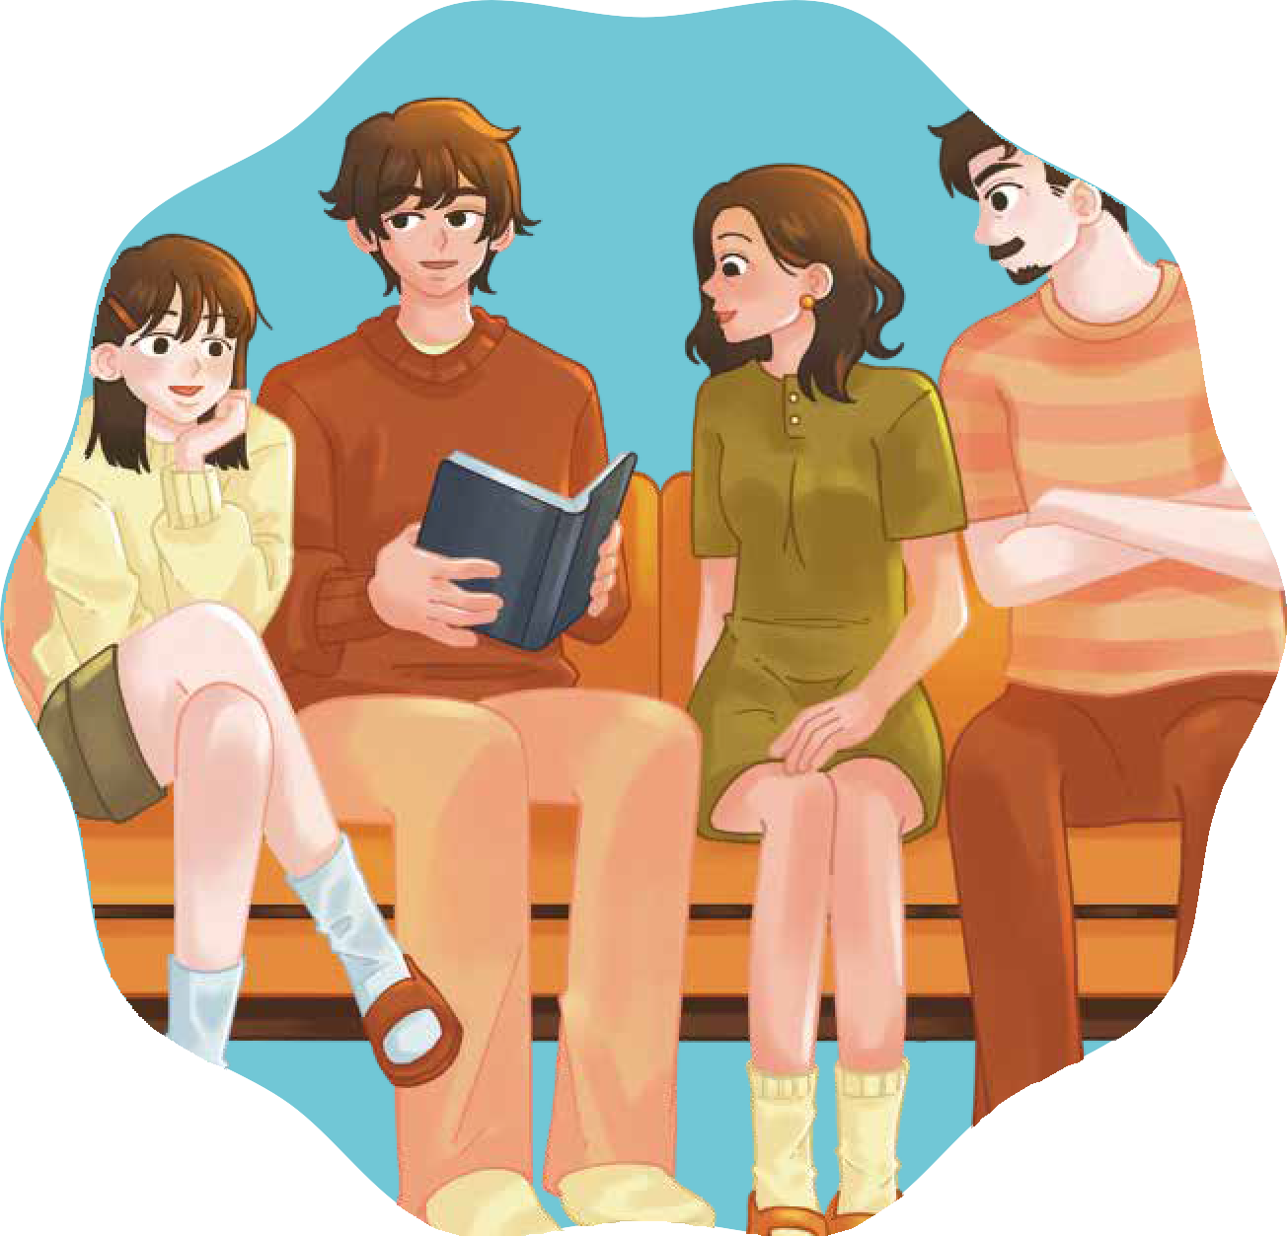
Teacher’s guide

Secondary School activities[)

Secondary School activities

INDEX
- Introduction and objectives 3
- Key points for the teacher 4
- Activity 1. What is mental illness? 5
- Activity 2. Myths and realities 7
- Activity 3. General impact on adolescents 9
- Activity 4. What helps? — Support network 11
- Activity 5. Closing and Integration 13
- Complementary activities
  - Complementary Activity 1 — Real responsibility vs. assumed responsibility 15
  - Complementary Activity 2 — What helps vs. what does not help 17
- Printable materials and resources
  - Checklist of materials per session 18
    - Activity 2
▫ Myths and truths 19

INTRODUCTION
During adolescence, students develop a greater capacity for analysis, reflection, and critical thinking. At this stage, they begin to better understand the complexity of family relationships and the different situations that can affect adults.

Mental illnesses are part of social reality. They are conditions that affect thoughts, emotions, and behaviours, and can influence the daily life of those who suffer from them and their close environment. They are not rare, they are not a weakness, and they are not a consequence of a lack of effort or will.

Some adolescents live with adults going through a mental illness. This situation can generate questions, doubts, excessive responsibility, or confusion, especially when clear information is not available.

This module has a preventive and educational focus. It does not seek to explore personal experiences or turn the classroom into a therapeutic space. Its purpose is to offer:

- Clear and rigorous information about mental illness.
- General understanding of how it can influence the family environment.
- Messages of safety and non-blaming.
- Knowledge of available support networks.

The work is carried out from a general perspective, using third-person examples and structured dynamics that encourage reflection without personal disclosure.

Through this module, students will be able to expand their understanding of mental health, reduce stigmas, and recognise the importance of asking for help when necessary, always maintaining a safe and respectful environment.

Expected results module 7

Key words

- Mental health
- Difference between distress and disorder
- Myths and realities
- Impact on adolescents
- Real vs. assumed responsibility
- Stigma
- Protection factors
- Support network
- Seeking help
- Critical thinking
- Healthy boundaries
- Emotional safety

At the end of this module, students will understand what a mental illness is from an informed perspective, identify possible impacts on adolescents, recognise the importance of healthy boundaries in responsibility, and know how to identify resources and available support networks.

Before starting

  - Review the complete PowerPoint presentation
  - Pre-read the theoretical content to maintain conceptual clarity.
  - Prepare projector and technical equipment.
  - Have whiteboard and markers available.
  - Prepare cards or posters for the "Myths and realities" activity (optional).
  - Have paper and a box/envelope prepared for anonymous questions.
  - Remember the module's focus: general understanding, no personalisation, no therapeutic intervention.

During the development of the module

  - Active and visible visual presentation for the whole group.
  - Whiteboard available to note down key ideas.
  - Organised space for plenary participation.
  - Active supervision of the group's emotional climate.

For the closing

  - Collect anonymous questions.
  - Review final key messages.
  - Have a referral protocol prepared if necessary.

A1 Activity 1. What is a mental illness? (20 minutes duration)
Materials
PowerPoint Presentation (Slides 2-6) Projector
Whiteboard Felt-tip pens
Classroom in frontal or semi-circle layout.

Objectives
      - Understand what a mental illness is from a
clear and scientific basis.
      - Differentiate between occasional distress and prolonged disorder.
      - Reduce stigma and false beliefs.
      - Establish the conceptual framework of the module.

Activity procedure:
      - Conceptual introduction (Slide 2)
        - "Before talking about family situations, we need to understand what a mental illness actually is."
- Maintain an informative and neutral tone.
- Do not open a debate at this point.

      - Mental health as part of health (Slide 3)
        - "Mental health forms part of our general health. Just as we take care of the body, we also take care of our thoughts and emotions."
- Ask the group:
  - "What things can influence our state of mind?"
- Allow brief answers such as:
▫ Exams,
▫ relationships with friends,
▫ sport,
▫ social networks,
▫ rest...
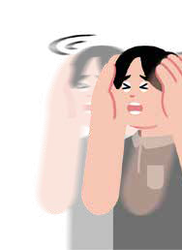
  - Do not personalise.

      - Key difference: occasional distress vs. mental illness (Slide 4)
- Explain the comparison clearly:

Occasional distress

  - Lasts a short time
  - Has a specific cause
  - Improves with rest or support
Mental illness

  - Lasts longer
  - Affects different areas of life
  - Needs professional treatment

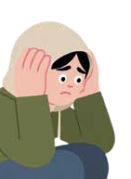

- “Feeling sad one day isn’t the same as having depression.”

      - Clear example: depression (Slide 5)
        - "Depression is not simply being sad. It can affect energy, concentration, and motivation."
- Avoid technical jargon.
- Do not delve into complex symptoms.

      - Dismantling false beliefs (Slide 6)
- Read each phrase slowly:
  - It is not a weakness.
  - It is not a lack of effort.
  - It is not the family's fault.
- You can ask:
  - "Why do you think these ideas are important?"
- Keep answers brief and avoid emotional discussion.

      - Structural message of the module (Slide 6)
- Read slowly:
  - Mental illnesses exist.
  - They are common.
  - They can be treated.
  - Asking for help is a sign of strength.
- Closing:
  - "With this clear basis, we can now better understand how a situation like this can affect a family."

Note for the teacher

- Maintain a general and educational focus.
- Do not ask: "Is anyone living through something like this?"
- Do not turn the session into a deep clinical debate.
- Supervise the emotional climate of the group.
- If a personal experience arises:
  - "Thank you for sharing. Here we are going to work on the topic from a general perspective to take care of the group."
- Central objective
  - Build solid understanding
  - Reduce stigma,
  - Prepare the ground for the impact on adolescents.

A2 Activity 2. Myths and realities (15-20 minutes duration)

Objectives
Materials
PowerPoint presentation (slides 6–14) Projector
Optional: red/green cards (Myth / Fact) Whiteboard and markers
Classroom arranged in a plenary layout.
      - Identify erroneous beliefs about mental illness.
      - Develop critical thinking.
      - Reduce stigma through clear information.
      - Reinforce messages of non-blaming.

Activity procedure:
      - Introduction to the dynamic (Slide 7)
        - "We are going to read several phrases. You will have to decide if you think they are a myth or a reality."
- Clarify:
  - "This is not an exam. It is an exercise for thinking."

      - Presentation of phrases one by one (Slide 8)
- After each phrase, students can:
  - Raise a card, raise their hand, answer verbally, or open a brief exchange before giving the correct answer.

"Mental illnesses are common worldwide. Many people experience them at some
point in their lives."
Slide 9
Mental illnesses are rare.
Correct answer: Myth
01
"Many mental illnesses are not visible from the outside. A person can appear to be fine while going through a difficult time."
Slide 10
If someone looks fine, they cannot have a mental illness.
Correct answer: Myth
02

Correct answe: Myth
"Mental illnesses are not caused by the children. They are health conditions."
03
Slide 11
Children are responsible if a father or mother has a mental illness
"Asking for help is a show of responsibility and strength."
Slide 12
Asking for help is a sign of weakness.
Correct answer: Myth
04
Correct answer: Reality
"With support and appropriate treatment,
many people improve significantly."
05
Slide 13
People with depression or anxiety can improve with adequate help.


      - Final reflection (Slide 14)
- Ask:
  - "Why do you think these myths exist?"
- Allow brief answers such as:
  - Misinformation
  - Fear
  - Social prejudice...
- Closing:
  - "When we understand something better, we stop being afraid and we reduce stigma."

Note for the teacher

- Keep the discussion structured and brief.
- Do not allow stigmatising comments without redirecting them.
- Avoid personal experiences.
- Maintain an educational, not emotional, tone.
- If a sensitive comment arises:
  - "Let's remember that we are speaking in general and with respect."
- Central objective: Substitute erroneous ideas with informed understanding and build a culture of
respect and non-blaming.

Activity 3. General impact on adolescents (20 minutes dura-tion)
A3

Objectives
Materials
PowerPoint presentation (slides 15–19) Projector
Whiteboard Marker pens
Classroom arranged in a traditional or plenary layout.
      - Understand how a family situation of
mental illness can impact different areas of an adolescent's life.
      - Normalise the emotions and reactions
that may arise.
      - Identify the difference between real responsibility and assumed responsibility

Activity procedure:
      - Introduction (Slide 16)
        - "When an adult in the family is unwell, it is normal for everyone around them to feel the impact. Today we will see how this can affect an adolescent."
- Emphasise:
  - "We are going to talk in the third person."

      - Frequent thoughts (Slide 16)
- Read the points one by one.
- You can ask:
  - "Why do you think someone might feel this way?"
- Allow brief and general responses.
- Do not ask: "Does this happen to you?"

      - Possible emotions (Slide 17)
- Explain:
  - "When something is not well understood, it is normal for mixed emotions to appear."
- Brief reflection:
  - "Why might guilt or shame appear?"
- Maintain a conceptual level.

      - Possible behaviours (Slide 18)
- Explain:
  - "Sometimes, when someone wants to protect their family, they may try to take on more than they should."
- Emphasise:
  - "Trying to be strong all the time can be exhausting."
- Do not delve into personal experiences.

      - Structural message (Slide 19)
- Read slowly:
  - It is not the adolescent's responsibility to resolve the situation.
  - It is not their fault.
  - Understanding what is happening can help.
- Brief closing::
  - "Information and support make a great difference."

Note for the teacher

- Keep the conversation on a general level.
- Do not create space for sharing personal experiences within the group.
- Observe emotional reactions discreetly.
- If a personal experience arises:
  - "Thank you for sharing. We are going to keep the reflection in general terms to look after the group."
- Central objective:
  - Normalise possible reactions.
  - Reduce guilt.
  - Prepare the ground to talk about support and resources.

A4 Activity 4. What helps? — Support network (15-20 minutes)

Objectives
Materials
PowerPoint Presentation (slides 20-26) Projector
Whiteboard Marker pens
Classroom in plenary layout.
      - Identify protective factors in adolescents.
      - Reinforce the importance of trusted adults.
      - Promote seeking help as a strength.
      - Offer practical strategies without perso-nalisation.

Activity procedure:
      - Introduction (Slide 21)
        - "Now that we have understood the possible impact, let's focus on what can help."
- Maintain a solution-oriented tone.


      - Three fundamental pillars (Slide 21)
- Read and explain:
  - Clear information reduces confusion.
  - A trusted adult provides stability.
  - A support network prevents isolation.
- You can ask:
  - "Why do you think understanding what is happening can reduce fear?"
- Allow brief responses.

      - Trusted adults (Slide 22)
- Explain:
  - "A trusted adult is someone who listens without judging and takes our feelings seriously."
- Do not ask them to identify their own personal adult.
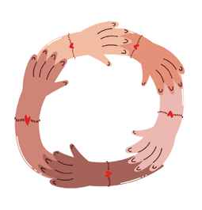

      - Strategies for health (Slide 23)
- Explain each point briefly.
  - "Even if we cannot change a situation, we can strengthen our stability."
- Emphasise balance and self-care.

      - Structural message (Slide 24)
- Read slowly:
  - You are not responsible for fixing the adults.
  - You can ask for help.
  - Support exists.
- Closing:
  - "Seeking support is a responsible and mature decision."

Note for the teacher

- Keep the conversation general and structured.
- Avoid asking who needs help.
- Reinforce non-blaming language.
- Supervise the emotional climate.
- If a sensitive disclosure arises:
  - "Thank you for sharing. We can talk about it more calmly in a more appropriate space."
- Central objective:
  - Strengthen protective factors.
  - Normalise the search for help.
  - Prepare a safe closing for the module.

A5 Activity 5. Closing and integration (10-15 minutes)

Objectives
Materials
PowerPoint Presentation (slide 25) Projector
Small pieces of paper
Box or envelope for anonymous questions Pens
Classroom in front-facing layout.
      - Consolidate the main messages of the module.
      - Reinforce safety and non-blaming.
      - Offer a structured space for doubts.
      - Close without emotional exposure.

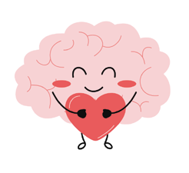
Activity procedure:
      - Structured recapitulation (Slide 25)
        - Read each point slowly.
        - After each one, you can ask:
          - "Why do you think this is important?"
        - Keep responses brief and general.
        - Do not open an emotional debate.

      - Safety reinforcement (Slide 25)
        - Explain:
          - "Sometimes adolescents may feel they should take charge of everything. It is important to remember that it is not their responsibility to resolve adult problems.”
        - Maintain a firm and calm tone.

      - Anonymous questions (Slide 25)
        - Hand out small pieces of paper.
        - Explain:
          - "If anyone wants to ask a question, they can write it down without putting their name."
        - Collect them in a box or envelope.
        - Read only those questions appropriate for the group.
        - If any require follow-up:
          - "That is an important question. We can talk about it more calmly at another time."

      - Clear and stable closing:
- "Today we have learned that mental health is part of health, that no one is to blame, and that
support is always available."
- Thank them for their participation.

Note for the teacher

- Do not end with an emotional circle dynamic.
- Avoid questions such as: "Who is going through something like this?"
- Maintain a stable and containing closing.
- If a sensitive disclosure arises, offer individual space afterwards.
- Final objective:
  - Transmit safety.
  - Reduce guilt.
  - Make it clear that asking for help is legitimate and possible.

AC1

Complementary activity
Activity 1. Real responsibility vs. assumed responsibility (15-20 minutes)

Objectives
Materials
Whiteboard Marker pens
Individual sheets (optional)
      - Differentiate between adult responsibility and adolescent responsibility.
      - Reduce the tendency to assume burdens that do not belong to them.
      - Reinforce healthy boundaries.

Activity procedure:
      - Introduction
        - "Sometimes, when something difficult happens in a family, adolescents may feel they should take on more than is their share."

      - Whiteboard dynamic
        - Divide the whiteboard into two columns.
        - Ask for general examples (not personal ones).
        - Guide towards ideas:

Responsibilities of adults

        - Seeking treatment
        - Making important decisions
        - Protecting their children
        - Managing finances

Responsibilities of adolescents

        - Going to school
        - Looking after school responsibilities
        - Asking for help when they need it
        - Expressing how they feel

      - Final reflection
- "What happens when an adolescent tries to assume responsibilities that belong to adults?"
- Guided conclusion:
  - It can generate stress.
  - It can cause burnout.
  - It does not cure the illness.
- Key message:
  - "Every person has responsibilities according to their stage of life."

Note for the teacher

- Maintain a general level.
- Do not ask: "Does this happen to you?"
- Avoid the analysis of specific family situations.
- Reinforce healthy boundaries without blaming.

AC2

Complementary activity
Activity 2. What helps vs. what doesn't help (15 minutes)

Objectives
Materials
Phrase cards (prepared in advance) Whiteboard
      - Identify helpful and unhelpful langua-ge.
      - Develop critical thinking regarding social comments.
      - Reinforce respectful communication.

Activity procedure:
      - Presentation
        - "Sometimes people say things with good intentions, but they don't always help."

      - Small group work
        - Hand out phrases such as
          - "I'm sure they'll get over it."
          - "Don't exaggerate."
          - "I'm here if you want to talk."
          - "It's not your responsibility."
          - "You have to be strong."
          - "We can look for help."
        - Ask them to classify these into:
          - Helpful phrases
          - Unhelpful phrases
          - Doubtful phrases

      - Feedback session
        - Reflect:
          - "Why might some phrases increase pressure?"
          - "Why do others reduce guilt or isolation?"

      - Closing
        - "Sometimes we cannot change the situation, but we can change how we support others."

Note for the teacher

- Maintain a general analysis.
- Do not ask for personal examples.
- Supervise respectful language.
- Gently correct stigmatising comments.

Material Checklist – All Activities

Main Activities

  - What is a mental illness?
PowerPoint Presentation (Slides 2-6)
Projector
Whiteboard
Felt-tip pens
Classroom in frontal or semi-circle layout.

What helps? — Support network
PowerPoint Presentation (Slides 20-24)
Projector
Whiteboard
Felt-tip pens
Classroom in plenary layout.

Myths and realities
PowerPoint Presentation (Slides 7-14)
Projector
Optional: red/green cards (Myth / Reality)
Whiteboard and felt-tip pens
Classroom in plenary layout.

General impact on adolescents
PowerPoint Presentation (Slides 15-19)
Projector
Whiteboard
Felt-tip pens
Classroom in frontal or plenary layout.

Closing and integration
PowerPoint Presentation (Slides 25-26)
Projector
Small slips of paper
Box or envelope for anonymous questions
Pens
Classroom in frontal layout.

Complementary Activities
2.1 Real responsibility vs. assumed responsibility
Whiteboard Felt-tip pens
Individual sheets (optional).
2.2 What helps vs. what does not help
Cards with phrases (prepared in advance)
Whiteboard
18

Printable Activity 2: Myths and Facts

Myths

Truths







Erasmus+

Enriching lives, opening minds.


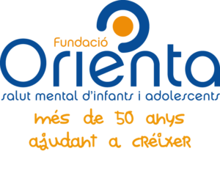

Carl von Ossietzky

Universitat Oldenburg



e.V.



